**Belize Oval Coffee Table**

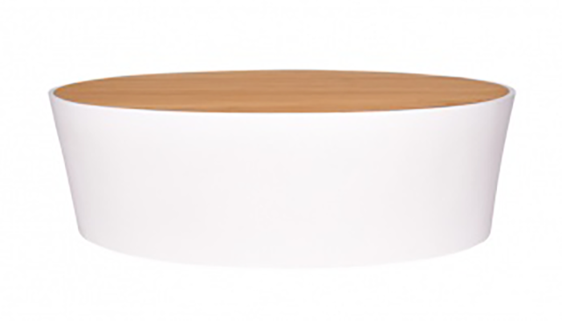

**SKU:** 1W-0004-30

## Product Summary

**Material:**Tubular Aluminum/Teak Wood

**Finishes:**Natural Teak



**Cushion SKU:** C1W-0002-30 + Fabric

**Dimensions:**48.4″ W 30.5″ D x 13.98″ H