Woven Storage Bin

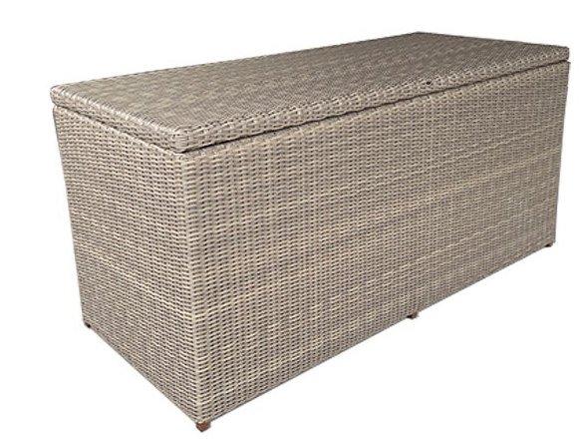
SKU: 18615

Product Summary
Material: Resin Wicker
Finishes: #2 Driftwood
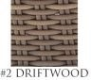
Dimensions: 69″ W x 31″ D x 33″ H
Weight: 65 lbs.

