# A blue and black logo AI-generated content may be incorrect.Environment & Safety

### The safety of communities, people, and the environment is at the heart of our project. We are committed to being good neighbors and incorporating feedback from all relevant stakeholders into both the proposed route and the project’s overall design.

Core Value. Safety is at our core and Traverse Pipeline’s highest priority.

**Operational Safety.** Once completed, highly trained pipeline controllers use advanced technology to carefully monitor our pipelines — 24/7/365 — and complete regular aerial and ground safety inspections along the route.

**Safety Team.** We employ a dedicated team of safety and environmental professionals who build and maintain stringent safety programs and practices, and every single employee and contractor has the authority to stop work they believe is unsafe.

**Safety Dedication.** We are dedicated to pipeline safety, use high-quality, US-made steel pipe, and ensure our pipelines meet or exceed the applicable standards for pipeline construction and operation and the contractor has the authority to stop work they believe is unsafe.

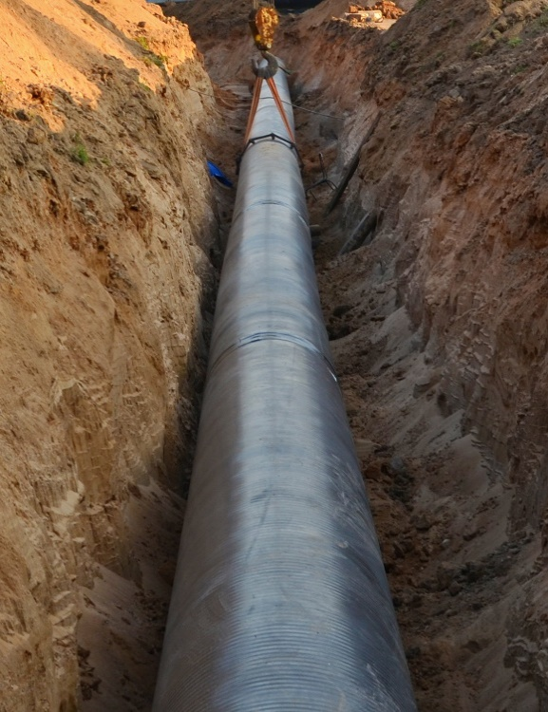

#### Safeguarding the Pipe’s Integrity

* Each joint of pipe is inspected before it leaves the mill and uses greater pipe wall thickness than is required by federal standards.
* One hundred percent of the field welds are examined by x-ray before the line is placed in service.
* A post-construction hydro test is conducted, and inspection tools are run upon completion to verify the condition of the pipe.
* The entire line is analyzed using an electrical device designed to identify any defects which can include pinholes and cracks in the pipe’s specialized coating.
* A cathodic protection system designed to guard against corrosion and to help maintain ongoing structural integrity.
* In cases where pipe installation is delayed, a special UV protective coating will be applied to the pipes to prevent coating degradation.

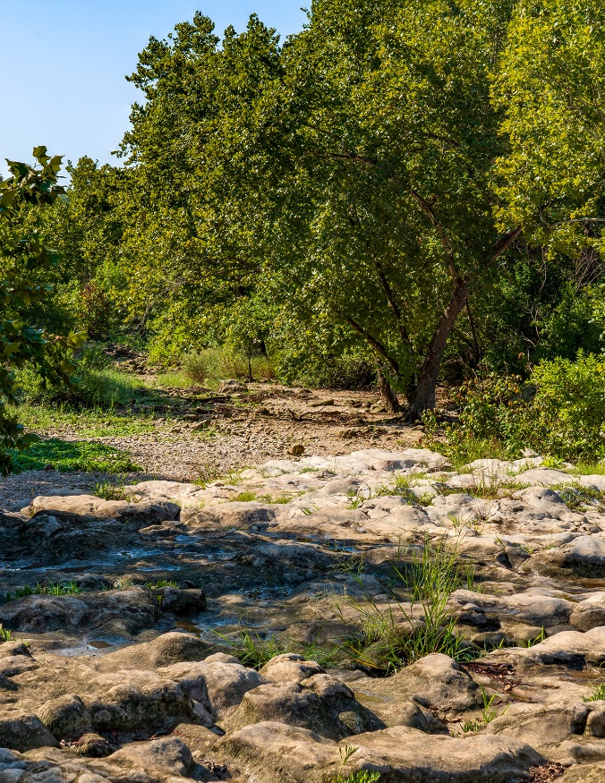

*Words such as “anticipated,” “expected,” “targeted,” “projected,” “estimated,” and similar expressions are intended to identify forward-looking statements. These forward-looking statements rely on a number of assumptions concerning future events and are subject to a number of uncertainties, factors and risks, many of which are outside the control of the Company, which could cause results to differ materially from those expected by management of the Company.e Company.*

#### Planning

* **Environmental Permits.** We’ve secured the environmental permits from state, and local agencies, and gathered significant amounts of environmental data through field study and analysis, which we provide, to regulators and permitting agencies as required.
* **Environmental Study/Biology**. Biologists have inspected the entire route and have not identified any potential for adverse effects to threatened or endangered species, or the habitat, that will occur during the construction or operation of Traverse Pipeline.

# **CALL 811**

*One of the biggest dangers to a pipeline, once it is in service, is a third-party line interference.   
Our industry works together to promote safe digging and excavating practices which, when employed, significantly decrease risks around a pipeline.*

#### Construction

* **Safe Construction**. The safety of our personnel, landowners, and the surrounding communities is of the utmost importance throughout the construction process. Utilizing industry best practices, we ensure Traverse Pipeline is completed in a safe and secure manner.

#### Operation

* **Remote Shutdown.** Highly trained pipeline controllers can take real-time action to remotely shut down a pipeline system if a problem is suspected and the line can only be returned to operation after field personnel conduct a visual inspection.
* **Pipeline Inspection.** Regular aerial surveillance of the line to look for potential risks to the pipeline, including encroachment or other unauthorized activity on the right-of-way, as well as any other potentially concerning surface conditions along the pipeline. We also conduct regular foot patrol inspections along the entire route.
* **Pipeline Markers.** Pipeline markers installed within line-of-sight on the pipeline route noting the general location of the pipeline, including at road, property, and creek crossings.