# A blue and black logo AI-generated content may be incorrect.FAQ

## Q: What product is the pipeline transporting?

A: The bi-directional Traverse Pipeline is designed to transport up to 2.4 billion cubic feet per day (Bcf/d) of natural gas through approximately 152 miles of 42-inch pipeline along the Gulf Coast connecting Agua Dulce in South Texas and the Katy area.

**Q: Why is the pipeline needed?**

A: As production in the Permian Basin continues to grow, additional takeaway capacity is needed to transport natural gas to end markets. The Traverse Pipeline will connect Katy-area pipelines outside Houston to the Agua Dulce hub, providing shippers access to multiple demand centers.

**Q: What route will the pipeline take?**

A: The bi-directional pipeline with capacity of 2.4 Bcf/d will move natural gas 152 miles between the Agua Dulce Hub in South Texas to the Katy area near Houston.

## Q: Where is the natural gas coming from?

A: Supply to the Traverse Pipeline will come from multiple sources, including connections with the Whistler, Blackcomb, and Matterhorn Express pipelines.

**Q: What is the economic impact of the project?**

A: Through the completion of construction, the Traverse Pipeline will contribute taxes to state and local governments and benefit local communities by bringing increased patronage to local hotels, restaurants, and other business. Once fully operational, the pipeline will contribute an estimated $10.6 million in taxes to state and local governments annually.

## Q: Will the Traverse Pipeline cross my property?

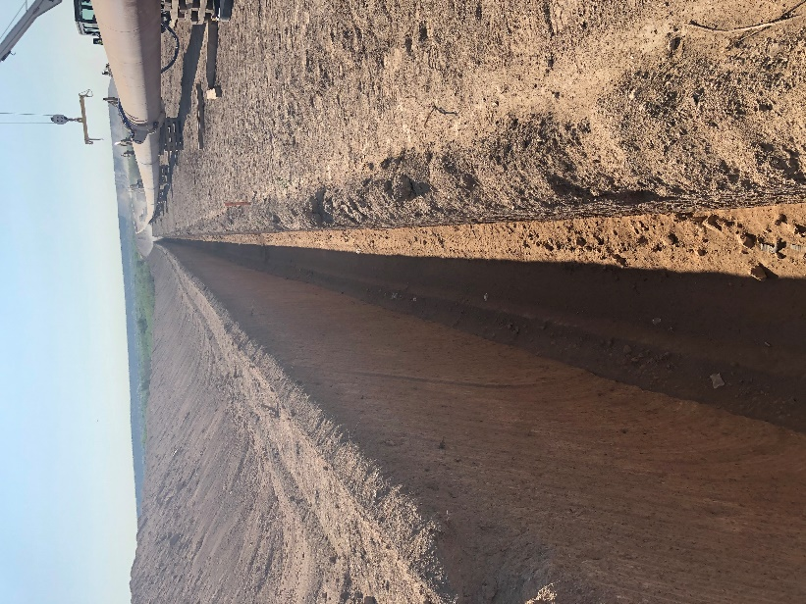A: If you have not been contacted by a representative of the Traverse Pipeline, the pipeline is not currently planned to go through your property. To those landowners contacted, we are committed to being good neighbors and look forward to working together, incorporating your feedback in the proposed route and the project’s overall design.

## Q: What will Traverse Pipeline do to minimize impact on my land?

A: We follow best management practices during construction to minimize erosion and sedimentation. We also return the area of impacts to preexisting contours, ensure vegetation is reestablished, and allow areas outside of our permanent right-of-way to return as close to previous conditions as possible.

## Q: How many people will be working on the project?

A: The Traverse Pipeline will employ more than 900 skilled workers during the construction phase of the project.

## Q: What is the diameter of the pipe used?

A: The Traverse Pipeline will consist of 42-inch bidirectional line buried below the ground.

## Q: How far will the pipeline be below ground?

A: The pipeline will be at least 3 feet below the surface and a minimum of 5 feet under road crossings.

## Q: What is the width of the right of way?

A: As typical with natural gas transmission pipelines, the Traverse Pipeline will have a permanent easement of 50 feet, plus approximately 75 feet of additional workspace during the construction phase.

## Q: When will construction begin and how long will it last?

A: Construction is expected to begin in 2026 and conclude by 2027 with an in-service date in the first half of 2027.

## Q: Will the project use eminent domain?

A: While the project does have the right of eminent domain, it is only used as an absolute last resort. We are committed to being good neighbors and incorporating feedback from all relevant stakeholders in both the proposed route and the project’s overall design.

## Q: Will my land be restored back to how it was prior to construction?

A: Once construction is complete, our teams will work to restore the area to as near to its original condition as possible and in accordance with the easement agreement. Once restoration is complete, many easements blend right in with the surrounding area.

#### Additional information

The Traverse Pipeline will be wholly owned by the Blackcomb Pipeline joint venture, which is owned by WPC, Targa and MPLX.The bi-directional Traverse Pipeline is designed to transport up to 2.4 billion cubic feet per day (Bcf/d) of natural gas through approximately 152 miles of 42-inch pipeline along the Gulf Coast between Agua Dulce in South Texas and the Katy area. Supply for the Traverse Pipeline will be sourced from multiple connections, including, but not limited to, the Whistler, Blackcomb, and Matterhorn Express Pipelines. The Traverse Pipeline enhances optionality for shippers to access multiple premium markets.

©2025 Traverse Pipeline. All rights reserved. For additional information visit [www.traversepipeline.com](http://www.traversepipeline.com) | 1-855-TRAVSPL | [info@traversepipeline.com](mailto:info@traversepipeline.com)

*Words such as “anticipated,” “expected,” “targeted,” “projected,” “estimated,” and similar expressions are intended to identify forward-looking statements. These forward-looking statements rely on a number of assumptions concerning future events and are subject to a number of uncertainties, factors and risks, many of which are outside the control of the Company, which could cause results to differ materially from those expected by management of the Company.*

