BWDance Uniform Requirements

At BWDance we are proud to have a beautiful studio uniform. New students have 4 weeks before a uniform is required to make sure they are happy with their selected dance style(s).

Where to purchase?
- Leotards, tights, shoes, crossovers and dance skirts are all to be purchased from the dance shop (Dancestuff).
- Plain shirts, pants, socks etc can be purchased from general clothing stores – please ensure these meet requirements.

Requirements for boys:
 | Top/leotard | Pants/legging | Shoes
Jazz/ Musical Theatre | Plain black t-shirt | Plain black pants/shorts/ leggings. No jeans | 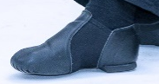  Black Jazz Shoes  – slip on  + Black socks
Contemporary/ Lyrical | Plain black t-shirt | Plain black pants/shorts/ leggings. No jeans | 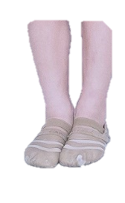  Tan Capezio  Freeforms
Tap | Plain black t-shirt | Plain black pants/shorts/ leggings. No jeans | 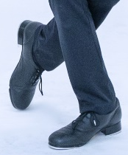  Black Tap Shoes  + Black socks
Ballet: | Plain white shirt or white cap sleeve leotard | Plain black shorts (not baggy) or black boys ballet tights | 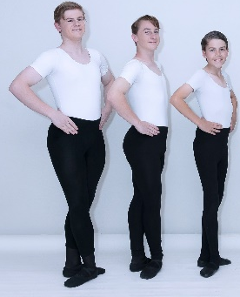  Black ballet shoes  + Black socks
Hip Hop | Plain black t- shirt or tank top | Plain black pants/shorts/ leggingsNo jeans. | 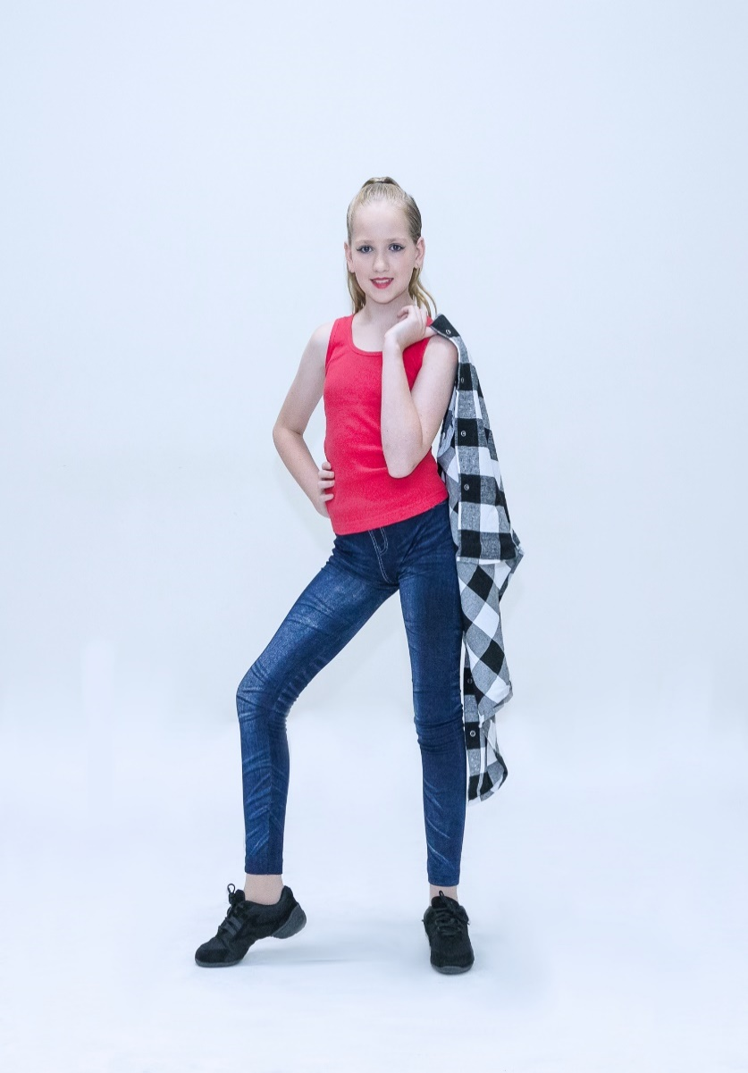  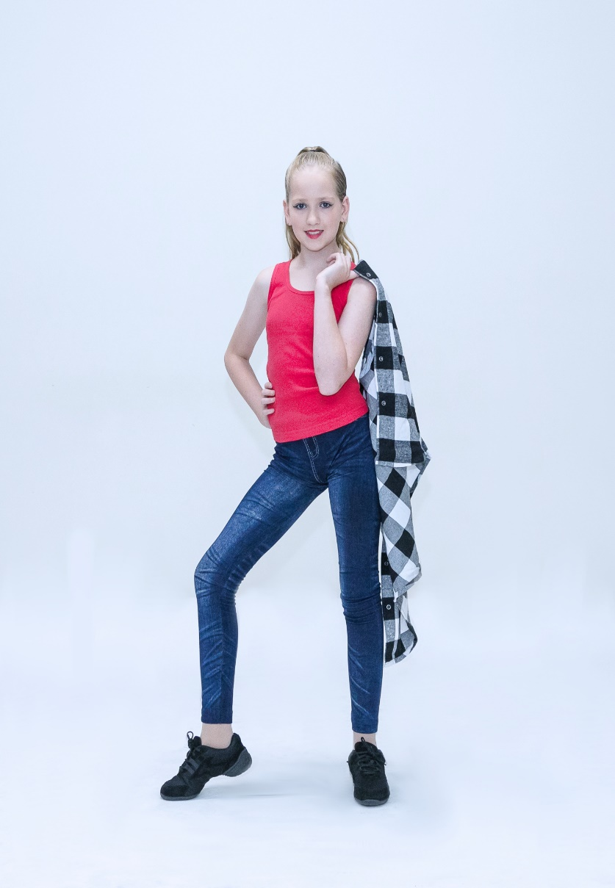  Black hip hop  shoes  + Black socks

Additional:
- For safety reasons jewellery is to be removed before class.
- Long hair to be tied back in ponytail for safety reasons
- In winter/cold weather a close fitting long sleeve t-shirt or crossover should be worn. Hip Hop students can wear a plain black jumper/hoodie as long as this isn’t bulky

Requirements for girls:
Leotard (required for all styles except hip hop):
- The leotard used for the BWDance uniform is the Energetiks Charlotte leotard*
- Sugarplum/Pre Juniors/Juniors also have the option of the Capezio CC101C leotard.
Pre-Junior & Junior
Capezio CC101C in Pink
Energetiks ‘Charlotte’ leotard in Candy Pink leotard is also accepted if required due to sizing.

Pre-Senior
Energetiks ‘Charlotte’
Punk Pink
Senior
Energetiks ‘Charlotte’
Black

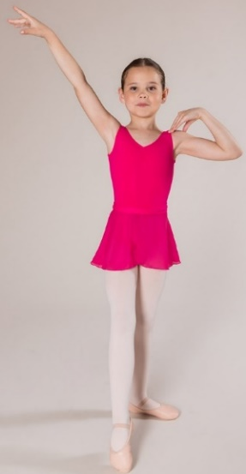
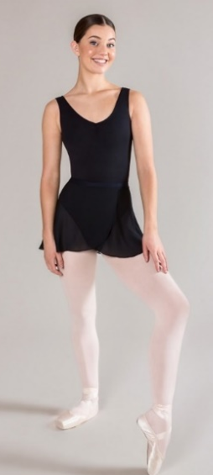
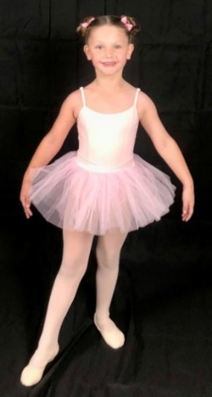

 | Leotard/top | Tights + Shoes | Hair | Optional
Jazz/ Musical Theatre | Leotard (as above) | 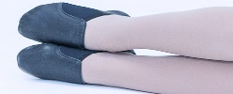  Tan tights+  Black Jazz Shoes  – slip on | Ponytail or bun | Black dance shorts
Contemporary/ Lyrical | Leotard (as above) | 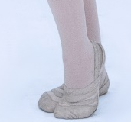  Tan tights  +  Tan Capezio Freeforms | Ponytail or bun | Black dance shorts/chiffon  skirt (Lyrical)
Tap | Leotard (as above) | 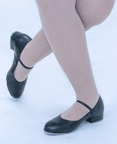  Tan tights  +  Black Tap Shoes | Ponytail or bun | Black dance shorts
Ballet | Leotard (as above) | 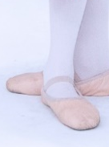  Theatrical pink tights  or ballet socks from  dance shop+  Pink canvas ballet shoes  Ribbons for Seniors | Ballet bun done with bun pins & a bun net | Chiffon ballet skirt matching leotard colour  Tutu skirt available for Sugarplums
Hip Hop | Plain black t- shirt or tank top | Black socks + Black  hip hop shoes | Ponytail | Required: Plain black shorts/pants. No jeans
Additional:
- Hair which is too short for a ponytail should be neatly pinned back/ headband should be worn
- For safety reasons jewellery is to be removed before class.
- In winter/cold weather a dance crossover can be worn, this should match the colour of the leotard. Hip Hop students can wear a plain black jumper/hoodie as long as this isn’t bulky
*Reference photos used are from the Energetiks brand website: https://www.energetiks.com.au/

