**BWDance 2025 Enrolment Information**

**Introduction & Contact Details………………………………. Page 2**

**Code of Conduct & Safety Guidelines………………………Page 2**

**BWDance 2025 Price List…………………………………………Page 4**

**BWDance Uniform………………………………………………….Page 6**

**Opportunities at BWDance…………………………………….Page 8**

**Introduction & Contact Details**

Dear parents, guardians, and students,

A very warm welcome (or welcome back) to the BWDance family. Before commencing classes for 2025 please read this overview of what you need to know before enrolling.

**Contact Details:**

Phone Number: 0407782966 (Miss Amanda)

0466527599 (Miss Cassie after 4:30pm only)

Email: danceclasses@y7mail.com

**What are the expectations for class attendance?**

* When a student enrols at BWDance it is expected that they attend class weekly. This is especially important if the student is participating in a performance.
* All missed classes must be paid for however dance classes can be made up.
* If a student is not able to attend a lesson as a matter of courtesy the parent/guardian of the student should text 0407782966 (Sugarplums – Intermediate) or 0466527599 (Seniors) before the class is due to commence.

**Code of Conduct & Safety Guidelines**

**Code of conduct for parent/guardians:**

* Please encourage your children to show respect for their classmates, teachers and any BWDance staff members and lead by example.
* Demonstrate consideration and respect for BWDance staff. If you have concerns please raise these in a civil, polite manner preferably in a private setting. Bullying and rude behaviour towards BWDance staff is unproductive, unnecessary and will not be tolerated.
* BWDance reserves the right to ask a student to leave as a result of inappropriate behaviour by the student, parent or family member.

**Code of conduct for students:**

* Wear appropriate clothing when you arrive and leave classes. Always put a t-shirt or tracksuit over your dance uniform.
* Listen to your teachers with attentiveness and respect. Do not talk while a teacher is talking or demonstrating (this includes nonverbal communication as well)
* Be mindful of body language when in class, behaviours such as eye rolling, intentional poor posture with folded arms, checking your watch all demonstrate disrespect to your teachers.
* You will receive constructive feedback throughout the lesson, this is because your teachers want to help you be the best dancer you can be.
* Practising at home is a standard expectation of any students who are participating in a performance or an exam. It is also absolutely essential if you want to be good or to improve. Ask your teacher if you’re not sure what’s best to practise.

**Using venue facilities**

Any damage or mess made to the class venues reflects on BWDance as a studio and may prevent BWDance being able to hire the venue for future classes. Please be considerate of keeping the venue clean and tidy.

* Place all rubbish in the bin
* Tidy up any mess made as a result of using kitchen facilities
* Sweep up any crumbs or mess made on floors
* Do not damage the property or any items within the property

**Safety guidelines**

* By signing the enrolment form the parent/guardian is confirming that the student is in good health and able to participate in dance as a physical activity.
* Any injuries and medical conditions must be explained in full. Parents or guardians will be contacted before any action is taken in the event medical treatment is required unless it is deemed to be an emergency.
* Please be aware that teachers cannot leave the class to supervise students outside of their allotted class times. BWDance staff cannot be responsible for the behaviour/safety of students waiting for classes or waiting to be picked up.
* Students waiting for classes to commence should be supervised by a parent/guardian.
* If parent/guardian is late to pick a student up the student is to wait inside the studio quietly.
* Students under 18 years are not to leave the premises without a parent/guardian -this includes trips to the surrounding shops.
* BWDance staff are also not responsible for the siblings of dance students. Siblings waiting while classes are running must be supervised by a parent/guardian.
* BWDance staff will not assume responsibility for any lost or stolen property.

**Advertising**

* If you indicate that you give BWDance permission to use your child’s image in advertising on the enrolment form this gives an automatic copyright to BWDance for all images taken of that child at any occasion involving BWDance.
* The use of these images may include advertising flyers, the BWDance website & promotional videos.
* In the event the student leaves BWDance unless otherwise stated by the parent the photos or videos/DVDs may continue be used for the purposes of publicity.

**What are the expectations around dance classes at other studios, workshops, auditions, talent quests etc?**

* When enrolled at BWDance students are not permitted to attend classes at any other dance studio without BWDance being informed and approving this. The reason is because different studios have different teaching methods and styles and it is important for teachers to be aware of other potential dance education the student is receiving.
* Please consult with BWDance staff before attending auditions or workshops associated with other dance studios.
* Students must ask permission before using BWDance choreography in any talent quest or audition.
* If a student is to leave BWDance they are no longer permitted to perform using BWDance choreography – this applies to solo and group dances.

**BWDance 2025 Price List**

|  |  |  |
| --- | --- | --- |
| Class Description | Time | Price per class |
| Preschool | 15 minutes  20 minutes  30 minutes | $7  $8  $9 |
| Pre junior | 20 minutes  30 minutes | $8  $10 |
| Junior | 20 minutes  30 minutes  40/45 minutes | $9  $11  $12 |
| Intermediate | 20 minutes  30 minutes  40/45 minutes | $10  $12  $13 |
| Senior | 20 minutes  30 minutes  40/45 minutes | $11  $13  $15 |
| Adult | 20 minutes  30 minutes  40/45 minutes | $11  $13  $15 |
| Private lesson | 20 minutes  30 minutes | $27  $38 |
| If this is a duo or trio lesson then cost can be divided between the participating students | | |

**BWDance offers for 2025!!**

* **Preschool classes combo special!**

Attend 3 preschool classes (ballet, jazz & tap) for just $22

* **Weekly inclusive fee:**

Attend unlimited classes in your age range for an all-inclusive weekly fee!

* $47 for Intermediates and Seniors
* $37 for Juniors and Pre Juniors
* Sibling discounts may apply on the inclusive fee, please enquire for details
* Does not include the Senior Pre-Pointe & Pointe class
* **Ballet classes:**

Participate in one ballet class get your other ballet classes half price

* **Combo deals:**

Some classes are ½ price if done in combination with another class. Check the timetable for details.

**How to pay?:**

* Payments may be made by bank deposit BSB 650000 Account number 500751118 Account name BWDance. Please ensure you include the invoice number or students name when payment is made.
* A late fee of **$15 per week** will apply to fees overdue by 21 days.
* If payment is still not received after 28 days BWDance reserves the right to refuse service.
* Overdue accounts of more than 60 days duration will be referred to a collection agency.

**Missed classes:**

* Missed classes have to be paid for, if a student misses a lesson they can make this up on another day or in another style as long as the class is the same age group.
* If a student ceases dance lessons ongoing fees are still payable if the parent/guardian does not inform BWDance.

**Additional Costs To Be Aware Of:**

1. **Enrolment Fee**

There is an enrolment fee $15 per student, $25 per family. This fee covers the costs of administration, music licencing, insurance and ensures enrolment in preferred classes.

1. **Uniform:**

Different dance styles may require different shoes or dance tights (see page 6-7 ). If you are participating in multiple dance styles you will require all outlined footwear and uniform.

**Optional: For students doing the end of year concert (see page 8)**

1. **Concert costumes & costume deposit:**

For each dance a student performs in the concert they will need a costume which will be set by the teacher of the dance. Generally each costume is $55 - $75, we will advise on the exact cost once the costume is ordered. In some instances, costumes are hired out instead for a fee of $30-$40 per costume.

To facilitate the gradual paying off of costumes there is a compulsory deposit of $15 per costume required at the beginning of each term. This means by the end of the year most of the costumes are already paid off.

1. **Concert Package Fee:**

Per student: $19/term Per family: $27/term

This fee will be billed each term and replaces the end of year stage rehearsal fee and cost of the concert video. For existing students this means you will receive the 2025 concert video automatically and will not have to pay the stage rehearsal fee at the end of the year. This fee covers: stage rehearsal, all extra performance rehearsals, venue hire, professional concert video link, presentation day disco, One Music licencing, personalised trophy and concert program costs.

**BWDance Uniform Requirements**

At BWDance we are proud to have a beautiful studio uniform. New students have **4 weeks** before a uniform is required to make sure they are happy with their selected dance style(s).

**Where to purchase?**

* Leotards, tights, shoes, crossovers and dance skirts are all to be purchased from the dance shop (Dancestuff).
* Plain shirts, pants, socks etc can be purchased from general clothing stores – please ensure these meet requirements.

**Requirements for boys:**

|  |  |  |  |
| --- | --- | --- | --- |
|  | **Top/leotard** | **Pants/legging** | **Shoes** |
| **Jazz/ Musical Theatre** | Plain black t-shirt | Plain black pants/shorts/ leggings. **No jeans** | A child in a black shirt  Description automatically generatedBlack Jazz Shoes  – slip on  + Black socks |
| **Contemporary/ Lyrical** | Plain black t-shirt | Plain black pants/shorts/ leggings. **No jeans** | A group of girls in blue dresses  Description automatically generated  Tan Capezio  Freeforms |
| **Tap** | Plain black t-shirt | Plain black pants/shorts/ leggings. **No jeans** | A person in a pink vest and black pants  Description automatically generatedBlack Tap Shoes  + Black socks |
| **Ballet:** | Plain white shirt or white cap sleeve leotard | Plain black shorts (not baggy) or black boys ballet tights | A group of people posing for a picture  Description automatically generated  Black ballet shoes  + Black socks |
| **Hip Hop** | Plain black t- shirt or tank top | Plain black pants/shorts/ leggings**No jeans.** | Black hip hop  shoes  + Black socks |

**Additional:**

* For safety reasons jewellery is to be removed before class.
* Long hair to be tied back in ponytail for safety reasons
* In winter/cold weather a close fitting long sleeve t-shirt or crossover should be worn. Hip Hop students can wear a plain black jumper/hoodie as long as this isn’t bulky

**Requirements for girls:**

**Leotard *(required for all styles except hip hop):***

* The leotard used for the BWDance uniform is the Energetiks Charlotte leotard*
* Sugarplum/Pre Juniors/Juniors also have the option of the Capezio CC101C leotard.

**Senior**

**Energetiks ‘Charlotte’**

**Black**

**Intermediate Energetiks ‘Charlotte’**

**Punk Pink**

**Sugarplum, Pre Junior & Junior**

**Capezio CC101C** **Energetiks ‘Charlotte’**

**Pink Candy Pink**

**OR**

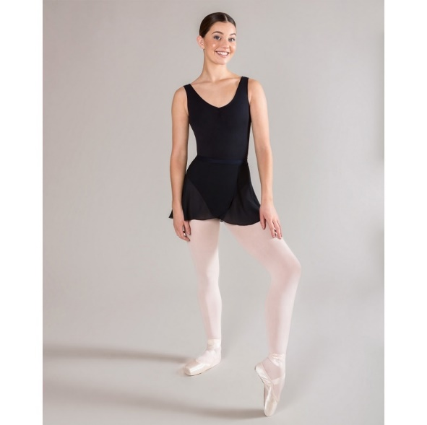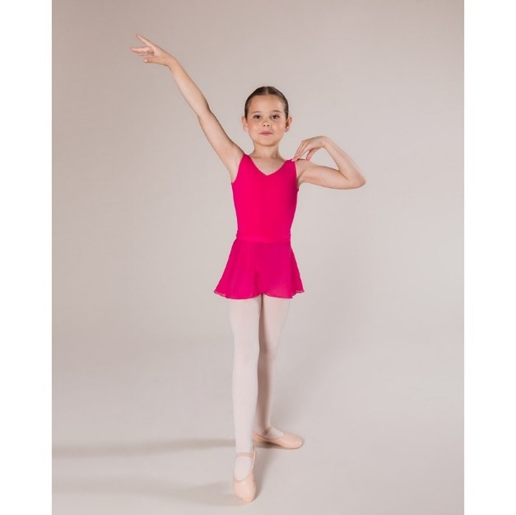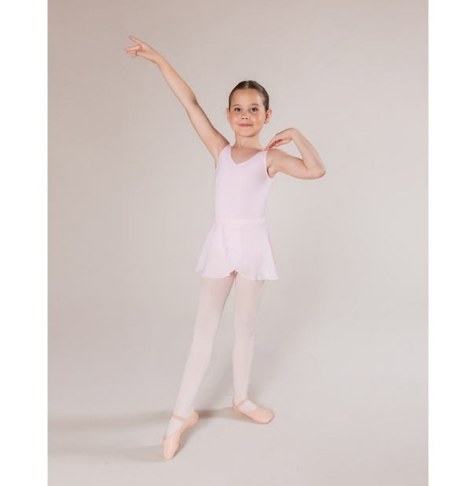

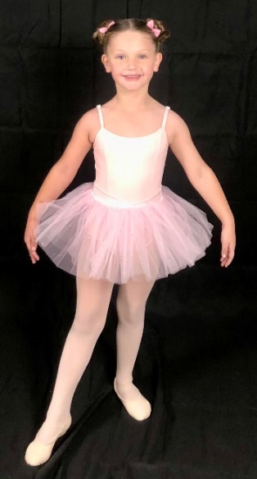

|  |  |  |  |  |
| --- | --- | --- | --- | --- |
|  | **Leotard/top** | **Tights + Shoes** | **Hair** | **Optional** |
| **Jazz/ Musical Theatre** | Leotard (see above) | A child in a purple outfit  Description automatically generatedTan tights+  Black Jazz Shoes  – slip on | Ponytail or bun | Black dance shorts |
| **Contemporary/ Lyrical** | Leotard (see above) | A child in a blue leotard  Description automatically generatedTan tights  +  Tan Capezio Freeforms | Ponytail or bun | Black dance shorts/chiffon  skirt (Lyrical) |
| **Tap** | Leotard (see above) | A person in a red dress  Description automatically generatedTan tights  +  Black Tap Shoes | Ponytail or bun | Black dance shorts |
| **Ballet** | Leotard (see above) | **Theatrical pink tights**  **or ballet socks from**  **dance shop**+  Pink canvas ballet shoes  Ribbons for Seniors | Ballet bun done with bun pins & a bun net | Chiffon ballet skirt matching leotard colour  Tutu skirt available for Sugarplums |
| **Hip Hop** | Plain black t- shirt or tank top | Black socks **+** Black  hip hop shoes | Ponytail | Required: Plain black shorts/pants. **No jeans** |

**Additional:**

* Hair which is too short for a ponytail should be neatly pinned back/ headband should be worn
* For safety reasons jewellery is to be removed before class.
* In winter/cold weather a dance crossover can be worn, this should match the colour of the leotard. Hip Hop students can wear a plain black jumper/hoodie as long as this isn’t bulky

*Reference photos used are from the Energetiks brand website: https://www.energetiks.com.au/

**Opportunities at BWDance**

1. 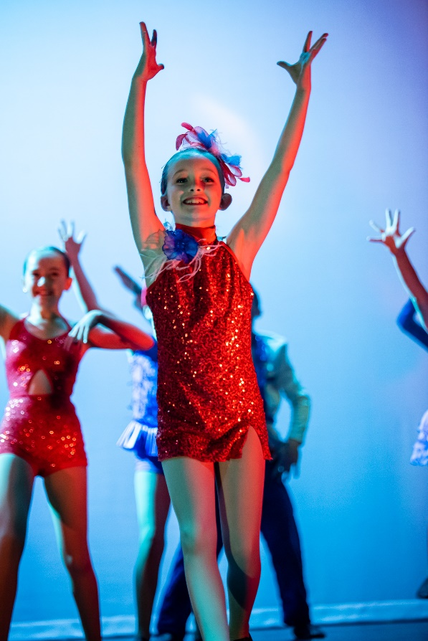**End of year concert**

* BWDance holds an annual concert to celebrate the hard work and accomplishments of BWDance students.
* Every class gets to perform a group dance that they have learnt during the year
* It is not compulsory but strongly recommended to provide students with the valuable experience of performing on stage and being a part of a stage production.
* The concert is held one evening generally between the 1st -19th December (exact date is provided when advised by the venue).
* The concert usually starts at 6:00pm and runs until 8:30 pm
* Additional costs related to the concert are outlined on page 5.
* As a gift to the students who participate in the end of year concert, we will present them with a personalised trophy at our presentation day. Students who have been with BWDance for 5 years and above are awarded with a perpetual trophy.
* **Note: All students who participate in the concert also need to attend a mandatory stage rehearsal held a few days before the concert. This the only opportunity that students have to get used to the stage and backstage areas.**

1. **Other group performance opportunities:**

In addition to the concert students may have the opportunity to perform at local events during the year. This includes events such as Kids Day Out, local school fetes/fairs and the Gosford Show.

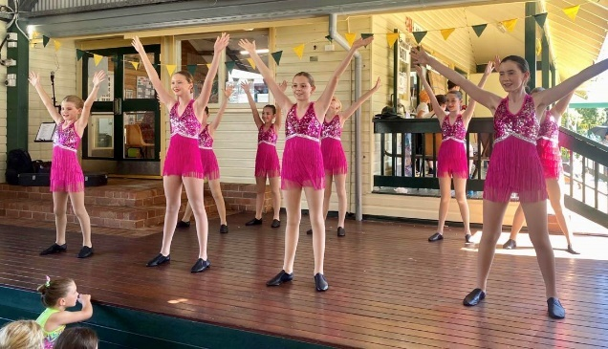

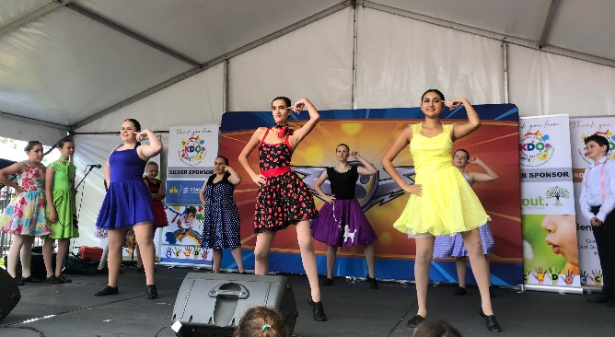

1. **Eisteddfod Participation**

* We offer the opportunity for students to learn solos, duos and trios to perform in dance competitions (called eisteddfods).
* Eisteddfods provide enthusiastic and dedicated students with the chance to perform on stage more often during the year.
* Requirements for eisteddfod work:
  + Fees must be up-to-date before a solo/duo/trio timeslot can be set aside or a payment plan must be in place.
  + Students must attend a weekly group class in the dance style they wish to perform
  + Students must attend at least one weekly ballet class (except for tap & hip hop solos)
  + Students must be prepared to do additional practice at home and demonstrate a willingness to receive and apply constructive feedback from their teachers and adjudicators.
  + Students must embody the BWDance Code of Conduct both in the studio and when representing BWDance at external events.

1. A group of women in ballet clothing

   Description automatically generated**Ballet Exams - Royal Academy of Dance (R.A.D)**

* BWDance classical ballet classes are based on the internationally recognised Royal Academy of Dance (R.A.D) Ballet Syllabus.
* Interested students have the option of entering ballet exams in which they perform a series of combinations based on the R.A.D syllabus.
* The exam is completed at the R.A.D headquarters in Sydney and assessed by a registered examiner.
* This is a valuable opportunity to receive feedback from highly respected professionals in the dance industry and gives students the experience of striving towards a goal.
* A child in a pink leotard

  Description automatically generatedRequirement for exam work:
  + Students must be attending at least two R.A.D ballet classes per week. They may also require a few private lessons in the lead up to the exam.
  + Student must also be prepared to do additional practice for their exam work at home.
  + There is an entry fee for the exams and a specific exam uniform will need to be purchased or hired.

*If you are interested in any of the above opportunities please let Miss Cassie or Miss Amanda know asap and we can discuss the options for 2025.*