Q&A with singer-songwriter Christopher Wyze, blends sounds and experiences that have shaped him: blues, rock-n-roll, Americana, and country - Blues.Gr

Q&A with singer-songwriter Christopher Wyze, blends sounds and experiences that have shaped him: blues, rock-n-roll, Americana, and country
- Posted by Music Network by Michael Limnios on July 19, 2024 at 9:30am
- View Blog
"Music makes the world smaller. Music is something we humans have in common that transcends language, borders, and everything else that makes us different. I find this quite curious, even mystical. Music communicates at the very core of what we as humans understand. All people understand a smile, a laugh, the cry of a baby, the sounds of nature."
Christopher Wyze:
A Blend That Revolves Around the Blues
Twenty years a blues band frontman (Christopher Wyze & The Tellers), singing the songs of others, Christopher Wyze has emerged as a powerful lyricist and stylist of his own music. None other than the Nashville Songwriters Association International named Wyze "One to Watch" in December 2023. His original outlook blends sounds and experiences that have shaped him: blues, rock-n-roll, Americana, and country, all melded together with Wyze’s distinctive voice and storytelling style. Born and raised in the hills of southern Indiana, Wyze has been deeply influenced by his time spent in the Mississippi Delta honing his narrative voice and musical sound. Wyze's debut studio 13-tracks album Stuck in the Mud (2024), takes listeners on a coast-to-coast journey through his Technicolor, movie-scape mind. The title track, Stuck in the Mud, tells the sometimes woeful, sometimes witty tale of a mucked-up serial loser. Back to Clarksdale about finding his oasis in music, and Three Hours from Memphis, about a musician looking for stardom, shed autobiographical light on Wyze’s own hopes and dreams.
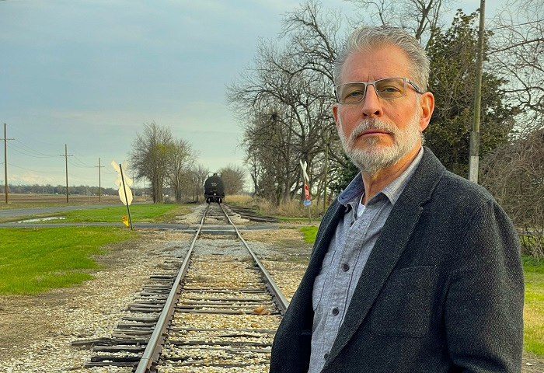
(Christopher Wyze, Clarksdale MS / Photo by Coop Cooper)
Wyze and the Tellers recorded Stuck in the Mud in Muscle Shoals, Alabama and Clarksdale, Mississippi. The Muscle Shoals Tellers feature artists Eric Deaton (guitar and background vocals, previous work with The Black Keys and Hank Williams Jr.), Gerry Murphy (bass), Brad Kuhn (keys, a FAME Studios musician), and Justin Holder (drums/ percussion, FAME Studios musician). In Clarksdale, singer-songwriter Cary Hudson, former frontman for the beloved rock band, Blue Mountain, and called "a national treasure" by Jason Isbell co-writes two songs with Wyze and joins the sonic ensemble. The rest of the Mississippi players include Englishman Douglas Banks on drums and Teller mainstay Gerry Murphy on bass.
Interview by Michael Limnios
How has the music influenced your views of the world?
Music makes the world smaller. Music is something we humans have in common that transcends language, borders, and everything else that makes us different. I find this quite curious, even mystical. Music communicates at the very core of what we as humans understand. All people understand a smile, a laugh, the cry of a baby, the sounds of nature. In the same way, we all understand music. It cuts through. It communicates. All of us, all humans, have this unique form of language in common. Pretty cool, and something we should all remember and feel good about. Perhaps the most amazing thing about music, for me at least, is that it makes time stand still. When I’m listening to music or playing music, I don’t feel past or future. There is only now. In a certain way, when any of us are “in” the music, we’re immortal. It’s a Zen thing, which I suppose is a world view.
What does the blues mean to you?
For me the blues makes up the most elegant, powerful and beautiful shorthand for all the mostly trying emotions we experience as people: love, disappointment, despair, betrayal, failure, struggle, human frailty and on and on. These are the universal themes that been part of the human experience through all ages. The blues paints pictures. It tells life’s stories in many dimensions: words, musical expression – notes, rhythm, highs/lows, screams, cries, whispers, even silence, like when the band hits a stop. I think we all see ourselves in the blues. It reminds us we’re not alone.
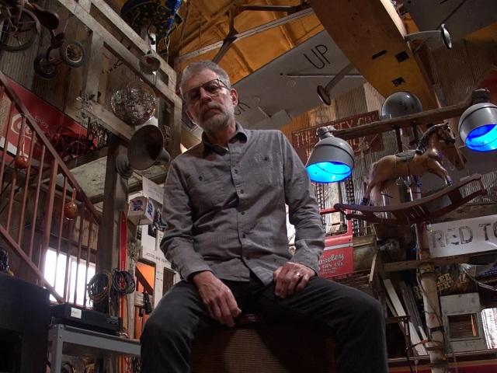
"I want the blues to keep going – in new forms and in the old classic forms. I don’t want it to get lost. So, my hope is that it continues forever. My fear is that it may not. Americans for the most part, don’t know and understand the blues." (Christopher Wyze, Juke Joint Chapel, Clarksdale / Photo by Coop Cooper)
How do you describe your sound, music philosophy and songbook?
Our sound, music philosophy and songbook is a blend that revolves around the blues. Imagine if the blues were a city, with lots of different streets, neighborhoods, people, architecture, churches, skid rows, liquor stores, juke joints and concert halls…you name it. For me our sound is something that visits all the various interesting nooks and crannies of this city called the blues – straight up 12-bar, hill country, down in the swamp, funk, jazz, country blues rock, ballads, burners…it’s a fun sound that hits all the cool sights and sounds of the blues city.
Where does your creative drive come from?
The creative drive for me is telling stories. I’m not a painter, or a sculptor, and I don’t write movies or plays or novels. But I do write stories, tiny little creative expressions – songs – that take only a few moments to play out for the listener. In my non-music career, I’m a writer. I write advertising and books. (I have five books in print). But all that writing is non-fiction. Music lyrics are my chance to write fiction in a form that is much more productive and frankly easier than writing a 40,000- or 50,000-word book that’s basically just a single looong story. In the time it takes me to write a book, I can write dozens, maybe even hundreds of song lyrics. I love that about songwriting. I know how to write and the form lets me be super productive. Sometimes the person or theme in my story-songs is me or my personal experience. Other times it’s that of someone I know or knew. And sometimes I just make it up – a fictional story of someone we all know – universal characters and situations we’ve all seen or witnessed. A fair number of the songs I write deal with people down on their luck…people folks might call losers. Not sure why, but those people – and I’ve been one of those people at times in my life – fascinate me. I feel like their stories are something I’m compelled to write. In many cases I feel I don’t write the stories. It’s more like the stories come through me. They almost write themselves with no conscious effort on my part. And start to finish, they happen quickly. I have no idea where they come from and how they end up on paper. Very weird and mystical and fun.
What moment changed your music life the most? What´s been the highlights in your life and career so far? (Christopher Wyze / Photo by Coop Cooper)
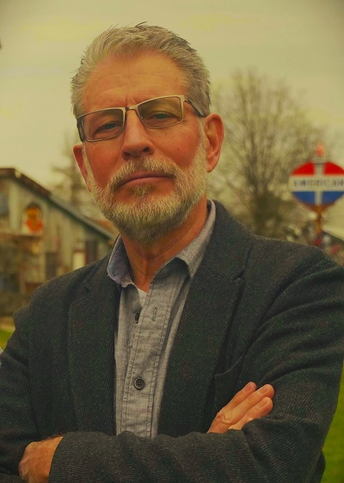
It had to be when my friend, mentor and uber-talented musician, composer, songwriter, and performer Ralph Carter told me I needed to start writing songs. Ralph, by the way, produced our new album Stuck in the Mud. Ralph’s suggestion – which felt more like a friendly directive – happened maybe five years ago. And almost in the same sentence, Ralph said, “Oh, and when you get those songs written, we’re going to make an album together.” I had been performing in a cover band, singing the blues, for a dozen years or so the day he told me that. Frankly, I thought Ralph had lost his mind. At that point in my life, I had not written one song. Well, maybe one, that I had never set to music. I’ll fast forward and say that about three years after he said that to me, there we were – me and Ralph and the rest of the band (mostly session players I had never met) – in a studio in Muscle Shoals recording my music. To be correct, I must say “our” music. Ralph and I co-wrote eight songs on Stuck in the Mud and I had three different co-writers for the other five tracks. When I co-write with Ralph or others, I come armed with a full set of lyrics. Then we collaborate. I might have a “feel” in mind for the music I envision for the story, but most of the true musical ideas and heavy lifting comes from my co-writers. I contribute musically. And my co-writers offer some great suggestions on tweaks to lyrics. It’s teamwork in the truest sense.
Why do you think that Muscle Shoals, AL; Memphis, TN; and Clarksdale, MS music legacy continues to generate such a devoted following?
People have been trying to figure that out for a long time! But one thing is for sure, those places you mention are just dripping with musical mojo. I’m from the Midwest. I understand farming. But until I had been to the Mississippi Delta, I had no clue about cotton country and agriculture of the South. I knew nothing about the world that gave birth to the blues. But from the first time I went there maybe a dozen years ago, I could feel it. I think Kingfish says it one of his songs, “There’s something in the dirt.” Hell yes there is. Every time I go there (and I go several times a year) the vibe and feel and music of the blues overtakes me. Maybe it has something to do with the vibe of the Shack Up Inn in Clarksdale, where I stay. You can’t help but feel the music and the blues when you stay there.
Memphis is just up the road from Clarksdale. And the history and feel of the Memphis music scene – same thing – it gets into you. The Memphis sound is a bit different from Clarksdale and the Mississippi Delta – maybe more soul, and rock and roll, blended together with a huge dose of the blues. So why does it have a following? Memphis music – past and present – is amazing. As an aside, Big Radio Records out of Memphis is my label. And to be associated with such a mainstay of the Memphis music community is beyond cool. Big Radio Records is a label of Select-O-Hits, a company founded by Sam Phillips and his brother in 1960. Sam is the Sun Records/Sun Studios guy, the guy who discovered Elvis. The company those two brothers founded 60+ years ago is still run today by the Phillips family. Johnny Phillips, Sam’s nephew, is who signed me to the label.
Finally, Muscle Shoals is another of America’s music treasures. We recorded 10 of my album’s songs there and mixed the entire album with Michael Wright at Ivy Manor at the Shoals Studio. One thing I learned from being in the Shoals area is that if it has anything to do with great American music, you will find it in there – great musicians, great studios, great clubs and venues. Why does it have a following? The Muscle Shoals sound is unique and amazing, just like the music that comes out of the Mississippi Delta and Memphis.
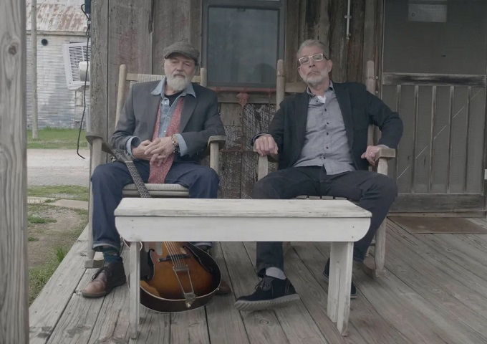
"The role of music is just that – to get people to slow down, reflect, enjoy, get pleasure, feel something, even if it may be longing or pain. The role of music is to make time stand still for the people who listen." (Christopher Wyze & Gary Hudson, Clarksdale MS 2023 / Photo by Coop Cooper)
What do you miss most nowadays from the music of the past? What are your hopes and fears for the future of?
I think a lot of the music today is overdone – over produced, overhyped, even over promoted. The music of the past seems so much simpler, and maybe more honest. I miss the music of Jimmy Reed and Michael Bloomfield, Paul Butterfield, Leon Russell, Howlin’ Wolf, Junior Wells, Ray Charles, the Mills Brothers and on and on. In particular I find myself daydreaming about what it must have been like to be in the studio with Ray Charles. There are a few outtakes from his sessions where you hear him talk to the band and the fellas n the booth. Super cool stuff…give me chills to hear and feel the music they were working out and creating in the studio. In particular I love listening to Jimmy Reed and imagining the same thing. The guy wrote and recorded hundreds of songs – and most of them have that same recognizable Jimmy Reed groove. But despite how similar they are, his tunes all sound fresh and new and different. On some of the recordings, you can even faintly hear Jimmy’s wife singing into his ear; they say he needed help with the lyrics. Chills! So cool!
My hopes and fears? I want the blues to keep going – in new forms and in the old classic forms. I don’t want it to get lost. So, my hope is that it continues forever. My fear is that it may not. Americans for the most part, don’t know and understand the blues. Today, the true blues lovers seem to be outside the U.S., Europe and other parts of the world. That’s why on any given day in Clarksdale, Mississippi about half the folks in the clubs and shops and restaurants and at the festivals are from outside the U.S. What’s with us Americans? Don’t we know what musical jewels and treasures we have here in our backyard? Buy blues albums, go see blues musicians, c’mon people!
How do you want your music and songs to affect people? What is the role of music in today’s society?
I want them to get pleasure and joy out of my songs. I want folks to be touched or amused or even riled up. I want them to hear our story-songs and maybe pause, focus and think for a moment. The role of music is just that – to get people to slow down, reflect, enjoy, get pleasure, feel something, even if it may be longing or pain. The role of music is to make time stand still for the people who listen.
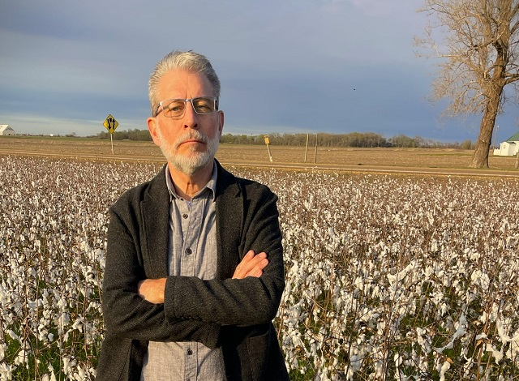
"Our sound, music philosophy and songbook is a blend that revolves around the blues. Imagine if the blues were a city, with lots of different streets, neighborhoods, people, architecture, churches, skid rows, liquor stores, juke joints and concert halls…you name it." (Christopher Wyze / Photo by Coop Cooper)
What are some of the most important lessons you have learned from your experience in the music paths?
I am as an older “new” musician. And here I am writing songs, signing a record deal, hitting the charts with a new album. None of this should be happening to me. But it is happening. Why? What are the lessons? I can think of a few. Try things…don’t say no. Put yourself out there. Get outside of your shell. Learn new things. Yes, it’s uncomfortable, but introduce yourself to other people. Ask them questions. Be curious. Listen. Never stop learning. Thirty years ago, I did not do those things. And at the time I was not a musician. I wasn’t singing or performing or playing a harmonica or writing songs or recording. I’d never been to Clarksdale or Muscle Shoals. None of that. I was in a rut. Only when I learned and accepted that I had to try new things did all of this happen. And I can’t wait to see where this whole amazing adventure continues to take me.
Life is more than just music, is there any other field that has influence on your life and music?
Yes, writing. In fact, my whole adult life has revolved around being a writer. It is the major influence that has made me be able to be a songwriter and musician. Over the decades I have been a newspaper guy, a magazine writer, an advertising writer, and a book author. Ideas expressed through words – that’s the central force my working life has revolved around. I’ve been paid to write stuff for decades, yet I still feel I’m in learning mode. I know I can get better. I am getting better. Yes, I still write advertising. And I may write more books. But I know for sure I will continue to write songs. I know I can do more and get better as a songwriter. Here’s the thing…I came to songwriting already very experienced as writer. So, I know how to use words. It’s been so enjoyable to sit down and write songs and not have to struggle too much with finding the right words. Thanks to my writing career, I arrived on the songwriting path with many of the fundamentals common to all forms of writing already developed. So now, for me, writing songs is mostly about coming up with the idea, the story. The word part of songwriting pretty much takes care of itself. I already know how to do that.
Christopher Wyze & The Tellers - Home
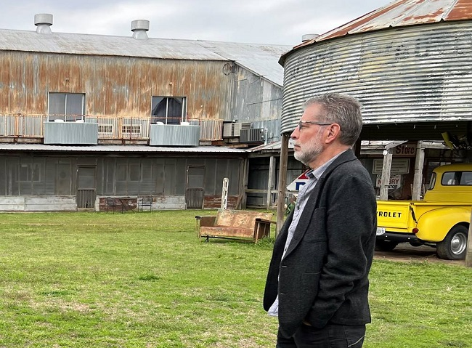
(Christopher Wyze, Clarksdale MS / Photo by Coop Cooper)

