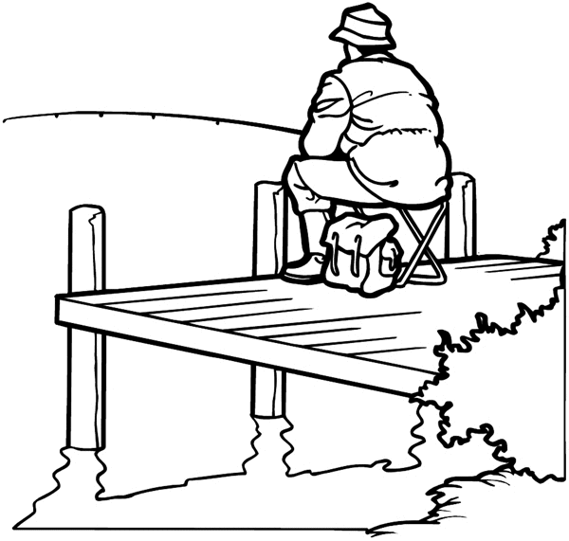
Anglican Diocese of Gippsland
St Peter’s by the Lake
A Line by the Lake
20th Sunday after Pentecost.
(October 18)
The Gospel Reading: Matthew 22: 13-22
The Pharisees went and plotted to entrap Jesus in what he said. So they sent their disciples to him, along with the Herodians, saying, "Teacher, we know that you are sincere, and teach the way of God in accordance with truth, and show deference to no one; for you do not regard people with partiality. Tell us, then, what you think. Is it lawful to pay taxes to the emperor, or not?" But Jesus, aware of their malice, said, "Why are you putting me to the test, you hypocrites? Show me the coin used for the tax." And they brought him a denarius. Then he said to them, "Whose head is this, and whose title?" They answered, "The emperor's." Then he said to them, "Give therefore to the emperor the things that are the emperor's, and to God the things that are God's." When they heard this, they were amazed; and they left him and went away.
Homily
The Prime Minister had a secret meeting with a religious advisor: "Good teacher, we know that you are sincere and teach the ways of God. Tell, me should Australia publicly oppose the expansion of China in our region, with its suppression of minorities, or should we passively acquiesce, given our dependence on trade?
The same day, members of community in the Middle East went to a Fundamentalist Mullah, asking, "Good teacher, we know that you teach in accordance with truth and show deference to no one. Tell us, then, is it right for our young men to resist overwhelming military power, by strapping bombs to their chest, or should we simply forsake our ancient claims to our land?"
And at another time, the Pharisees and the Herodians sent their disciples to Jesus saying, "Good teacher, we know that you are sincere, and teach the way of God in accordance with truth, and show deference to no one; for you do not regard people with partiality. Tell us, then, what you think. Is it lawful to pay taxes to the emperor, or not?"
The well-known exchange between Jesus and his critics recorded in our Gospel today is often used to provide a theological justification for the modern day separation of Church and State; some things are to be rendered to God as belonging to God and some things are to be rendered to Caesar as belonging to Caesar. There is the secular side of life with all its cut and thrust, and separated from that ordinary stuff, there is the religious side of life made up of worship and prayer. It sounds rather neat and tidy, really.
But it’s not. And that’s the point that Jesus makes. The critics of Jesus try to “wedge” him with an “either-or”, black-or-white dilemma: “Is it God, or is it Caesar?” This binary, either-or approach to big questions, so familiar today in confronting journalistic questions and presidential tweets, rarely does justice to life as it really is. So Jesus returns serve with a question himself: “whose image and inscription is on the coin you are holding up?”
The hyper-religious pharisees, and the politically compromised Herodians are equally exposed. Rome has conquered their region and both groups are using the emperor’s currency. Like it or not, they are all part of it; one way or another, all caught up in a messiness of conquest, compromise and resistance. Their simplistic “either-or” construct is exposed for what it is: a debating device, an attempt at rhetorical entrapment.
But behind this little exchange is all the pain and passion and anger of a conquered people. Behind this little exchange is the memory of brutal killings, as Rome occupied Palestine and a people lost their land and were forced to bear the yoke of a foreign power.
It is Rome and Israel in the first century. But equally, it might be Jerusalem and Gaza, Armenia and Azerbaijan, Syria, Afghanistan, or the streets of the United States, where “Black Lives Matter” and a hundred other places, where people suffer and struggle to know how to respond.
And so the scribe asks the recurring hard question, about what response is right before God. Is it the response of the zealot, resorting to violence, provoking a fight by withholding tribute; the coin with Caesar's image? Or is the quietist response of passive retreat and accommodation, a resort to a religious, disengaging from the hard realities of an oppressive world?
The response of Jesus is to say that we must deal with both God and Caesar; we must struggle with both, he says. We cannot opt out of the world's struggle, nor can we sell out the ethical and spiritual. We must live in both places; live in the places of question, live in the uncertainties, the ambiguities that world and Spirit throw up before us.
To a series of professional questioners, in this section of Matthew's Gospel, who come with their clipboards and BIC pens, with their tempered-hard questions and expectations of black and white rulings, Jesus provides not easy answers, but profounder questions.
We live in uncertain, even threatening times. We do well, with the Christ, to be wary of the superficial questions and answers of then and of now. This is not a time for black and white one-line answers, such as the scribes sought from Jesus, in order to test him, or as people might use to peddle their causes today.
Rather it is a time to live deeply and generously with difficult questions, looking as the rest of this Chapter of Matthew does, beyond the shallow and superficial, the guidance of love as lighting the way through the complex quandaries of human living.

Reflection and Response
At a personal level, most people dislike making difficult decisions. Because difficult decisions can make us anxious, we can either rush into them to avoid the anxiety, or procrastinate until the decision is made for us. Here are some suggestions for prayerful decision-making:
- Question the question. Where is this coming from? What emotions am I feeling as I face it? Clarify it, write it down if you need, seek the advice of one or two trusted and wise others, but don’t share your dilemma with everyone -- that will just produce confusion.
- Set your question and the decision aside for a set time (maybe a week if time allows) and give time for your subconscious and the Spirit of God to work on it together. If you have written it down, it may help to symbolically put it away --- perhaps in your Bible or under a Cross.
- Remember that in this world, there are very few completely perfect and clear cut answers to anything other than the straight mathematical or relatively simple. So be easy on yourself. Decisions sometimes become “good” decisions by how we live with them after the event.
Prayer of the Week
Almighty God, your Son has opened for us a new and living way into your presence; give us pure hearts and steadfast wills to worship you in spirit and truth, through the same Jesus Christ our Lord. Amen
Prayer for St Luke’s Day
Gracious and loving God, you chose Luke the Evangelist to reveal in his gospel the mystery of your love for the poor and outcast; unite in heart and spirit all who profess your name, and lead all nations to seek your salvation in Jesus Christ your Sion, who lives and reigns with you and the Holy Spirit, one God, forever and ever. Amen
Intercessions for this week
(Prepared by Sue Fordham)
God of the living, as you promise to hear the prayers of those who ask in the name of your Son, hear our prayers today.
We pray for your divided and troubled world and for the broader creation that we have failed to serve. Give us renewed endeavour to work for the unity and welfare of all created things. Bless organisations that work to heal your creation, especially local conservation groups and Anglican Earthcare Gippsland. We pray for all leaders that they may be mindful of the needs of their people and be motivated by equitable sharing of the world’s resources.
Lord in your mercy
Hear our prayer.
We pray for your church and its work in the world. We pray for Bishop Richard, for the people and interim priest, Jim Connelly of the cooperating parish of Neerim South, for our own priest, + Jeffrey and for us as we strive to be your heart and hands to the people in this parish.
Lord, in your mercy
Hear our prayer.
God of Abraham, Isaac and Jacob, we pray for the communities in which we live; for the lonely, the lost, the sick in mind and body. We give thanks for all the community builders living among us, for the service clubs, the welfare agencies, the schools, doctors and nurses, police and for the individuals who with small random acts of kindness lighten the lives of others. We pray for the sick, the sorrowful and for those suffering from Covid 19 as well as those who selflessly care for them.
Lord, in your mercy
Hear our prayer.
We give thanks for those whose lives have enriched and guided us, for those no longer present to us. Thank you for the life of Luke, evangelist and martyr whose life we celebrate today and for the life of James of Jerusalem, martyred brother of our Lord. We remember all those we love who has gone before, thinking of Stephen Reeves, with Jim and Del and family as they grieve. May we, with all who have gone before us in faith be numbered among the great cloud of witnesses to your truth and glory.
Lord, in your mercy
Hear our prayer.
Notes and News
Being Church in these Covid times
Although CCOVID19 restrictions are being eased, all indoor church gatherings remain on hold. Small outdoor gatherings are possible and that means that our Friday Morning Coffee group can begin to meet again. When it becomes possible for services to resume at St Peter’s, we will look to gather in worship and community again. In the mean-time, we continue to be church in prayer and care. Each week, +Jeffrey is putting out a reflection and there will be an intercession to guide your praying. Jenny Patterson is facilitating our “Pastoral Care Tree” (0419009430) and +Jeffrey is keeping in touch with “doorstop” visits and telephone calls.
Parish Council and AGM
It was good for Parish Council to actually manage a “face to face” meeting this week, although because of the present COVID19 rules, it was deemed safer to have the meeting at the local Pub than in the church building!
Draft minutes have been circulated for Council members. The Council set a date for the AGM as November 29th (the latest date possible to allow for an easing of restrictions). It will be unclear for a time, however, whether the meeting will be a physical gathering, and if so whether it will be limited in numbers. It may be, of course, that we might need to resort to “Zooming” together.

Please be in touch if you become aware of someone who needs pastoral care. Within the restrictions presently in place, I will follow up -- Jeffrey (0439144223)

Friday morning Coffee by the Lake has resumed (subject to social distancing)
10.30 on the foreshore!

Celebrating birthdays
18/10 – Sheryl Selliani
20/10 – Lois Kingston
22/10 – Eleanor Patterson
25/10 – Warren Ingle (sorry to Warren for getting his special day a week early.

St Peter’s by the Lake Website
With the COVID19 restrictions in place, there’s a little more time to do things indoors. With the technical guidance from his son, Robert, +Jeffrey has been developing a parish website. With Paynesville. Newlands Arm and Eagle Point being a desired destination for the holiday maker, the website will help people find and identify with the people of St Peter’s. It will be updated regularly with Sunday homilies, notices and news, and perhaps even a “rogues gallery” of pictures. There is more to go on the site, but you might like to have a look at:
https://stpetersbythelakeanglicanchurc.godaddysites.com
You can navigate around the site with the headings at the top of the page (some people had difficulty so I checked the web address -- just click on the link above). Still to be included: links to related sites and more contributions from people like you!
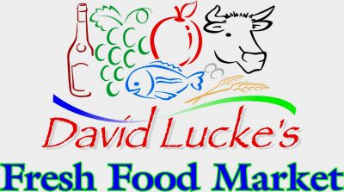
Loyalty Rewards
If you shop at David Lucke’s Fresh Food Market, don't forget we can earn money for St. Peter's By the Lake by participating in their loyalty program.

All you have to do is collect a key tag from them and state that it is for St. Peters. Each time you shop at Lucke's you just present you key tag. Each month we will receive 2% of our purchases back to the church, this is an easy way to generate some extra funds for St. Peters on your normal shop. If you already have a tag for St. Peters don't forget to use it.

