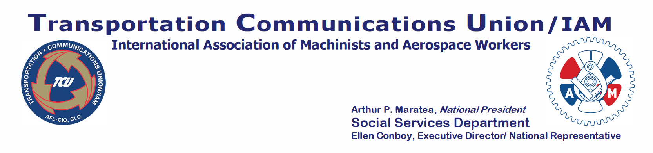
Subject: Union Plus Programs-October 2025

October 8, 2025

TO: ALL NATIONAL REPRESENTATIVES
ALL ASSISTANT NATIONAL REPRESENTATIVES
ALL DIVISION CHAIRPERSONS
AND ALL LOCAL LODGE OFFICERS

Dear Sisters and Brothers:

Since 1991, the Union Plus Scholarship Program has awarded more than $5.6 million to students of union families. Over 4,000 union families have benefited from Union Plus’s commitment to higher education.
The Union Plus Scholarship Program application for courses beginning in the Fall of 2026 is now available at https://www.unionplus.org/benefits/education/union-plus-scholarships. The Program awards annual scholarships to eligible union members, current and retired, their spouses, and dependent children. The recipients are chosen based on outstanding academic achievement, personal character, financial need, and commitment to organized labor values.
The program provides one-time cash grants ranging from $500 to $4,000 to eligible undergraduates and graduates attending a U.S. accredited university, college or community college, or a recognized trade or technical school. Students may re-apply each year. The deadline for applications is 12 p.m. (Noon), EST, January 31, 2026. Scholarship recipients will be selected by May 31, 2026, and award recipients will be notified via postal mail the first week of June 2026.

Additionally, the IAMAW offers a union college benefit through the Employee Benefit Systems (EBS) powered by the EDUTrust Network of colleges and universities. TCU/IAM members and family can access discounted tuition rates for certificates and degrees. Get matched with an in-network college or university through your IAMAW education benefit by clicking here https://edutrustnetwork.org/goiam.

If you have any questions concerning the Scholarship Program, you may contact the TCU/IAM Social Services Department at 301.840.8762. Further details can be found at www.unionplus.org. They can find these and more member-only benefits and programs as well.

In Solidarity,

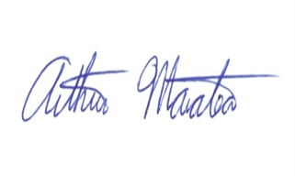

Arthur P. Maratea
National President

cc: Executive Council
Carmen Division Officers
Department Directors
TCU/IAM - TSD Employees and Staff

3 Research Place, Rockville, Maryland 20850-3279, Email - conboy@tcunion.org,
Phone 301-840-8746, Fax 301-330-7665, tcunion.org

