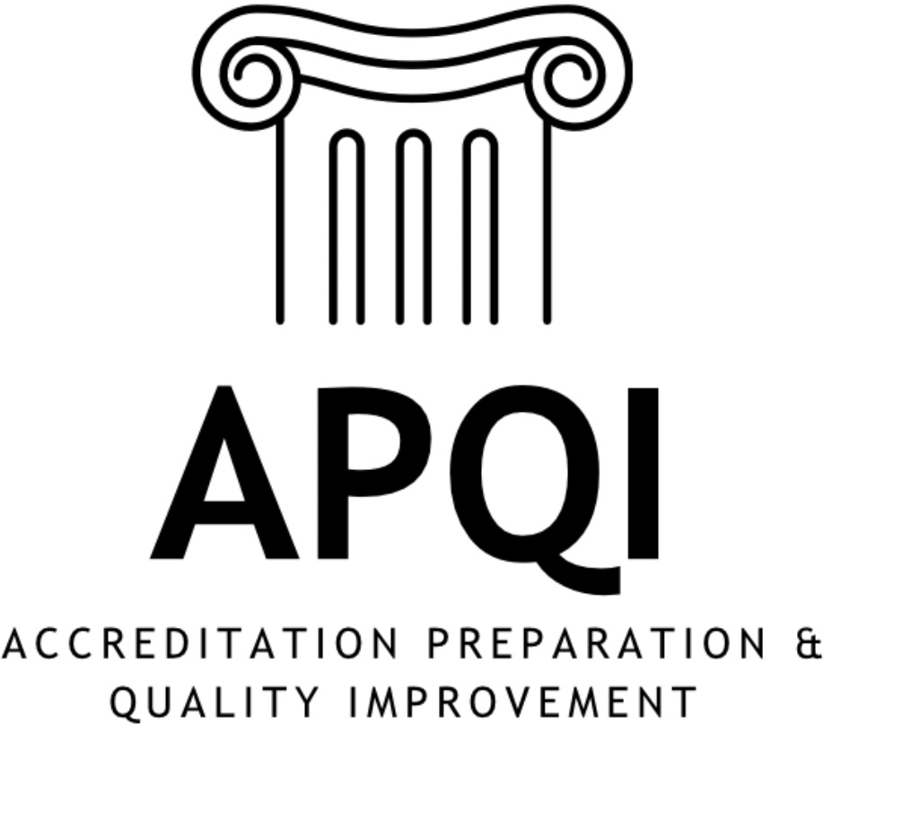

A 501(c)(3) Organization

Summer 2025

APQI

Quarterly*
The Place Where AccrediNation Stays Informed!

SUMMER 2025
Hello APQI Community!

How is it the middle of August already?! We are all likely welcoming our newest cohorts of medical students to our schools—such an exciting, stressful, exhilarating time for them and us!! I have so many things to note…so here it goes:
- We are only a few months from our 3rd Annual APQI Business Meeting on Saturday, November 1st from 1-4:30pm CT in San Antonio, ahead of AAMC Learn Serve Lead. Please fill out this RSVP form so that we can plan accordingly if you have not already done so!
- An exciting FIRST for our community is that we are on the OFFICIAL schedule for LSL this year!! Click here to review, in case this might help secure support from your school to travel to TX this fall. We will meet at the Grand Hyatt, Texas Ballroom C—one of the main conference hotels so extremely convenient for our business meeting!
- As always, so much good news and information to share throughout the rest of this newsletter, so please do continue to scroll down!!
- Very excited that the APQI Elections almost upon us this season and I cannot wait to see who among you will help lead us into the future!
And…though bittersweet, this is my last “note from the chair” memo to you all, as we hand over the APQI chair reins to the extremely amazing Dr. Melisa Pierce! APQI has a huge piece of my heart and always will! <3

Most sincerely, signing off one last time as your APQI chair,
Colleen Hayden

*New Newsletter Name and Slogan*

Thank you to our two winners who submitted names for this newsletter: Lori DeShetler, PhD and Michaela Jansen, PharmD, PhD

Annual APQI Business Meeting
Saturday, November 1, 2025
1:00-4:30pm CT (In-person)
Join us for our annual members business meeting at Learn Serve Lead in San Antonio, TX. For the first time, we are on the official AAMC schedule and the event will occur at the Grand Hyatt. We appreciate the hospitality of all of the schools who hosted us in the past (Belmont University, University of Washington, and Morehouse University).

Please join us in-person on Saturday, November 1st. Use this link to register.

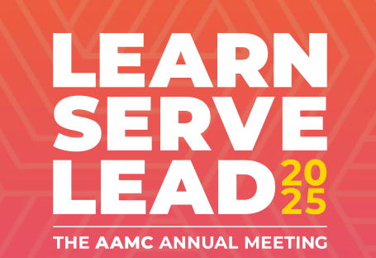
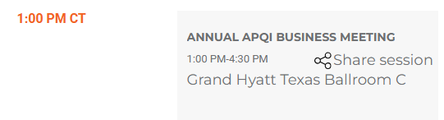
Grand Hyatt-San Antonio Address: 600 E Market St, San Antonio, TX 78205

Register Now!
Learn Serve Lead 2025 San Antonio, TX Nov. 1-5, 2025

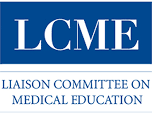

Connecting with the Secretariat Upcoming Webinars
Sept 25- Topic of the Month: Mythbusters Part 1
Oct 9- Topic of the Month: Mythbusters Part 2
Submit questions via e-mail to lcme@aamc.org in advance of the webinar. Questions submitted at least 24 hours in advance will be de-identified and posted below as they are received.
Nov 1-5- Learn Serve Lead: LCME Secretariat Consultations. See lcme.org for details.
Nov 2- Learn Serve Lead: ‘Strategic Re-visioning of the LCME Accreditation Standards: Take Two’

Presenting at LSL? Tabletop? Poster? Anything? Send your information to grn18@pitt.edu for inclusion in the November pre-LSL issue!
Upcoming Regional Calls for Proposals
Conference | Location/Date | Deadline
CGEA Joint Meeting | Rochester, MN; TBD | Sept 29
NEGEA Joint Meeting | Scranton, PA; March 11-13, 2026 | Sept 29
SGEA Joint Meeting | New Orleans, LA; TBD | Sept 29
WGEA Joint Meeting | Phoenix, AZ; TBD | Sept 29

APQI On the Road: A Busy Conference Season Ends
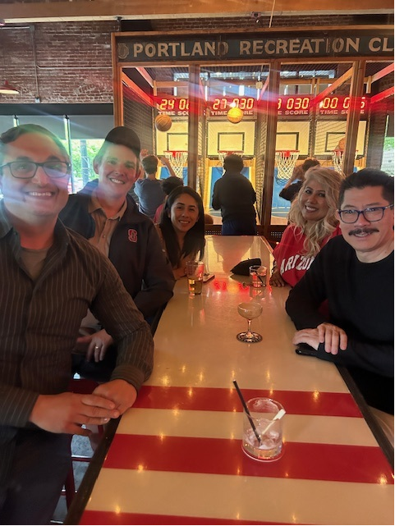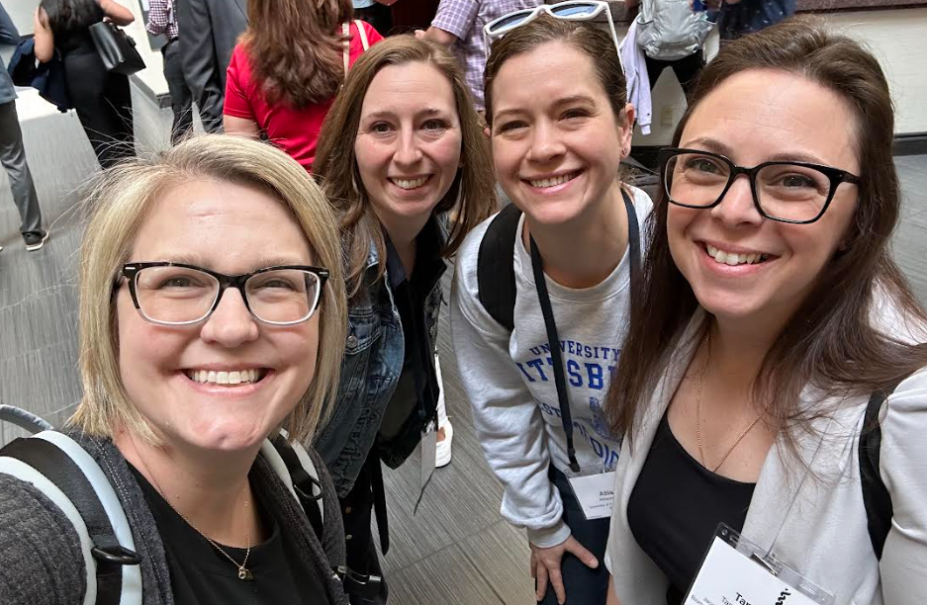
WGEA in Portland Group on Institutional Planning/Business Affairs in Phoenix
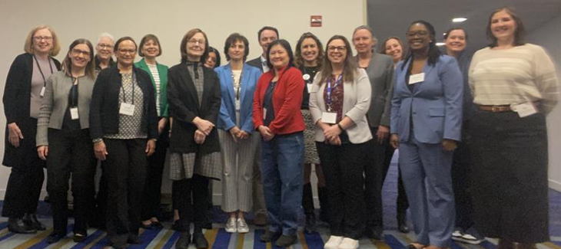
NEGEA in New Brunswick

Award Winner and Promotion!

Congratulations to Jason Hedrick, PhD (West Virginia University School of Medicine) for being recognized by SGEA as an early career scholar!

Congratulations to Katie Maietta, MPPM (University of Pittsburgh School of Medicine) for her promotion to Assistant Dean of Education Administration

Foot-long Bookshelf
Send your Foot-long Bookshelf to Greg Null (grn18@pitt.edu)! All submitters remain anonymous!

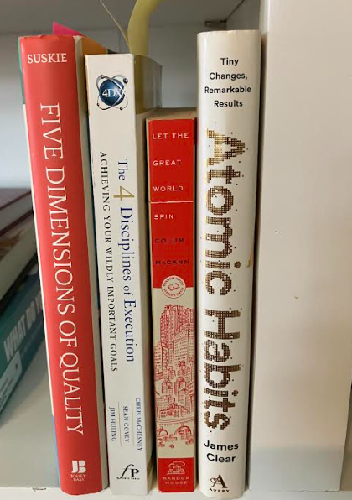
“Perhaps a sign of a good bookshelf is that many of the books are absent and shared with others”
Atomic Habits. An incredible book that can show you how to add and stick with habits in work and life.
The Culture Code. You know right away the sort of culture you have at work. This book focuses in on steps you can take to create and foster it.
Five Dimensions of Quality. An in-depth introduction to accreditation.
Four Disciplines of Execution. It is not easy to get stuff done. This book offers a path. But that path isn’t an easy one either.
Let the Great World Spin. Just a great work of fiction.
Zen and the Art of Motorcycle Maintenance. Incredible notes on quality. Less handy as a Buddhist how-to or a maintenance manual.

A 501(c)(3) Organization

Connect
Visit our website at https://ap-qi.org/ Listserv information: https://ap-qi.org/listserv

Steering Committee Leadership

Steering Committee Chair
Colleen Hayden, EdD
Secretary
Rebecca Molter, MS
Treasurer
Katie Maietta, MPPM
Communications Representative
Greg Null, MA
Membership Chair
Joseph Oppedisano, DAc
Scholarship Representatives
Jason Booza, PhD Jason Hedrick, PhD
Chair Elect
Melisa Pierce, EdD, MPH
Regional Representatives
CGEA
Jason Booza, PhD Amber Todd, PhD NEGEA
Tanya Biscardi, MS Sabrina Nunez, PhD SGEA
Teresa Isbell, PhD WGEA
Raquel Givens, PhD 9

