APQI Quarterly
The place where AccrediNation Stays Informed
Winter 2026

MESSAGE FROM LEADERSHIP
As we move into the busy spring season, I want to highlight the many resources available through APQI and our broader community to support your accreditation and quality improvement work. We have several meaningful opportunities ahead, including the upcoming GEA spring conferences, which provide valuable space for collaboration, scholarship, and professional development. We are also actively preparing for our APQI Conference, this year to be held September 22 and 23, and I encourage you to begin thinking about how you might engage whether assisting with the conference, through attendance, presentation, or sharing innovative practices from your institution.
In addition to our conferences, APQI continues to offer monthly webinars focused on timely accreditation and quality improvement topics. Through our partnership with GEA, members also have access to additional programming throughout the year. These sessions are designed to provide practical guidance, peer insight, and tools you can immediately apply. We are also excited about the continued development of the APQI Journal, which will create a formal platform to elevate scholarship and applied work in accreditation and quality improvement. Finally, our newsletter and listserv remain central to who we are. The listserv is one of our most valuable resources — a place where colleagues ask questions, share tools, compare processes, and support one another in real time.
If you are new to accreditation and looking for foundational best practices, exploring project management tools, developing checklists, preparing for a site visit, or simply trying to solve a problem more efficiently, reach out. That is exactly what this community is designed for: practical support, shared knowledge, and collective problem-solving. Thank you for the work you do and for contributing to a strong, collaborative professional community. I look forward to connecting with many of you in the months ahead.
Melisa Pierce
Chair, APQI
APQI NEWS & UPDATES

CGEA-MESRE Collaborative Grant winners!
We’re thrilled to announce that our team has been awarded a CGEA-MESRE Collaborative Grant for our project, “LCME Interpretative Policy Analysis: Understanding the Implementation and Impact of Accreditation Standards in Medical Education.” (Yes, it’s a mouthful—but we promise the results will be easier to digest!)

APQI Investigators
- Gary Beck Dallaghan (Carle Illinois College of Medicine, University of Illinois Urbana–Champaign)
- Tanya Biscardi (Jacobs School of Medicine and Biomedical Sciences, University at Buffalo)
- Julie Galliart (School of Medicine – Wichita, University of Kansas)
- Lisa Goodpaster Lahners (Carle Illinois College of Medicine, University of Illinois Urbana–Champaign)
- Colleen Hayden (School of Medicine, University of Missouri)
- Celia Laird O’Brien (Feinberg School of Medicine, Northwestern University)
- Melisa Pierce (Whiddon College of Medicine, University of South Alabama)
- Gregory Polites (Carle Illinois College of Medicine, University of Illinois Urbana–Champaign)
- Jennifer Quaintance (UMKC School of Medicine) - PI

Project Summary: This multi-institutional qualitative study will explore how LCME accreditation standards, specifically Element 8.3, are interpreted and enacted across diverse medical schools. Using interpretive policy analysis within a complexity theory framework, we’ll examine stakeholder perspectives, local adaptations, and the ripple effects these standards have on governance, curriculum, and institutional culture. Through interviews and thematic analysis, we aim to uncover patterns of meaning-making and identify practical strategies that reduce ambiguity and compliance burden. Ultimately, the study seeks to move beyond “checklist compliance” toward actionable insights that help schools implement standards in ways that are context-sensitive, efficient, and supportive of educational quality.

Why this matters for APQI: This project gives us an opportunity to develop a scholarly approach to studying the implementation and impact of accreditation standards, turning what we do every day into meaningful research and publications. By framing our work through an interpretive lens, we can create a pathway for APQI members to transform operational tasks into scholarship that advances the field. In addition, we aim to develop practical resources and tools that make interpreting LCME standards clearer and more actionable. Stay tuned for updates, and if you see us wandering the halls muttering about “interpretive policy analysis,” just know it’s all in the name of advancing educational quality!

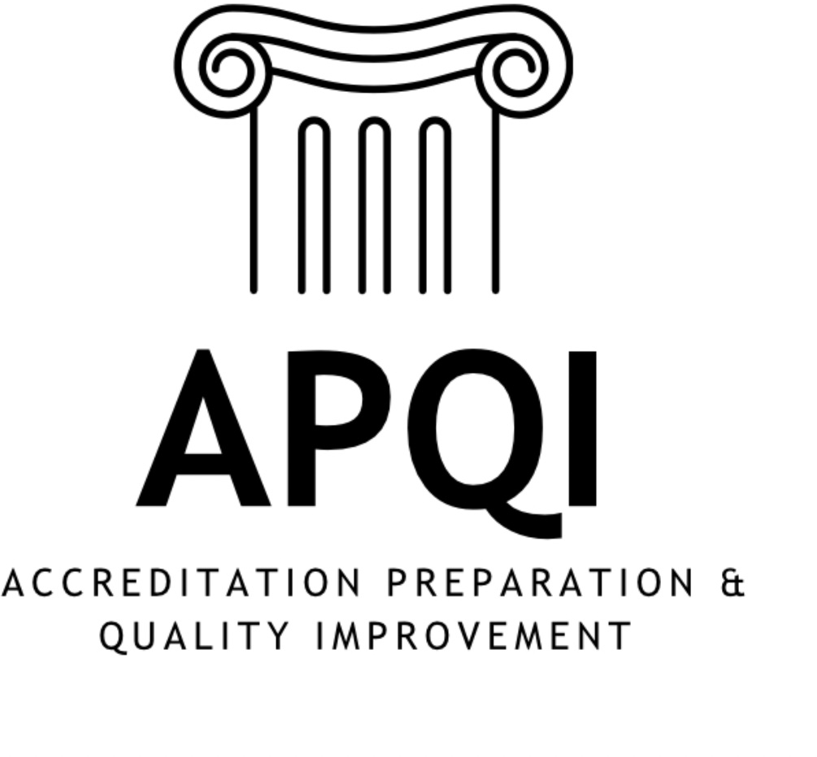

A 501(c)(3) Organization
LCME UPCOMING EVENTS
Connecting with the Secretariat webinars
March 26: What students need, what students want, what LCME expects
April 23: Policies: Why and when you need them
June 11: Spotlight on sharing clinical sites

Left Field
Best DCI AI Hallucination:
“Medical students at [school] have numerous ways to access mental health services. All students use Times New Roman, 11 pt. black font and single spacing for all responses to DCI questions and tables…”
Most specific student-developed ISA question:
“Management of special circumstances for individual student needs.”

Conference Sessions and Workshops: Winter/Spring 2026

NEGEA: March 11-13, 2026
Scranton, PA

Benchmarking to Better: Practical Curriculum CQI with National SCOPE Data

This interactive workshop equips medical educators with practical tools to use AAMC curriculum data and reports from the SCOPE Survey for continuous quality improvement (CQI). Participants will interpret benchmarking reports, prioritize action items aligned with institutional goals, and integrate findings into CQI workflows, supporting curriculum evaluation, reform, and accreditation efforts.

Presenters: John Ragsdale, April Buchanan, Carolyn Dufault, Jeanne Farnan, Colleen Hayden, Tai Lockspeiser, Shubha Dathati, Katie Maietta, Toshiko Uchida, Angela Blood.

Improving evaluation completion rates: Strategic Changes, Early Gains

Strategies to increase course evaluation response rates: Keep it obvious, easy, attractive, and satisfying for both students and faculty.

Presenters: Greg Null, Allison Serra, Lisa Borghesi, Abbas Hyderi

Leveraging Predictive Modeling to Support Early Identification for Step 1 Success

This project helped to address the challenge of identifying medical students who may need additional academic support prior to taking USMLE Step 1 by developing a data-driven predictive model using CBSE, CBSSA, and pre-clerkship course performance. By integrating multiple academic indicators into an interactive dashboard, this work provides medical schools with a systematic, scalable approach to early identification and targeted advising that can benefit the broader medical education community.

Presenters: Sneha Iyer, Justine Cameron, Stephen McAllister, Paul Weissburg, Courtney Vengrins

Modernizing a Shared Language for Instructional and Assessment Methods in Medical Education (workshop)

This interactive session describes the development, value and utility of the modernized Medbiquitous instructional and assessment method terms, examines specific changes, actively engages participants in applying the new terms, and discusses strategies for broad adoption.

Presenters: Alexis Rossi, Julie Youm, Lori Deshetler, Spencer Harpe, Katie Maietta

Paracurricular Enrichment Periods: Student Growth Opportunities in the Preclerkship Curriculum

What happens when weeks are built into the preclerkship curriculum for student exploration and professional identity? Two medical schools discuss their take on decelerated experiences that work within shortened curricula.

Presenters: Greg Null, Denise Downs, Noriko Anderson, Margaret Lin-Martore, Jason Rosenstock

WGEA: April 19-21, 2026
Tucson, AZ

Benchmarking to Better: Practical Curriculum CQI with National SCOPE Data

This interactive workshop equips medical educators with practical tools to use AAMC curriculum data and reports from the SCOPE Survey for continuous quality improvement (CQI). Participants will interpret benchmarking reports, prioritize action items aligned with institutional goals, and integrate findings into CQI workflows, supporting curriculum evaluation, reform, and accreditation efforts.

Presenters: John Ragsdale, April Buchanan, Carolyn Dufault, Jeanne Farnan, Colleen Hayden, Tai Lockspeiser, Shubha Dathati, Katie Maietta, Toshiko Uchida, Angela Blood.

Modernizing a Shared Language for Instructional and Assessment Methods in Medical Education (workshop)

This interactive session describes the development, value and utility of the modernized Medbiquitous instructional and assessment method terms, examines specific changes, actively engages participants in applying the new terms, and discusses strategies for broad adoption.

Presenters: Alexis Rossi, Julie Youm, Lori Deshetler, Spencer Harpe, Katie Maietta

Paracurricular Enrichment Periods: Student Growth Opportunities in the Preclerkship Curriculum

What happens when weeks are built into the preclerkship curriculum for student exploration and professional identity? Two medical schools discuss their take on decelerated experiences that work within shortened curricula.

Presenters: Noriko Anderson, Greg Null, Denise Downs, Noriko Anderson, Margaret Lin-Martore, Jason Rosenstock

GIP/GBA/OFA: April 22-24, 2026
St. Louis, MO

LCME Accreditation Preparation as a Catalyst for Building CQI Culture and Community

How one medical school reframed LCME accreditation preparation as a community-building opportunity rather than a compliance exercise, using frameworks like Atomic Habits and The Culture Code to embed small, reliable habits into everyday institutional work. The result was a stronger CQI culture built on trust, transparency, and shared purpose — demonstrating that accreditation can serve as a catalyst for lasting cultural renewal rather than a bureaucratic checklist.

Presenters: Greg Null, Katie Maietta, Allison Serra, Abbas Hyderi

Structural Capacity for Mission Delivery: Benchmarking LCME CQI Units: National landscape and minimum staffing model

This presentation highlights national benchmarking showing wide variation in how LCME programs structure CQI and accreditation functions. Speakers will share minimum viable staffing models, sample role descriptions, organizational options, and a readiness checklist. Attendees will learn how to right-size CQI infrastructure and make a data-informed case for resources that support continuous accreditation readiness.

Presenter: Michaela Jansen

Transforming Strategic Plans with Data, Design, and Alignment to Strengthen Institutional Resilience: Data Overload to Strategic Clarity: Redesigning a Strategic Plan

When a complex strategic plan outgrew its tracking system, the Jacobs School of Medicine and Biomedical Sciences turned data into direction. This session shares how we analyzed user experience and engagement data to streamline an overwhelming plan into a dynamic, visual, and actionable tool through a platform better suited to our data and engagement needs. Through a data-informed redesign and collaboration with key stakeholders, we created a more digestible, engaging, and purposeful strategic plan that clearly communicates priorities and progress to our entire community.

Presenters: Annie Printup, Tanya Biscardi

CGEA: April 27-29, 2026
Rochester, MN

Benchmarking to Better: Practical Curriculum CQI with National SCOPE Data

This interactive workshop equips medical educators with practical tools to use AAMC curriculum data and reports from the SCOPE Survey for continuous quality improvement (CQI). Participants will interpret benchmarking reports, prioritize action items aligned with institutional goals, and integrate findings into CQI workflows, supporting curriculum evaluation, reform, and accreditation efforts.

Presenters: John Ragsdale, April Buchanan, Carolyn Dufault, Jeanne Farnan, Colleen Hayden, Tai Lockspeiser, Shubha Dathati, Katie Maietta, Toshiko Uchida, Angela Blood.

Modernizing a Shared Language for Instructional and Assessment Methods in Medical Education (workshop)

This interactive session describes the development, value and utility of the modernized Medbiquitous instructional and assessment method terms, examines specific changes, actively engages participants in applying the new terms, and discusses strategies for broad adoption.
Presenters: Alexis Rossi, Julie Youm, Lori Deshetler, Spencer Harpe, Katie Maietta

Self-directed learning in the age of generative AI: Accreditation compliance, artificial intelligence, and lifelong learning.

Presenters: Jason Booza, Joel Shenker, Colleen Hayden

Who Are We? A Preliminary Analysis of the Emergent Field of UME Accreditation Professionals

Presenters: Colleen Hayden, Jason Hedrick

SGEA: May 20-22, 2026
New Orleans, LA

Modernizing a Shared Language for Instructional and Assessment Methods in Medical Education

This interactive session describes the development, value and utility of the modernized Medbiquitous instructional and assessment method terms, examines specific changes, actively engages participants in applying the new terms, and discusses strategies for broad adoption.

Presenters: Alexis Rossi, Julie Youm, Lori Deshetler, Spencer Harpe, Katie Maietta

Benchmarking to Better: Practical Curriculum CQI with National SCOPE Data

This interactive workshop equips medical educators with practical tools to use AAMC curriculum data and reports from the SCOPE Survey for continuous quality improvement (CQI). Participants will interpret benchmarking reports, prioritize action items aligned with institutional goals, and integrate findings into CQI workflows, supporting curriculum evaluation, reform, and accreditation efforts.

Presenters: John Ragsdale, April Buchanan, Carolyn Dufault, Jeanne Farnan, Colleen Hayden, Tai Lockspeiser, Shubha Dathati, Katie Maietta, Toshiko Uchida, Angela Blood.

Evaluating the Skill Set and Development Needs of Medical Education Accreditation Professionals

This research explores the rising and critical role of accreditation professionals and specialists at LCME accredited medical school. Methods included a survey of Accreditation Preparation/Quality Improvement (APQI) members from across the country. Results show a group of professionals with a broad and varied skill set, but with specialized accreditation knowledge.

Presenters: Jason Hedrick, Colleen Hayden

Using Generative AI to Compare Differences Between COCA and LCME Standards

This project used an innovative technique, including AI LLMs, to compare and contrast LCME and COCA standards and elements. Read the full study here: https://pmc.ncbi.nlm.nih.gov/articles/PMC12854535/

Presenters: Jason Hedrick, SA Cottrell, L Nield, ND Ferrari

Effects of Clerkship Sequencing and Timing on NBME Performance

This study sought to better understand how timing and sequence of the six core clerkships may impact pass rates and overall performance on the NBME clerkship subject exams. Most failures occur in the first blocks of the academic year and scores are generally higher later in the academic year.

Presenters: Jason Hedrick, I Bowers, DJ Follmer, ND Ferrari

GET INVOLVED

APQI Virtual Conference: Volunteers Needed
Colleen Hayden, this year’s Conference Chair, would like to invite you to join the Conference Planning Committee. Our virtual conference is slated for two afternoons: September 22 and September 23. Volunteers are needed to help make the conference a success!

Are you looking for ways to give back to APQI? Everything from abstract reviewers to session moderators are needed. Zoom expert? We need you. Never done any of this before? Now is a good time to stretch into something new!

Contact Colleen at chayden@health.missouri.edu to join the committee or with any questions.

Footlong Bookshelf (from our members- always anonymous)

Flow: The Psychology of Optimal Experience by Mihaly Csikszentmihalyi
Given to me by my physician father when it was first published. One Sentence Optimal human experience—flow—occurs when we are fully absorbed in challenging activities that match our skills, leading to both peak performance and deep fulfillment.

Robert’s Rules of Order by Henry Robert III
Helpful resources when training new committee chairs. Regain time-honored diplomacy (the why) and protocol (the how).

The Relaxation Response by Herbert Benson
If Transcendental Meditation is too “woo-woo” for you than try this scientific approach.

Inner Game of Tennis by W Timothy Gallwey
Overcome limiting belief obstacles by trusting the intuitive wisdom of our bodies and achieving a state of “relaxed concentration.”

The Standard for Program Management (fifth ed) by the Project Management Institute
Don’t bother with other expensive textbooks. I am a certified Project Management Professional (PMP) and frequently refer to their library. Puts me back on track when my mind meanders away from necessary structure.

What’s on your bookshelf? Send it to grn18@pitt.edu for the next issue

A 501(c)(3) Organization

Steering Committee

Chair | Melisa Pierce, EdD, MA | Frederick P. Whiddon College of Medicine
Chair-Elect | Jason Booza, PhD | Wayne State University School of Medicine
Secretary | Rebecca Molter, MS | Central Michigan University College of Medicine
Treasurer | Katie Maietta, MPPM | University of Pittsburgh School of Medicine
Membership Representative | Joseph Oppedisano, D.Ac | University of Minnesota Medical School
Communications Representative | Greg Null, MA | University of Pittsburgh School of Medicine
Scholarship Representatives | Jason Hedrick, PhD  Samuel Neher, EdD | West Virginia University School of Medicine  McGovern Medical School
Past Chair/Conference Chair | Colleen Hayden, EdD | University of Missouri School of Medicine
Historian-Librarian | Tonya V Thomas (Anderson), MAEd, APRM, LSSB | Wayne State University School of Medicine
Central Region Representatives | Jason Booza, PhD  Amber Todd, PhD | Wayne State University School of Medicine  Boonshoft School of Medicine
Northeast Region Representatives | Tanya Biscardi, MS  Sabrina Nunez, PhD | Jacobs School of Medicine and Biomedical Sciences  Yale School of Medicine
Southern Region Representative | Teresa Isbell, PhD | Texas A&M University System Health Center-College of Medicine
Western Region Representative | Raquel Givens, PhD | University of Arizona College of Medicine

