APQI Quarterly
The place where AccrediNation Stays Informed
Summer 2026

MESSAGE FROM LEADERSHIP

I hope you've had a chance to enjoy some downtime this summer and are feeling excited for the year ahead. As another academic year gets underway, there are several opportunities to connect with colleagues through APQI.
Our next big event is this year's virtual APQI conference. One of the things I value most about APQI is our members' willingness to share ideas, challenges, and practical solutions. Whether you're looking for a new approach to assessment, accreditation, strategic planning, or institutional effectiveness, I think you'll come away with ideas you can put to work right away and maybe even a few new colleagues to connect with throughout the year.
If you'll be attending Learn Serve Lead, I also encourage you to join us for our annual business meeting beforehand. It's a great opportunity to reconnect in person, hear what's happening with the Association, and help shape where we're headed next. Your ideas and involvement are what keep APQI such a strong and welcoming professional community.
Finally, don't forget to explore the resources available through APQI. Our association continues to grow, so do the opportunities to learn from one another. If you've developed a process, tool, or strategy that's worked well at your institution, I'd encourage you to consider sharing it. Some of the best ideas come from conversations with colleagues who are doing this work every day.
Thank you for being part of APQI and for everything you do to support planning, quality improvement, and accreditation at your institutions. I look forward to seeing many of you online at the conference and, hopefully, in person at the annual business meeting this fall.
Have a great semester. I look forward to connecting with you soon!
Melisa Pierce, EdD
Chair, APQI
Frederick P. Whiddon College of Medicine

APQI CHARTER UPDATE: NEW LEADERSHIP POSITIONS & SUBCOMMITTEES

As a testament to the growth and evolution of our “little” community of practice, the APQI Steering Committee is excited to announce the creation of new leadership positions and subcommittees! Full details can be found in our updated Charter on the APQI website.
Summary of Major Changes
- Regional Representatives become Members-at-Large. In response to the elimination of regional groups within the AAMC, APQI is transitioning our Regional Representative positions to four Member-at-Large (MAL) positions. Current regional representatives will rotate off the Steering Committee one at a time over the next four years, so that MAL terms can be staggered.
- A new Annual Conference Committee is established. The Charter now formalizes an Annual Conference Committee, to be populated by the MALs as well as volunteers from the general membership.
- The Elections Committee is codified. The Charter formally establishes the Elections Committee, along with a new Steering Committee position, Elections Committee Chair. This position is currently held by Tanya Biscardi and will be up for election during the next election cycle, in 2027-2028.

Thank You & Congratulations
We would like to formally recognize Teresa Isbell for her contributions to APQI and her commitment to representing the Southern region. From all of us, it has been an honor to serve alongside you.
Special thanks to Raquel Hernández Givens for taking on the role of MAL3 and Chair of the Annual Conference Committee.

CALL FOR NOMINATIONS: 2026 STEERING COMMITTEE ELECTIONS

The Nominations Committee is pleased to announce the call for nominations for five open positions on the APQI Steering Committee. We invite nominations of individuals with strong collaboration and implementation skills. Nominees must be dues-paying members of APQI.
Open Positions
- Chair Elect (3-year term)
- Secretary (1-year term)
- Communications Representative (2-year term)
- Scholarship Representative (2-year term)
- Member at Large (4-year term)
The Steering Committee is the representative body of the APQI community. Members are responsible for soliciting and communicating updates, planning webinars and conferences, and overseeing the group's finances, including approving disbursements and setting annual dues. Steering Committee members are expected to be active in helping to further establish and strategically expand APQI's impact on medical education, accreditation, and quality improvement processes.
The Nominations Committee suggests that potential nominees who will be participating in their institution's self-study or preparing for an LCME survey visit during the position term take time to consider their capacity to do both.

Key Dates
Nomination deadline: August 14, 11:59 PM EST
Elections: September-October 2026 (slate election, voted on by full membership)
Transfer of leadership: November 2026, at the APQI meeting during AAMC's Learn Serve Lead in Anaheim, CA. Elected candidates are not required to attend.

How to Nominate
Self-nominations are welcome. To nominate a candidate, complete the online nomination form. Nominees will need to submit:
- A focused CV of relevant experience (maximum 2 pages)
- A brief statement outlining qualifications and interest in joining the Steering Committee
If you are nominating someone else, use the link at the end of the form to share the nomination with your nominee, and please allow them enough time to submit their materials before the deadline.
Not yet a dues-paying member? Join APQI here. Ready to nominate someone (or yourself)? Submit a nomination. You can also review position qualifications and Steering Committee responsibilities in the APQI Charter.
Election Process
APQI elections use a slate election process. The Nominations Committee evaluates each nominee's qualifications for the position and forwards the top-ranked candidates for each position, along with documentation of the selection process, to the Steering Committee for review. The full slate is then voted on by the full membership. Slate elections simplify the voting process and reduce the likelihood of internal competition, particularly in smaller organizations.
Questions? Contact Tanya Biscardi, Chair of the Nominations Committee, at biscardi@buffalo.edu.

APQI ANNUAL CONFERENCE: SEPTEMBER 22-23, 2026

Mark your calendars! The APQI Annual Conference Planning Committee is excited to begin planning for this year's virtual conference, taking place September 22-23, 2026 (Tuesday and Wednesday), 1:30-5:00 PM ET. As an encore of last year's conference, this year's theme is Amplifying the Impact, Performing with Purpose.
Call for Proposals
The official Call for Proposals is now open. Please consider submitting your innovations, scholarship, and workshop ideas around this year's theme. We encourage submissions from individuals at all levels of experience and welcome a broad range of perspectives, innovations, lessons learned, and practical strategies relevant to APQI work.
Note: If you submitted an “early idea” in the last two months, you will still need to resubmit with a more robust proposal using the form below.
Submit your proposal: APQI 2026 Conference Proposal Form
Key Dates
Proposals due: Friday, July 31, 2026, by 11:59 PM PT
Acceptance decisions sent: No later than August 24, 2026
Conference dates: September 22-23, 2026, 1:30-5:00 PM ET (virtual)

Thank you for your contributions to our APQI community of practice!

MEMBERS SPOTLIGHT: BACK TO SCHOOL

Across the accreditation and quality improvement field, more and more professionals are choosing to go back to school, often while working full-time, raising families, and running accreditation cycles. To capture some of that experience for the community, APQI sat down with three members currently pursuing (or recently completing) advanced degrees to talk about what pushed them to apply, how their coursework shows up in their day-to-day work, and how they make it all fit.
Meet the Panel
 | Siwar Bizri  Senior Accreditation and Quality Improvement Lead at USF Morsani College of Medicine, a role she's held for 11 years. She's now a doctoral candidate in USF's EdD program (concentration in program innovation and curricular enhancement), working on her dissertation proposal.

 | Shoaib Lalani  CQI Program Manager at the newly established Texas A&M School of Engineering Medicine (SEM), which achieved “candidate status” for preliminary accreditation. He's finishing a master's in higher education at Texas A&M this December and plans to pursue an EdD next.

 | Justine Cameron  Director of Accreditation, Program Evaluation, and Quality Improvement at Dartmouth's Geisel School of Medicine. She's about a third of the way through Marymount University's EdD in Educational Leadership and Organizational Innovation.

Why Now? The Personal Side of the Decision
For all three, the decision to go back to school wasn't just a career calculation. It was deeply personal, and often about timing.
Justine had been accepted to a doctoral program nearly five years earlier, but chose to start a family instead. After having her son and recovering from a serious arm injury, she finally felt ready: “It's time for me to take on something I've been excited about for a while now.”
Siwar's timing was tied to motherhood, too. She waited until her daughter was old enough to feel like she could carve out evenings and weekends without guilt. The flexibility of her program, designed for working professionals with evening, weekend, and online classes, made it possible: “If that program didn't exist, I don't even know if I would have been able to pursue it the way I wanted to.”
Shoaib chose an online, asynchronous program partly for flexibility and partly for practical reasons: tuition assistance through his university system made the decision easy.
Mentors played a big role for everyone. Justine credited MedEd mentors who pushed her to think about long-term goals and the value of a terminal degree. Shoaib pointed to a mentor who mapped out a leadership roadmap and made the case for an EdD as he moved up in CQI. Siwar named her longtime supervisor and her mother as steady sources of encouragement, along with watching colleagues (including other mothers) successfully complete their own doctorates.
From Classroom to Conference Room: Coursework in Action
A recurring theme: the coursework isn't staying in the classroom. It's showing up directly in accreditation and QI work.
Shoaib and Siwar both pointed to courses on higher education law as turning points. For Shoaib, understanding the legal reasoning behind institutional policy changed how he interprets decisions happening across higher ed nationally. Siwar took that further into medical education specifically, diving into case law and national conversations around technical standards for students with disabilities. That interest became her dissertation focus, and it's already shaping conversations with leadership at USF about best practices and policy gaps.
Justine's needs-assessment coursework has sharpened the evidence-based rigor of the program evaluation work she does every day and lets her use real-world projects to satisfy course requirements, accomplishing two goals at once.
Juggling It All
None of the panelists pretended this was easy.
Siwar described the coursework phase as genuinely exhausting at times: full Saturdays of back-to-back classes, late nights, and hard tradeoffs between family time and deadlines. Her program's structure helped: students are pushed to start their literature review from day one, so by the time coursework wrapped up, most of the review was already done.
Justine is still deep in coursework and leans heavily on her husband and friends for support, questioning at times whether she's giving enough at home and at work. She's found creative ways to be efficient, reading during her son's soccer practice, and using an app that converts research articles into podcast-style audio for her commute.
Shoaib's asynchronous format lets him plan a whole semester in advance using his CQI instincts, mapping deadlines and prioritizing early. Family support has been essential, especially with two young children at home, including one born after he started the program.
Advice for Anyone Considering It
The panel's advice for APQI members weighing a return to school:
- Adopt a lifelong-learning mindset, even outside a formal degree. As Shoaib put it, that mindset, not the credential itself, is what keeps you resilient and adaptable.
- Recognize how much you've grown. Siwar noted that returning as an experienced professional feels different, and often easier, than being a student in your 20s: “You can do it. You really can.”
- Expect it to be a marathon, not a sprint. Shoaib's take: “It's easy to start but difficult to finish.” Getting back into an academic rhythm after years away takes real adjustment.
- Test the waters first. Siwar suggested starting with a graduate certificate or a single class, which is exactly what she did before committing to her doctorate, and those credits ultimately transferred into her EdD program.

POLICY WATCH: PROPOSED FEDERAL ACCREDITATION REFORMS

What LCME-accredited schools need to know about the U.S. Department of Education's May 2026 AIM negotiated rulemaking consensus
Executive Summary
- On May 21, 2026, the U.S. Department of Education's (USDE) Accreditation, Innovation, and Modernization (AIM) negotiated rulemaking committee reached consensus on changes to federal accreditation regulations (34 CFR Parts 600, 602, and 668), covering transfer-of-credit policy, accreditor conflict-of-interest controls, market entry for new accreditors, accreditation cost burden, outcomes-focused standards, and academic freedom/intellectual diversity requirements.
- A Notice of Proposed Rulemaking (NPRM) is expected in July 2026, with a public comment period to follow. Analysts anticipate a final rule by November 1, 2026, taking effect July 1, 2027.
- For LCME-accredited schools, the provisions most likely to matter are the conflict-of-interest rules (given LCME's joint sponsorship by AAMC and AMA), the outcomes-focused standards (which parallel work most CQI offices already do), and the academic freedom/intellectual diversity requirements (which build on standards changes LCME has already begun making).
Background
The AIM rulemaking traces back to an April 2025 executive order directing the USDE to reexamine the federal role in recognizing accreditors. After public hearings in spring 2025 and negotiating sessions in early 2026, the committee reached consensus on May 21, meaning no negotiator formally dissented from the draft regulatory language. Consensus at the table is not the same as a final rule: the next steps are an NPRM, a public comment period, and then a final rule, which multiple law firms and higher-education associations expect by around November 2026, effective July 1, 2027. Those dates are analyst projections, not confirmed by the Department.
Because this is a USDE rule affecting recognition of accrediting agencies, it applies most directly to how it recognizes accreditors like LCME. It does not rewrite LCME's own accreditation standards directly, but it will shape the framework LCME must operate within.
Why This Matters for LCME-Accredited Schools
Conflict-of-interest and disclosure requirements
This is likely the provision with the most structural significance for LCME schools. LCME's relationship with its two sponsoring associations, AAMC and AMA, is a defining feature of its operations, not an incidental affiliation. If the final rule's conflict-of-interest and shared-resource restrictions apply to programmatic accreditors in the same way they apply to institutional accreditors, all three organizations may need to reassess shared staff, services, or infrastructure and expand public disclosure of their relationships.
A shift toward outcomes-based evaluation
This provision is the one most likely to feel familiar. Accreditation and quality improvement offices already collect and report USMLE Step outcomes, residency placement data, and program evaluation results. The federal push toward outcomes over inputs validates that direction, and may eventually push LCME to formalize outcome thresholds more explicitly in its standards.
Continued evolution of academic freedom and diversity-related standards
LCME had already begun revising standards language connected to health equity and diversity content ahead of this rulemaking. The AIM consensus language formalizes a federal expectation that accreditors evaluate academic freedom, civil rights protections, and intellectual diversity, so schools should expect continued evolution here rather than treating current standards language as final.
Timeline
- April 2025-May 2026: Executive order directs a review of federal accreditation recognition; the Department holds public hearings, forms the AIM Committee, and convenes negotiators.
- May 21, 2026: Committee reaches consensus on draft regulatory language.
- Expected July 2026: NPRM published, opening a formal public comment period.
- Expected November 2026-July 2027: Final rule issued and takes effect (analyst projections, not yet confirmed by the Department).

Bottom Line
The provision most likely to require direct action from LCME-accredited schools is the conflict-of-interest and disclosure requirement, given LCME's joint sponsorship by AAMC and AMA. The outcomes-focused provisions largely reinforce existing CQI practice. The academic freedom and intellectual diversity provisions continue a trend already visible in recent LCME standards revisions. The rule is not final: the NPRM and public comment period represent the next concrete opportunity for schools and associations to weigh in.

Sources
Council for Higher Education Accreditation. (2026). Negotiated rulemaking on accreditation (2026). https://www.chea.org/negotiated-rulemaking-accreditation-2026
U.S. Department of Education. (2026, May 21). U.S. Department of Education reaches consensus to reform and strengthen America's higher education accreditation system [Press release]. https://www.ed.gov/about/news/press-release/us-department-of-education-reaches-consensus-reform-and-strengthen-americas-higher-education-accreditation-system
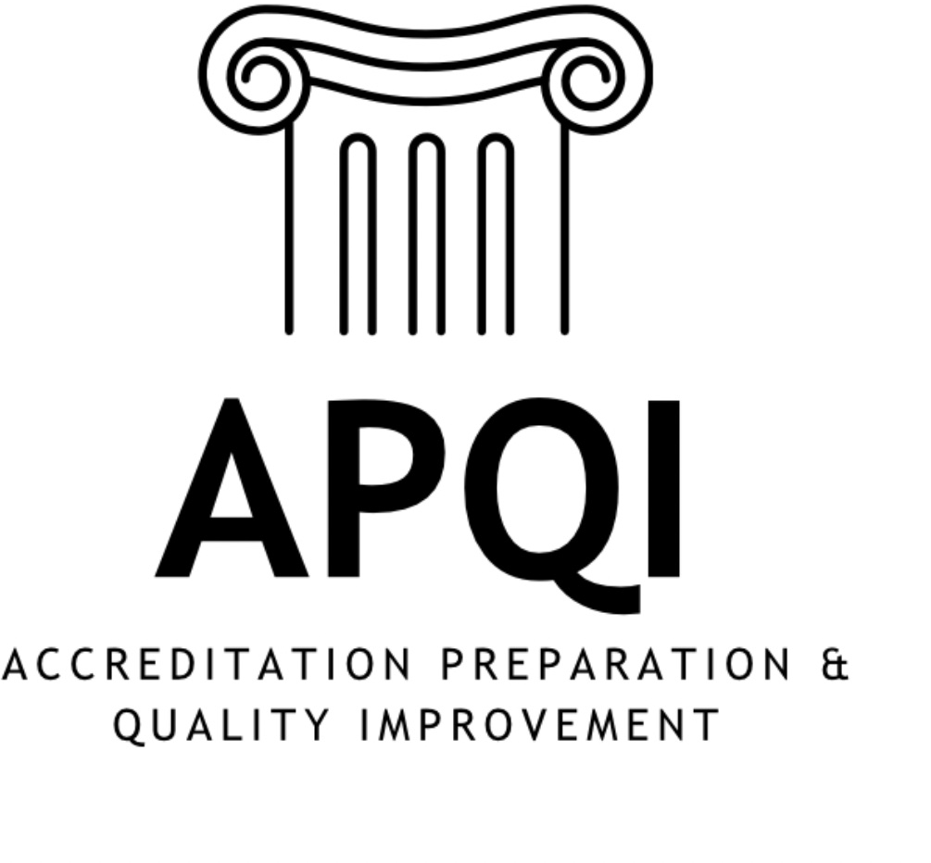
STEERING COMMITTEE

Role | Name | School
Chair | Melisa Pierce, EdD, MPA | Frederick P. Whiddon College of Medicine
Chair-Elect | Jason Booza, PhD | Wayne State University School of Medicine
Secretary | Rebecca Molter, MS | Covenant Healthcare College of Medicine at Central Michigan University
Treasurer | Katie Maietta, MPPM | University of Pittsburgh School of Medicine
Membership Representative | Joseph Oppedisano, D.Ac | University of Minnesota Medical School
Communications Representative | Greg Null, MA | University of Pittsburgh School of Medicine
Scholarship Representative | Jason Hedrick, PhD | West Virginia University School of Medicine
Scholarship Representative | Samuel Neher, MS, EdD | McGovern Medical School
Conference Chair / Past Chair | Colleen Hayden, EdD | University of Missouri School of Medicine
Historian-Librarian | Tonya V Thomas (Anderson), MAEd, APRM, LSSB | Wayne State University School of Medicine
Member-at-Large | Tanya Biscardi, MS | Jacobs School of Medicine and Biomedical Sciences
Member-at-Large | Raquel Givens, PhD | University of Arizona College of Medicine
Member-at-Large | Amber Todd, PhD | Boonshoft School of Medicine
Member-at-Large | Teresa Isbell, PhD | Texas A&M University Naresh K. Vashisht College of Medicine

