Spring Board Civic Pool Weather Policy
Spring Board adheres to The American Red Cross weather policy which dictates the following:
  - All Swimming pool patrons must seek shelter (outside of the facility and its showers or bathrooms) during a thunderstorm, as the pool is unsafe for patrons until 30 minutes after the last lightning or roll of thunder, OR when the last lightning strike is detected outside a 10 miles radius of the pool.

  - We encourage our patrons to use the Spark Lightning tool inside the Weather Bug app to monitor the distance of lightning.
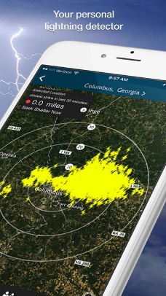
Date: __________
Signature: __________________________________________________
Printed Name: _______________________________________________
Office Use Only: Date: ___________ Membership Application on File: ___________

I/We agree to abide by the Spring Board Civic Pool Weather Policy as well as directives of attendants and pool board members. I/We hereby release and hold harmless SBCP from any and all liability arising from injury arising from swimming activities.
I certify that I am 18 years of age or older and I agree to abide by the Spring Board Civic Pool weather policy.

