Sunday Monday Tuesday Wednesday Thursday Friday Saturday
All Recreation Programs will continue to be offered house to house or one house at a time in the Heritage Room. Refer to white board for scheduled activities on the weekends. |  | 1  AM Friendly Visits  PM Balloon Badminton | 2  10am Keep fit  Church in the afternoon | 3  10am Coffee club  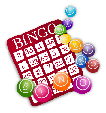  PM Bingo | 4  Lobster Dinner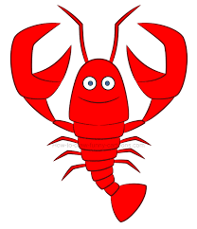  Am Keep Fit  PM Green Thumbs | 5  Friendly visits
6  June is Brain Injury Awareness month | 7  10am Keep fit  PM Sing Song | 8  AM Jeopardy  PM Walk & Groove | 9  10am Keep fit  Church in the afternoon | 10  10 am Fruit Smoothies  PM Bingo | 11  AM Keep Fit  PM Green Thumbs | 12  Friendly visits
13  Friendly visits | 14  10am Keep fit  PM Making Dream Catchers | 15  AM Name 10  PM Milk Shakes  Floor Hockey | 16  10am Keep fit  Church in the afternoon | 17  10am Coffee club  PM Bingo | 18  Father’s Day BBQ  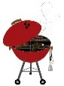  PM Yard Games | 19  Friendly visits
20 | 21 First Day of summer  10am Keep fit  PM Sing Song | 22  AM Lexicon  PM Ice Cream Social | 23  10am Keep fit  Church in the afternoon | 24  9:30 Tim Hortons Drive Through  PM Merchandise Bingo | 25  10am Keep fit  1:30 Memorial Service | 26  Friendly visits
27  Friendly visits | 28  10am Keep fit  PM Painting and Relaxation | 29  AM Time Slips  PM Walk & Groove | 30  10am Keep fit  Church in the afternoon |  | Contacts: Recreation Therapist- Georgina Megens (885-2562) & Recreation Coordinator- Sandra Carver (885-3638)

