Sunday Monday Tuesday Wednesday Thursday Friday Saturday
If you have any questions please contact: Recreation Therapist- Georgina Megens (885-2562) & Recreation Coordinator- Sandra Carver (885-3638) | Refer to whiteboard for any changes and weekend plans (subject to change Re: Public health measures) |  |  |  | 1  10:30 Keep Fit  PM Music with the Peters Family | 2  Car Show
3  Friendly Visits | 4  10am Keep fit  2pm Country Hicks | 5  10am Jeopardy  2pm Curling | 6  10 am Keep Fit  2pm Church with Father Vincent | 7  10am Thanksgiving Baking  2PM | 8  10am Keep fit  PM Thanksgiving Craft | 9  Friendly Visits
10  Movie | 11 | 12  10am The Price Is Right  2pm Glamour Day | 13  10am Keep fit  2pm Church | 14  10am Coffee Club  Roberts Pick  “Italian Day”  2PM | 15  10am Keep fit  2:30pm Continuing Care Celebration | 16  Balloon Badminton
17  Friendly Visits | 18  10am Keep fit  1:30pm Music with Russ, Rick & Dougie  “Birthday Bash” | 19  10am Reminiscences with Wendy  2pm Curling | 20  10am Keep fit  2pm Church | 21  10am Floor Hockey  2PM | 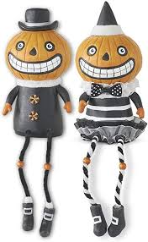  22  10am Keep fit  PM Pumpkin People | 23  Friendly Visits
24 / 31  Trick or Treating | 25  10am Keep Fit  11:00 Elders Council  2:00 Sing Song | 26  10am Treat Packing  2pm Pumpkin Bowling | 27  10am Keep fit  2pm Church | 28  10am Carving Pumpkins  2pm Merchandise Bingo | 29 10am Keep Fit | 30

