Sunday Monday Tuesday Wednesday Thursday Friday Saturday
 | 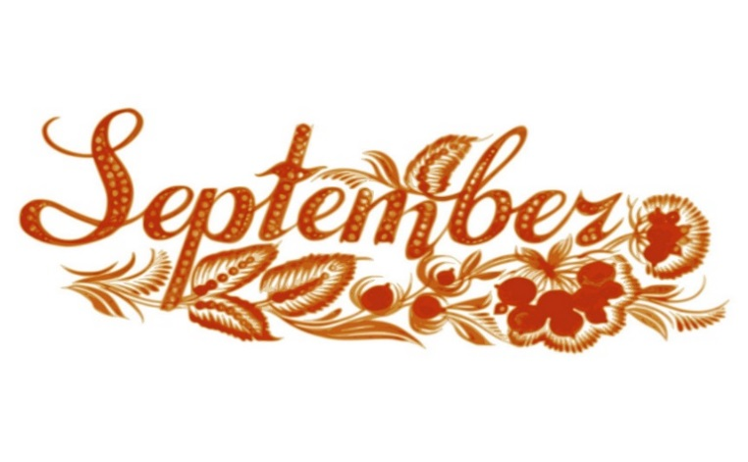 |  | 1  2pm Church with Father Vincent | 2  2:00 Music  Country Hicks | 3  Activity  To be Announced | 4  Friendly Visits  Going Outside
5  Friendly Visits  Going Outside | 6  Labour Day | 7  10am Shake Loose a Memory  2pm Curling | 8  Activity  To be Announced | 9  10am Baking  PM Bingo | 10  10am Keep fit  PM Community Stroll | 11  Friendly Visits  Going Outside
12  Friendly Visits  Going Outside | 13  10am Keep fit  1:30pm Music with Russ, Rick & Dougie  “Birthday Bash” | 14  10am Jeopardy  2pm Balloon Badminton | 15  10am Keep fit  2pm Church | 16  Farm visit  (date to be changed)  PM Bingo | 17  10am Keep fit  2pm Fall Craft | 18  Friendly Visits  Going Outside
19  Friendly Visits  Going Outside | 20  10am Keep fit  2PM Sing Along | 21  Glamour Day | 22 First Day of Fall  10am Keep fit  2pm Church | 23  2pm Car Show | 24  10am Keep fit  PM Bingo | 25  Friendly Visits  Going Outside
26  Friendly Visits | 27  10am Keep Fit  11:00 Elders Council  1:30pm Music with Russ and friends | 28  10am Name 10  Out for Lunch | 29  10am Keep fit  2pm Church | 30  National Day of Truth and Reconciliation | If you have any questions please contact: Recreation Therapist- Georgina Megens (885-2562) & Recreation Coordinator- Sandra Carver (885-3638) | Refer to whiteboard for any changes and weekend plans (subject to change Re: Public health measures)

