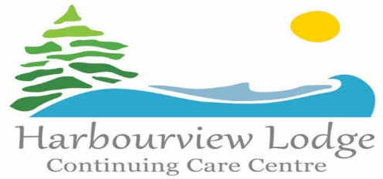

**Family Council**

**Meeting**

**March 25, 2025 @ 2pm**

**Harbourview Lodge**

**Boardroom/**

**Teleconference**

**Please RSVP to Natasha Sharpe at 902-885-3678 or by email** [**natasha.sharpe@nshealth.ca**](mailto:natasha.sharpe@nshealth.ca)**. If you would like to join by teleconference the conference number is 1-855-453-6962 conference ID# 4049929. Thanks**