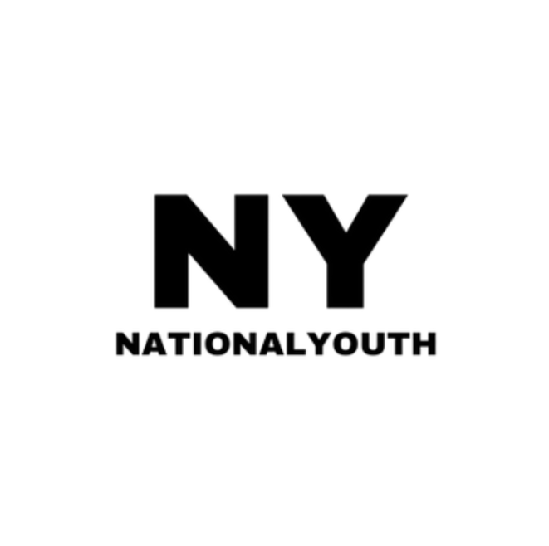

National Youth (NY)

Privacy Policy

Produced by:
UK Youth edited by National Youth (NY)
Reviewed annually by National Youth (NY)

National Youth (NY) promises to take great care with your personal data. We commit to protecting any personal information we obtain about you.
This Privacy Policy sets out how and why we obtain, use and protect personal information

Who we are

National Youth (NY) is a not-for-profit organisation in England, and we are also a company limited by guarantee.

How your data is used?

When you give us your details e.g. subscribe to receive email updates or register for our events, you may receive follow up information from us relevant to this activity, such as resources and details for an event or age-relevant projects if you consent to sharing your age with us. We will also contact you about our current and upcoming projects and other ways to support us by mailshots and newsletters because of you subscribing.

We make it very easy for you to opt out at any time from our marketing. We aim to communicate with you in a way that keeps you involved with us as you see the impact of your support, therefore we will act according to your instructions – please notify your preferences with us via email by requesting an update profile form which tailors your email content based mainly on age group/educational status which can be found in all our emails. Alternatively, you can just contact us via our website and write to us your communication preferences from there.

Sharing details – NOT

We assure you that you will not receive offers from other organisations as a result of you sharing your details with us.

We may share information with our service providers to help prepare and send communications or process your donations and other responses. However, these organisations will not use your details for their own purposes and will keep your details secure, and delete it when no longer needed. But some of these organisations may ask you to subscribe to them in which case this is your decision and extends beyond our remit an example of this is financial detail processed by third party organisations

Details – What and Why ?

There are 3 main categories of details that we can collect for different purposes should you share details. We ask for your:
- Identity details e.g. Full name, age/educational status, pictures (please see below)
- Contact details e.g. Postal address and email address
- Payment details e.g. card details and billing address

These are the reasons we ask for the above information:
- We know how to contact you for events and any of our age related projects (pictures will be used for publicity purposes)
- Deliver merchandise you may have requested or bought
- You can financially support our work
- Occasionally, we may ask you to re-verify your details to ensure that they are up to date in our systems to receive the relevant marketing and for your support to continue. This will be done once a year by an email which will have an update profile form link for you to choose your preferences.

Publicity

We have decided that for most of our events we will be taking pictures/videos/other publicity material. For events that we give an option to have publicity taken there will be an option to select NO should you wish to not be included in the publicity or else please assume that publicity will be taken regardless. Please be assured that in most cases that material of individuals will not be a complete close-up and you are not likely to be the attention of the material for significant periods of time (20-30 seconds plus) unless you give consent for more time. We do recommend that you take part in our publicity so we can publicise the work that we as an organisation do in order to benefit the wider community by increasing awareness of our projects. Also note that agreeing to have your publicity taken in any format and the privacy policy such as in online forms is effectively the same as signing our waiver release form which can be found HERE, essentially we have complete ownership of the material for as long as we decide. Should you wish to stay out of these then please select the appropriate options on the relevant event forms and ALSO alert a member of our team during events and follow any procedures stated in our registration forms. If either of these steps are not enacted, we will not be held liable for the release of any material that contains an individual.

Collecting details – How ?

National Youth (NY) may collect your personal data in the following circumstances:

- When you give it to us DIRECTLY
  - E.g. process donations, register for events, communicate via email, physically attend events, mail subscriptions and informing our members directly (e.g. in person or virtually)
- When you give it to us INDIRECTLY
  - E.g. through business partners or third party organisations. These independent organisations provide access to your non-payment details if consented. For example, if you contribute large donations through online platforms we may contact you to become a more active supporter.

Sometimes your personal data is collected by an organisation working on our behalf, but as they are acting on our behalf, we are the “data controller” and are responsible for the security and proper processing of that data.

3) When using National Youth (NY) Social Media

We may obtain your information through your use of social media such as Facebook and Twitter e.g. if you tag or like our pages etc. Please see the privacy settings of these social media if you wish otherwise.

4) When information is publicly available

We may obtain information about individuals who may be interested in attending our events or giving large donations. In this scenario, National Youth (NY) may seek to find out their interests and motivations through publicly available information e.g. media coverage, open postings on social media sites such as LinkedIn, and data from Companies House. National Youth (NY) will not retain publicly available data relating to major donors without their consent, which will be sought at the earliest practical opportunity.

Legal Requirement

We will comply with legal requests where disclosure is required or permitted by law (for example to government bodies for tax purposes or law enforcement agencies for the prevention and detection of crime, subject to such bodies providing us with a relevant request in writing).

Your data is only processed outside the EU where National Youth (NY) has verified that appropriate standards and safeguards are in place

Keeping personal information – Length

All data about an individual is stored on secure databases or password protected files as long as legally required and is necessary for the relevant activities. An individual’s data will be erased when requested by the individual at the earliest practical opportunity. An individual’s data is accessible to all the relevant staff. We are aware under UK law that gift aid donation receipts must be kept for a minimum of 6 years. This may change depending upon the law.

Opting Out/Changing information

If you wish to stop or change how we communicate with you or update/delete the details we have of you, please email us via the following address:
Email: admin@nationalyouth.co.uk

You can also opt out of our emails by clicking on the unsubscribe link within any of our emails. Please bear in mind that some of these changes may take a week to occur. You can also request an update profile form to change your preferences for mail content, this will be available via a small link in all our emails for you to click on.

Data Subject Rights:

- The right to be informed as to whether National Youth (NY) holds and individual’s data
- The right of access to data
- The right to have an individual’s data rectified
- The right to have data deleted
- The right to opt-out of particular data processing operations
- The right to receive data in a form that is “portable”
- The right to object to data processing
- The right to receive an explanation about any automated decision making and/or profiling, and to challenge those decisions where appropriate

With regards to data profiling and automation, National Youth (NY) may use profiling to predict a person’s age for marketing purposes such as sending emails with our age tailored events/projects or determining the best times to send emails based on email opening analysis.

How to make complaints about this policy or raise privacy concerns?

If you would like more information or have any questions about this policy, please contact our team by email at admin@nationalyouth.co.uk .
You also have the right to make a complaint directly to the UK’s data protection authority, the Information Commissioner’s Office (ICO). The ICO can be contacted at: https://ico.org.uk/global/contact-us/
Concerns can also be logged via the ICO website.

Changes to National Youth (NY) privacy policy?

This Privacy Policy may be updated from time to time so you may wish to check it each time you submit personal information to National Youth (NY). The date of the most recent revisions will appear on this page. If you do not agree to these changes, please do not continue to use the National Youth (NY) website to submit personal information to National Youth (NY) but instead raise your concern via email before proceeding further. If material changes are made to the Privacy Policy we will notify you by placing a prominent notice on the website.

Contacting us

You can contact us by email: admin@nationalyouth.co.uk

Alternatively, you can get in touch with us by post:
National Youth
71-75 Shelton Street,
London, England,
WC2H 9JQ

DOCUMENT CONTROL SHEET

Document Name: Privacy Policy
Document Owner: National Youth (NY) Director
Document History:
First issue: March 2025
Next Review Date: March 2026

Document approved by: National Youth (NY) Board of Trustees
Date approved: March 2025

