Fall Fly-in

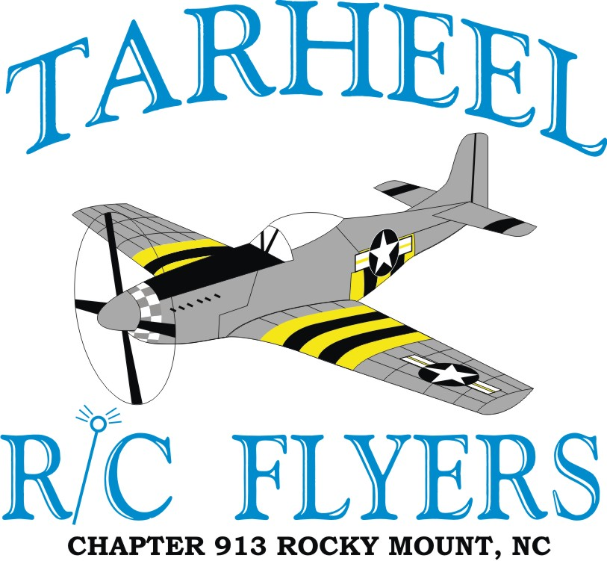

***Saturday, Sept. 7*, *2019***

**AMA** Sanctioned Event

**Event Begins at 9:00 am**

**Food and Drinks Available**

**Spectators always welcome!**

**Pilot Registration $10.00**

**All aircraft will be allowed, Run what you bring!**

**Directions**

For More Information and map please visit our website at**: www.tarheelrcflyers.com** or Contact: **A. B. Gentry, Jr.,** 2942 Avalon Road, Rocky Mount, NC 27801 Phone 252-343-3961 E-mail: wn4z462@centurylink.net