SUNDAY   | MONDAY  AUGUST BIRTHDAYS  9 – Kieth Hollar  14 – Joe Kennedy  14 – Debra Nisporic  22 – Larry Keen | TUESDAY  24 – Judy Alberson  24 – Juanita Gutierrez  26 – Marie Nymeyer  30 – Linda Schmidt  31 – Dee Stratchan | WEDNESDAY | THURSDAY 1  8:30 Mentone Breakfast  10:00 Coffee & Chatting | FRIDAY 2  10:00 Coffee & Chatting  11:00 Dollar Tree Run-Sign-up in Atrium   | SATURDAY 3
4 | 5  10:00 Coffee &Chatting  RESIDENT MEETING    Claudia - Hairdresser | 6  10:00 Coffee & Chatting  10:30 RAC Meeting-Library | 7  10:00 Coffee & Chatting  10:30 Chair Volleyball  11:00 Stater’s Shopping | 8  8:30 Mentone Breakfast  10:00 Coffee & Chatting  11:00 Craft Day-Upstairs Atrium  4:45 Spaghetti Night-Bus | 9  10:00 Coffee & Chatting | 10  5:00 Family & Friends Pie Potluck-On the Lawn  
11 | 12  10:00 Coffee & Chatting  2:30 BINGO TIME! Upstairs Atrium  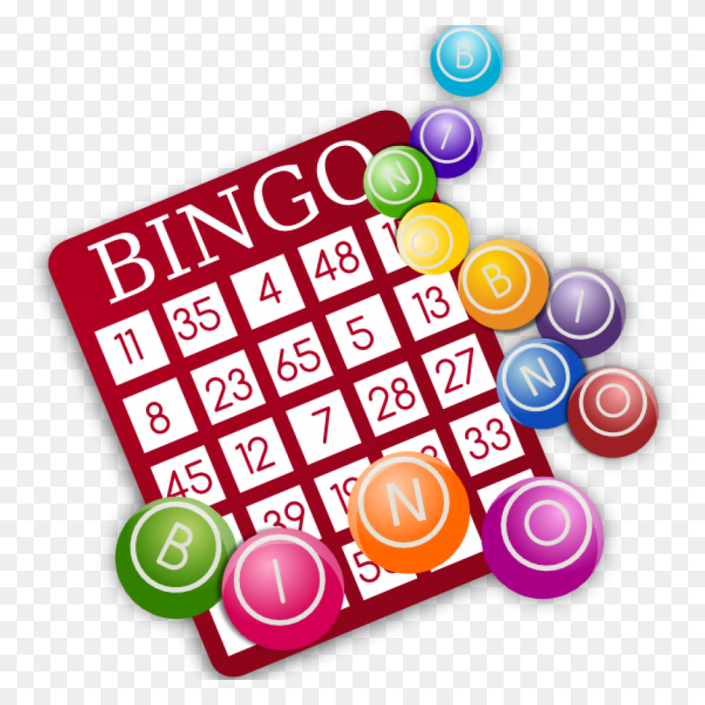  Claudia - Hairdresser | 13  10:00 Coffee & Chatting  DONUT DAY!!!  5:45 Next Dimension – Redlands Bowl - Bus | 14  10:00 Coffee & Chatting  11:00 Stater’s Shopping  11:15 Lunch Bunch-Gourmet Pizza-Bus   | 15  8:30 Mentone Breakfast  10:00 Coffee & Chatting  3:30 Yee-Haw Dance-Joselyn Center - Bus    Cecilia-Mani/Pedi | 16  10:00 Coffee & Chatting   | 17
18 | 19  10:00 Coffee & Chatting  4:30 Taco Monday – Mill Creek-Front of Apartments  Claudia - Hairdresser | 20  10:00 Coffee & Chatting  10:30 RAC Meeting - Library | 21  10:00 Coffee & Chatting  10:30 Chair Volleyball  11:00 Stater’s Shopping | 22  8:30 Mentone Breakfast  10:00 Coffee & Chatting  APPLE FRITTERS!!! | 23  10:00 Coffee & Chatting  12:00 Birthday Bash  Hawaiian Theme Potluck - Lounge   | 24
25 | 26  10:00 Coffee & Chatting  Claudia - Hairdresser | 27  10:00 Coffee & Chatting   | 28  10:00 Coffee & Chatting  11:00 Stater’s Shopping | 29  8:30 Mentone Breakfast  10:00 Coffee & Chatting | 30  10:00 Coffee & Chatting | 31



