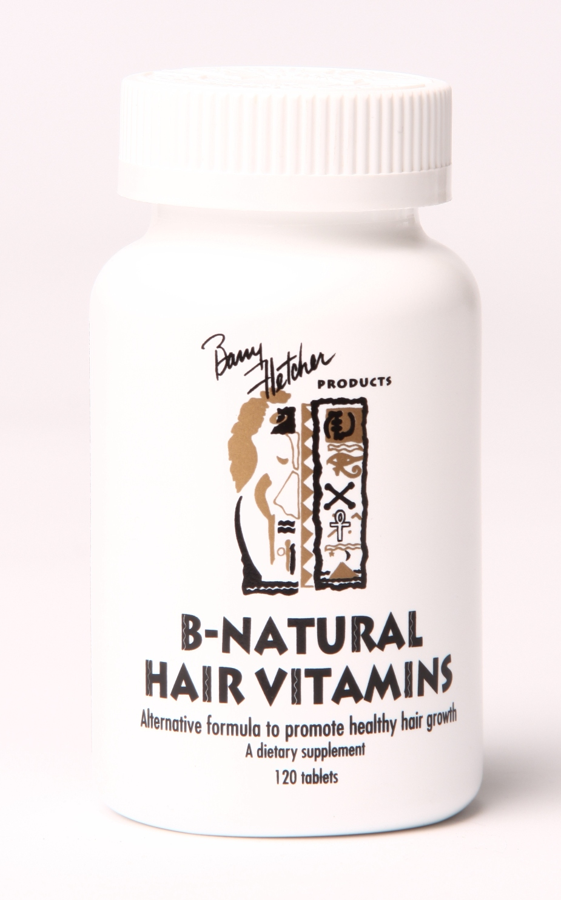
B Natural Vitamins Article

B-Natural Hair Vitamins are a healthy alternative formula to promote hair growth. These vitamins are designed to increase the energy level at the root of the hair which promotes growth. This multi-vitamin is the ultimate in hair restoration and maintenance.

The assortment of vitamins is selected specifically to affect an aspect of hair growth and general healthiness. Vitamin supplements should be a part of most of our daily routines along with eating better quality foods and in moderation. A regular exercise routine is also essential – not just physically but mentally and spiritually as well. Let me take you inside our B Natural vitamins.

Vitamin C – ascorbic acid is an essential nutrient. It is made internally by almost all organisms. Vitamin C improves blood circulation. It is an antioxidant and protects the body against oxidative stress.

Vitamin E – is a fat-soluble antioxidant that stops production of reactive oxygen species formed when fat undergoes oxidation. It protects cell membranes from oxidation. Protect neurons from damage, cancer prevention, and cholesterol reduction. Protects against stroke-associated brain damage in vivo. Vitamin E improves oxygen level in the bloodstream.

Thiamine – (B1) – considered an "anti-stress" vitamin because it may strengthen the immune system and improve the body's ability to withstand stressful conditions. help the body to convert food (carbohydrates) into fuel (glucose), which is "burned" to produce energy.

Riboflavin – (B2) – easily absorbed micronutrient with a key role in maintaining health. Plays a key role in energy metabolism and is required for metabolism of fats, carbohydrates and proteins.

Niacin – (B3) – involved in both DNA repair and the production of steroid hormones in the adrenal gland. May reverse atherosclerosis by lowering low density lipoprotein. Promotes health and growth

Vitamin B6 – regulates the release of glucose (sugar). It is necessary in the processes to metabolize proteins, fats, and carbohydrates, to make hormones and neurotransmitters, and to support the immune system. It also plays a role in the production of normal, healthy red blood cells and some of the neurotransmitters needed for proper nervous system function.

Folic Acid – (B9) – the body needs folate to synthesize DNA, repair DNA. Needed to produce healthy red blood cells and prevent anemia. Folic acid helps prevent hair loss.

Vitamin B12 – key role in normal functioning of the brain and nervous system and formation of blood. B12 increases the energy at the root

Biotin – necessary for cell growth. Helpful in maintaining a steady blood sugar.

Pantothenic Acid – (B5) – is critical in the metabolism and synthesis of carbohydrates, proteins and fats.

Calcium - a soft gray alkaline earth metal. A major material used in mineralization of bones and shells. Helps strengthen your bones.

Iron – a metallic chemical element that helps maintains strength

Zinc – a metallic chemical element that fights bacteria

Selenium – Selenium is a trace mineral that is essential to good health. The antioxidant properties of selenoproteins help prevent cellular damage from free radicals that may contribute to the development of chronic diseases such as cancer and heart disease. Helps regulate thyroid function and play a role in the immune system

Copper – The body needs copper for normal growth and health. Copper is needed to help body use iron. It is also important for nerve function, bone growth, and to help body use sugar.

Inositol – is a carbohydrate, though not a classical sugar. Inositol is important for regulating serotonin and insulin, and breaking down fats and reducing blood cholesterol.

Methionine – is an essential, sulfur-containing amino acid. The body uses sulfur to influence hair follicles and promote healthy hair, skin, and nail growth. Sulfur also increases the liver's production of lecithin (which reduces cholesterol), reduces liver fat, protects the kidneys, helps the body to excrete heavy metals, and reduces bladder irritation by regulating the formation of ammonia in the urine. Helps prevent fat accumulation in the liver, and usually helps detoxify metabolic wastes and toxins.

Acetylcysteine – ACETYLCYSTEINE AS A MUCOLYTIC AGENT. Relieves bronchial tract problems

Aloe Vera – promotes healing, moisturizes, relief of digestive issues such as heartburn and irritable bowel syndrome. Antibacterial and antifungal

