Author Barry Fletcher Releases Second Printing of Book on President Barack Obama’s Two Presidential Terms

By Brianna Rhodes, Special to the AFRO
Author, CEO and entrepreneur, Barry Fletcher released the second printing of his latest book “President Barack Obama’s Two Tremendous Terms: Monthly Political Chronicle 2008-2016” in January of this year. The book takes readers on an unique, poetic journey of President Barack Obama’s presidency.
The book, whose original version was released around the time Obama left office, provides readers of all ages, a detailed, historical monthly recap of Obama’s presidential experiences from 2008 to 2016.
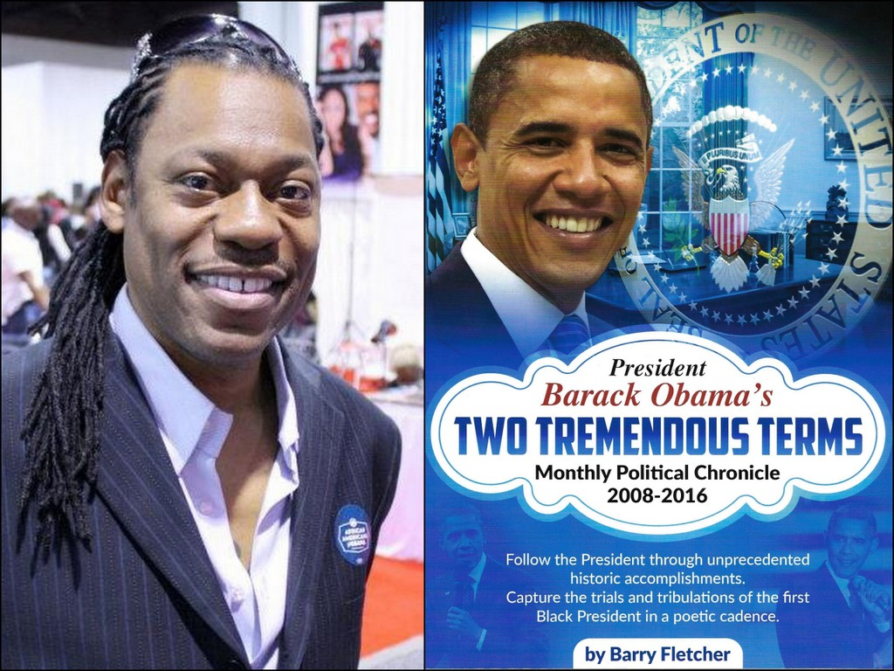Author Barry Fletcher, left, releases the second printing of his latest book “President Barack Obama’s Two Tremendous Terms: Monthly Political Chronicle 2008-2016.”
The second printing is updated and includes a compelling foreword from Fletcher along with more news-based, politically savvy, information. It includes contextual preludes to each poetic entry as well.
With each month, Fletcher uses his rhymes influenced from old school R&B and hip hop to describe Obama’s presidency – both ups and down where he provides a summary, a poem and picture that goes along with each entry.
“I wrote it in a poetic cadence because I wanted the amateurs – the layman’s or the young to be able to understand what Obama did,” Fletcher said. “So, I thought my plain words were better than just me using a whole lot of sophisticated writing and big words. Just break it down and then maybe compare it to some stuff that happened in history.”
Fletcher describes the book as an easy and fun read for his audience. He described the book as a coffee table book that sits there, where you can choose what chapter you want to read based on your curiosity about what Obama was doing at a certain time in a year.
The copy gives a sense of nostalgia, but it will also help the reader connect to historical events in the African-American community and information from U.S. History that relates to President Obama’s term, ranging from the beginning of the country’s history to Jim Crow and current issues.
“What African-Americans accomplished a lot of times, is not brought out . . .,” Fletcher said.
“You’ve got to look at the past you know. How did we get to this point? And tie it into where we are now and how that might affect our future.”
Fletcher recounts other major events such as Obama’s first inauguration, the passing of the Affordable Care Act and more in the book. He acquired most of his information from newspapers, news channels and political figures. Although it took Fletcher eight years to write the book, he said it was worth it.
“The message was merely to follow him, but Obama is such a scholar,” Fletcher said. “He takes you back in history. He pulled me back to my roots. He lets you know what’s going on.”
“So, it made me research and get more into the whole political discourse,” Fletcher added.
“Then after I learned, I was so anxious about telling other people . . . share with other folks you know. Let them see the light.”
Through the 96 poems, Fletcher attempts to reignite the love they had and continue to have for the 44th president of the United States and the first African-American president, despite the current president’s effort to diminish Obama’s legacy. He wants readers to understand the journey Obama took and the trials, tribulations and accomplishments he experienced – and maybe it could inspire the Black family, especially the young audience, to become politically involved.
“If the millennials don’t get in line, we’re doomed to repeat ourselves,” Fletcher said. “We’re going to go backwards. I started thinking, “What can you say to a senior to ring a note for them to say, maybe I should talk to my nephew, should be running for counsel?’”
Fletcher also spoke on how hard it is to find people who can even hold conversations about politics. He said people just don’t know and are not aware. “That’s the weakest part of the Black community if you ask me,” Fletcher said. “Obama was a shining, beacon of light to make us more aware. I could tell President Obama to his face, that, ‘You woke me up brother’ and so I tried to do all that I could to try to spread the word.”

