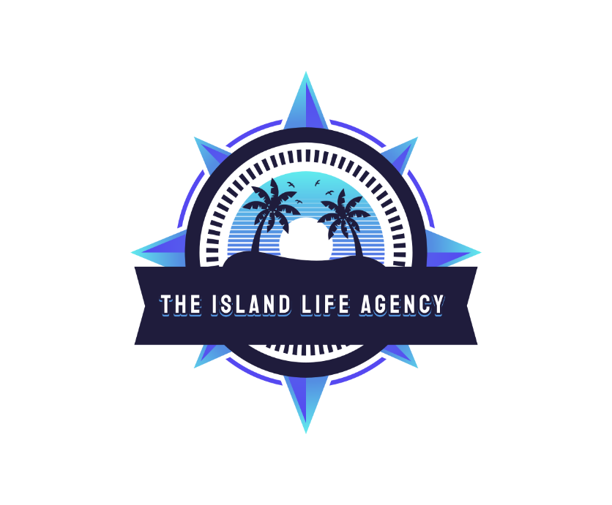
NCL FIRST TIME CRUISE GUIDE

The Island LIfe AGency 2025-2026
NCL Cruise guide
Samantha Martin- AGENCY OWNER
2025
First-Time Cruising Guide for Norwegian Cruises

Congratulations on booking your first Norwegian Cruise Line cruise! NCL is known for its "Freestyle Cruising" philosophy, offering flexibility in dining, entertainment, and onboard experiences. Whether you're sailing to the Caribbean, Alaska, or beyond, this guide will help you navigate your journey with ease.

Embarkation Procedures

Embarkation day is when you board the ship and start your adventure. Here’s what to expect:

-Online Check-In: NCL strongly recommends completing online check-in via your My NCL account (on their website or app) before arriving at the port. This allows you to select an arrival time, upload travel documents, and speed up the process. Do this at least a day prior.

-Arrival Time: If you’ve checked in online, arrive at the terminal no later than one hour before the ship’s scheduled departure. If you haven’t, arrive at least two hours prior (NCL suggests after 12 PM if not pre-checked in).

- At the Terminal: Porters will take your checked luggage (tag it with provided luggage tags from your e-Docs). Bring carry-on with essentials like medications, valuables, and a swimsuit, as luggage may take a few hours to reach your cabin.

- Check-In Process: Present your e-Docs (printed or digital) and travel documents at the counter. Staff will verify your information, take a photo for your onboard ID, and issue your keycard.

- Boarding: Once cleared, you’ll board the ship, where crew members will direct you to your muster station or onboard activities.

Tip: Download the Norwegian Cruise Line app before boarding—it’s your hub for booking dining, excursions, and more once onboard.

Disembarkation Procedures
Disembarkation day is when you leave the ship at the end of your cruise. Preparation starts the night before:

Luggage Options:

-Standard Disembarkation: Pack your bags and place them outside your cabin door by the specified time (usually 10 PM–midnight) the night before. Attach the color-coded luggage tags provided by NCL, which correspond to your assigned disembarkation time. Crew will move them to the terminal, where you’ll retrieve them after customs.
- Self-Assist: Carry your own luggage off the ship for an earlier exit. This is ideal if you’re able-bodied and have a tight schedule (e.g., an early flight). You’ll disembark as soon as the ship is cleared, typically between 8–10 AM.

- Final Bill: Check your onboard account (via the app, TV, or Guest Services) the night before to settle any charges or disputes.

- Morning of Departure: Vacate your cabin by around 8 AM (exact time varies by ship). Enjoy a final breakfast, then wait for your assigned group to be called. Follow announcements or app notifications to proceed to the gangway.

- Customs: After leaving the ship, collect your luggage (if not self-assist) and proceed through customs with your declaration form (provided the night before).

Tip: Book flights home no earlier than noon to account for customs and travel time to the airport.

Muster Drill

The muster drill is a mandatory safety briefing required before the ship departs:

- When: Held on embarkation day, typically after boarding but before sailing.
- Where: Your muster station is printed on your keycard. Follow crew directions to this designated area (e.g., a lounge or deck).
- What Happens: Crew explains emergency procedures, life jacket use, and lifeboat locations. It’s quick—usually 20–30 minutes.
-How: On newer NCL ships, you may watch a safety video on your cabin TV or app first, then check in at your muster station to confirm attendance.
Tip: Bring your keycard and listen attentively—safety is key!
Travel Document Requirements for a Closed-Loop Cruise

A closed-loop cruise starts and ends at the same U.S. port (e.g., Miami to the Caribbean and back). For U.S. citizens:

- Passport: Not required, but NCL strongly recommends bringing one valid for six months beyond your return date for ease and emergencies.

- Alternative: A state-issued birth certificate (original or certified copy) plus a government-issued photo ID (e.g., driver’s license) is accepted.

- Minors: Kids under 16 need only a birth certificate. If you are travel without both parents, bring a notarized consent letter from the absent parent(s).

- Non-U.S. Citizens: Contact your embassy for visa requirements, even for closed-loop cruises.

Tip: Always check NCL’s website or your e-Docs for specific itinerary requirements.

Security Screening
Security is like an airport but tailored for cruising:

- At the Terminal: You’ll pass through metal detectors and X-ray machines. Place carry-ons on the conveyor belt.

- Prohibited Items: No weapons, large batteries, drones, or alcohol (except sealed wine/champagne with a corkage fee—$15 for 750ml, $30 for 1500ml). Check NCL’s full list online.

- Beverages: Only sealed water for medical use or infant formula is allowed; other drinks must be discarded.

Tip: Keep travel documents and medications in your carry-on for quick access.

Arriving at Port

- Timing: Aim to arrive at your assigned time (from online check-in) or at least two hours before departure if not pre-checked in. Don’t arrive too early—security may delay entry.

- Transportation: Book transfers through NCL if flying in or arranging a taxi/rideshare. If you drive, follow the port signage to park the baggage drop-off zone.

- : Tip them $1–2 per bag (optional but customary) for handling your luggage.

Tip: Fly into the departure city the day before to avoid stress from delays.

Cruise Check-In

- Online: Complete it via My NCL before arrival to save time.
- At the Port: Present your e-Docs, travel documents, and credit card (for onboard charges) at the check-in counter. You’ll get your keycard, which doubles your ID and payment method onboard.

Tip: Link a credit card to your account for seamless spending; a $300 hold is placed initially, adjusted as you spend.

Tips for Cabins

- Choosing a Cabin: Inside cabins are cheapest, but balconies offer views and fresh air. Research deck plans on NCL’s site to pick a quiet spot (avoid areas near elevators or entertainment).

-Space: Cabins are compact—pack light and use under-bed storage for suitcases.

- Amenities: Expect a mini fridge, safe, hairdryer, and basic toiletries (shampoo, body wash).

- Organization: Bring magnetic hooks (the walls are metal) for extra hanging space.

Tip: Midship cabins on lower decks feel less motion if you’re prone to seasickness.

How to Buy Things on a Ship

- Onboard Account: Link a credit card or deposit cash at Guest Services. Your keycard is used for all purchases (dining, shops, excursions).

- Currency: U.S. dollars are standard. ATMs are available (with fees).

- Shops: Duty-free items like jewelry, alcohol, and souvenirs are sold onboard. Alcohol bought in ports or shops is held until the last night or disembarkation morning.

Tip: Track spending via the app or cabin TV to avoid surprises.

Internet

- Wi-Fi Packages: NCL offers unlimited Wi-Fi (with or without streaming) starting at $25–$40/day. Book pre-cruise for discounts.

- Free Access: The NCL app works on the ship’s Wi-Fi without a package for schedules and bookings.

- Signal: Expect slow speeds and occasional drops—perfect for basics, not heavy streaming unless upgraded.

Tip: Log off when not in use to save minutes if on a limited plan.

Tip for Motion Sickness

- Prevention: Book a midship, lower-deck cabin. Use over-the-counter meds like Dramamine or wear Sea-Bands (wristbands).
- Onboard: Visit the ship’s medical center for free motion sickness pills if needed. Fresh air on the deck helps, too.
- Tender Ports: Smaller boats can be rockier—take meds 30 minutes before boarding.

Tip: Ginger candies or green apples (available at the buffet) can settle your stomach naturally.

Tender Ports
Some ports require tender boats (small vessels) to shuttle you ashore when the ship can’t dock:

- Process: Get tender tickets (if required—check the Freestyle Daily newsletter) and wait for your group to be called.
- What to Bring: Carry essentials (ID, keycard, sunscreen) in a small bag—luggage stays onboard.
- Tips: Wear sturdy shoes for boarding; it can be bumpy. Priority tendering is available for suite guests or with certain packages.

Tip: Tendering can take time—be patient and enjoy the ride!

Tips and Gratuity

- Automatic Gratuities: NCL adds $20/day per person ($25 for suites) to your bill for crew tips. Adjust at Guest Services if needed.

- Extra Tipping: Optional but common for exceptional service (e.g., $1–2 for bartenders, room stewards). Give cash directly or add via your account.
- Packages: Drink and dining packages include a 20% gratuity upfront.

Tip: Budget about $150–$200 per person for a 7-day cruise in gratuities.

What to Wear

- Daytime: Casual attire—shorts, t-shirts, sundresses. Bring layers for cooler climates (e.g., Alaska).

- Evening: "Freestyle" means no formal dress code, but “Dress Up or Not Night” encourages smart-casual outfits (slacks, blouses). Specialty restaurants may suggest collared shirts.

- Shoes: Comfortable walking shoes for ports; flip-flops or sandals for the pool.

Tip: Check your itinerary’s weather—pack a jacket for chilly nights.
Theme Nights

- Examples: White Hot Party, Glow Party, or 80s Night—check your Freestyle Daily for specifics.

- What to Wear: White outfits, neon colors, or retro gear. Participation is optional but fun!

- Prep: Pack a themed item (e.g., a white shirt) to join in.

Tip: Buy accessories onboard if you forget anything.

What to Pack

- Essentials: Passport/ID, medications, swimsuit, sunscreen, charger, reusable water bottle.

- Clothing: Mix of casual and smart-casual, plus a jacket or sweater. Pack for ports (e.g., hiking boots for Alaska).

- Extras: Magnetic hooks, power strip (non-surge), small first-aid kit, snacks for excursions.

Tip: Pack a carry-on with Day 1 needs—your luggage might arrive late.

Preparing for Debarkation

- Night Before: Pack most items, leaving out clothes and toiletries for the morning. Settle your bill and fill out the customs form.

- Luggage: Decide between standard (tags outside door) or self-assist (carry off yourself).

- Morning: Check your cabin thoroughly (safe, drawers) before leaving. Grab breakfast—buffets may close early.

Tip: Request a later disembarkation time at Guest Services if you’re not in a rush.

