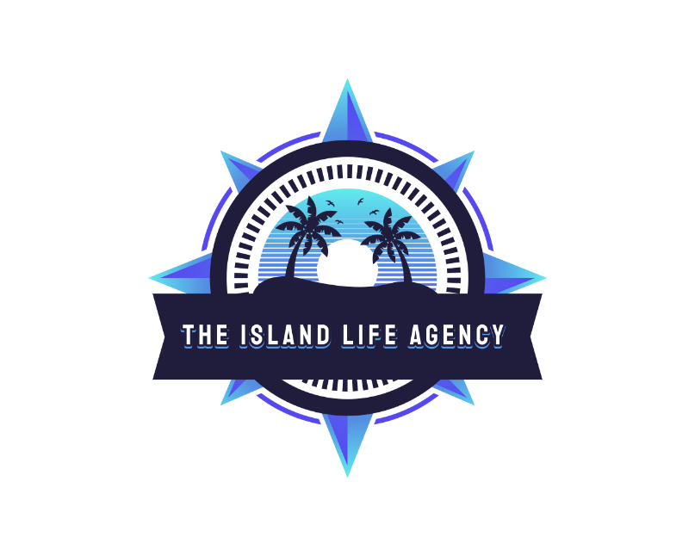

Team Lead Bonus Program

The Team Lead Bonus Program is The Island Life Agency's elite path for agents ready to lead, recruit, and grow thriving travel teams. This is more than just a title - it's your gateway to greater income, leadership recognition, and long-term impact in the travel industry.

Enrollment Requirements
- $200 one-time enrollment fee
- Active CLIA membership (yearly)
- Registered business with business bank account
- $59.99/month leadership program fee
- Must remain in good standing with the agency

Earnings & Incentives
- 100% commission on all personal bookings
- 10% Profit share on your team's total monthly commission revenue
- Legacy Leadership Status at $50,000+ in team revenue
- Opportunities to host supplier webinars and lead team retreats
- Free access to TBO holiday

Program Benefits
- Full earnings on your own sales

Host Program Overview
- Passive income from team production
- Custom team portal and onboarding support
- Legacy Leader spotlight & recognition
- Priority access to exclusive perks and FAM trips

Who Should Join
The Team Lead Bonus Program is for agents with vision - those ready to lead with heart, grow with purpose, and inspire others in the travel industry

