Dia De Los Muertos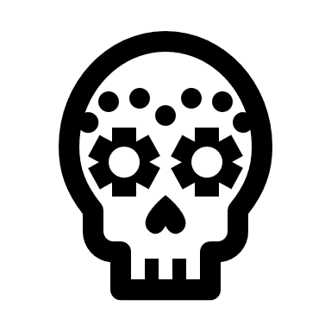
Puerto Vallarta Nov.1-5, 2025

Fiesta Americana Puerta Vallarta
Join us for an experience of a LIFETIME!
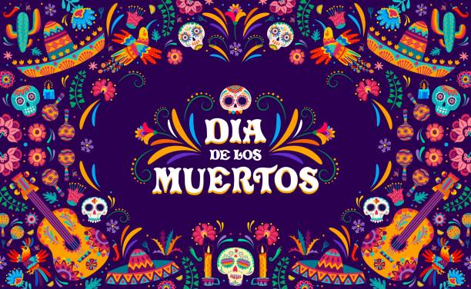

Fiesta Americana Puerto Vallarta is a premier all-inclusive resort located on the stunning beachfront of Banderas Bay, surrounded by the breathtaking Sierra Madre mountains. This idyllic setting offers guests a unique blend of luxury and natural beauty, with direct access to soft sandy beaches and crystal-clear waters. The resort features a variety of accommodations, including spacious rooms with ocean views, ensuring a comfortable stay for all visitors
Dia de los Muertos, or Day of the Dead, is a vibrant Mexican tradition that honors deceased loved ones. Celebrated primarily on November 1st and 2nd, this festival combines indigenous beliefs with Catholic traditions. In Puerto Vallarta, the celebration is particularly lively, showcasing the city’s rich cultural heritage and artistic expressions.
History and Traditions of Dia de los Muertos in Puerto Vallarta
The origins of Dia de los Muertos can be traced back to ancient Mesoamerican cultures, particularly the Aztecs, who believed that death was a part of life’s continuum. The modern celebration incorporates elements from Catholicism, with November 1st dedicated to honoring deceased children (Día de los Inocentes) and November 2nd for adults (Día de los Muertos).
In Puerto Vallarta, the festivities are marked by colorful parades, music, and art displays. The city transforms into an open-air gallery filled with altars (ofrendas), decorated with flowers, photographs, and offerings for the departed.
Altars (Ofrendas) and Their Significance
Altars are central to Dia de los Muertos celebrations. They serve as a welcoming place for spirits to return to the world of the living. Key components of these altars include:
- Photographs: Images of the deceased are prominently displayed.
- Marigolds (Cempasuchil): These bright orange flowers are believed to guide spirits back home with their vibrant color and scent.
- Candles: Lit candles symbolize hope and faith; they illuminate the path for returning souls.
- Food Offerings: Traditional foods such as pan de muerto (a sweet bread), sugar skulls, and favorite dishes of the departed are placed on the altar.
- Personal Items: Objects that belonged to or were cherished by the deceased help personalize each altar.
Each item has deep significance; together they create a space where memories are honored and celebrated.
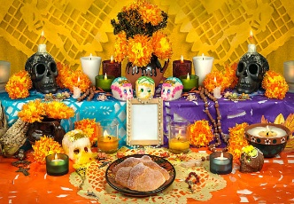
Different Days and Their Meanings
- October 31st - Halloween: While not traditionally part of Dia de los Muertos, this day marks the beginning of festivities.
- November 1st - Día de los Inocentes: This day honors deceased children. Families often visit cemeteries to clean gravesites and leave toys or sweets.
- November 2nd - Día de los Muertos: This day is dedicated to adults. It involves larger gatherings at cemeteries where families celebrate with food, music, and storytelling.
Each day reflects different aspects of life and death within Mexican culture.
Celebrating Pets
In recent years, there has been a growing recognition of pets in these celebrations. Many families create small altars for their beloved animals who have passed away. These altars may include pet toys or favorite treats as a way to honor their companionship.

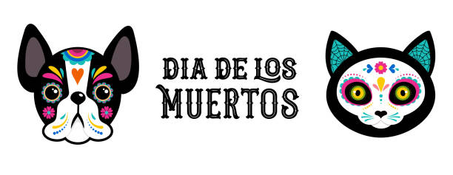

Fun Fact:
Puerto Vallarta has been featured in many movies, including The Night of the Iguana, Limitless, The Domino Principle, and Predator.

The Largest Catrina in the World on Puerto Vallarta Malecon
One of the most iconic symbols associated with Dia de los Muertos is La Catrina—a skeletal figure dressed elegantly in traditional attire. In Puerto Vallarta, visitors can find one of the largest Catrinas in the world located along the Malecon. This impressive statue serves as a focal point during celebrations and attracts numerous tourists eager to take photos.
The Malecon itself became a canvas for artistic expression during this time. Local artists display intricate Catrina sculptures made from various materials such as papier-mâché or metal. These artworks reflect both traditional styles and contemporary interpretations.
Artwork and Catrina Displays on the Malecon
Throughout the Malecon during Dia de los Muertos festivities, visitors will encounter numerous art installations celebrating life through death’s lens. The displays often feature:
- Catrinas in Various Forms: Artists showcase their creativity through unique interpretations—some whimsical while others more somber.
- Murals & Street Art: Local artists paint murals that depict scenes related to death and remembrance.
- Live Performances: Musicians often perform traditional songs that resonate with themes of loss and celebration.
These artistic expressions contribute significantly to Puerto Vallarta’s cultural landscape during this festive period.
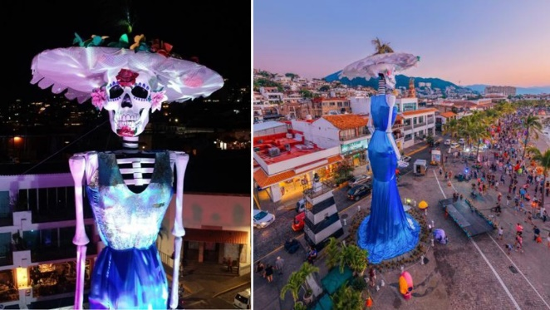
Fun fact:
Thousands of humpback whales migrate to the Bahía de Banderas every winter.

Visiting Yelapa – A Small Fishing Village Accessible Only by Boat
While in Puerto Vallarta for Dia de los Muertos, consider taking a boat trip to Yelapa—a picturesque fishing village known for its stunning beaches and laid-back atmosphere. Yelapa offers an escape from bustling city life where you can enjoy nature’s beauty while immersing yourself in local culture.
In addition to its scenic views, Yelapa provides opportunities for eco-tourism activities such as hiking waterfalls or snorkeling in clear waters.
Sea turtle Release
Separately, Guests can engage with local non-profits focused on conservation efforts—one notable activity is releasing baby sea turtles into their natural habitat. This experience not only supports wildlife preservation but also connects participants with local traditions surrounding marine life.
Releasing sea turtles typically occurs during specific seasons when hatchlings emerge from nests along Yelapa’s beaches. Participants learn about conservation efforts while contributing positively to environmental sustainability.
