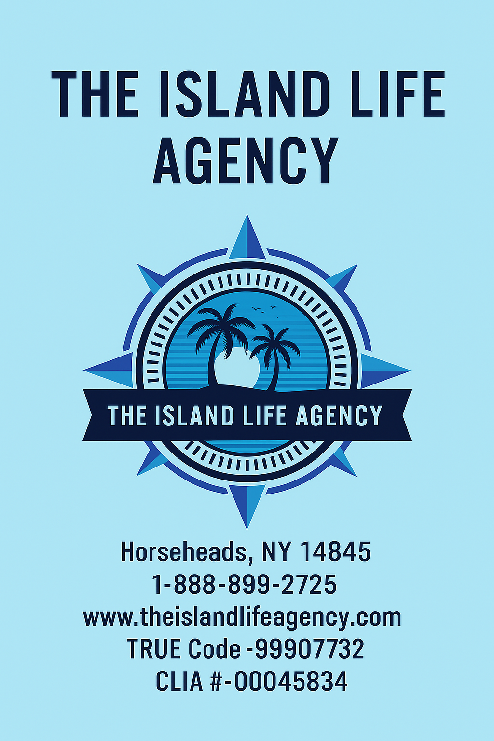
Welcome to The Island Life Agency

Welcome to The Island Life Agency — your new home in the travel industry. As a boutique host agency founded on a love for adventure, connection, and tropical serenity, we empower independent travel advisors across the U.S. to build profitable, passion-driven businesses. Whether you're helping a couple plan their dream destination wedding or curating a wellness escape for a group of professionals, you're now part of a supportive, growth-minded community that thrives on collaboration and excellence.
We believe in setting high standards, embracing creativity, and delivering unforgettable experiences to clients — all while giving you the tools, training, and freedom to grow your own business, your way.

Our Mission
To empower and elevate travel advisors through personal support, professional development, and access to high-value travel experiences, so they can deliver exceptional service and unforgettable journeys to every client.

Our Vision
To be the leading boutique host agency in North America for advisors who specialize in all-inclusive
resorts, group travel, destination weddings, and wellness escapes — while fostering a vibrant, connected network of travel entrepreneurs.

What Makes Us Unique

Specialized Focus: We are experts in high-demand niches — all-inclusive resorts, group getaways, destination weddings, and wellness travel. Our training, supplier relationships, and marketing are tailored to help you thrive in these segments.
Boutique Feel, Big Support: With a close-knit team of 40+ agents nationwide, we offer personalized onboarding experience, 1-on-1 mentorship, and direct access to leadership — without sacrificing the tools and perks of a large agency.
Accelerated Growth Paths: From our Fast Track program for experienced agents to our Team Lead
Bonus structure: we reward ambition and leadership at every stage.
Exclusive Incentives & FAM Trips: Our curated familiarization trips, monthly booking challenges, and bonus programs keep our agents motivated, connected, and continually learning.
Authentic Culture: We’re built on heart. We believe in leading with kindness, celebrating wins (big and small), and always delivering the “island life” mindset — relaxed, reliable, and rooted in service.

Host Program Overview

Welcome to The Island Life Agency Host Program
At The Island Life Agency, we empower travel entrepreneurs to build their dream businesses. Our host program is designed for both new and seasoned agents looking for freedom, high commissions, and a supportive community.

Commission Plans
- Explorer: $25/month | 60/40 split | Ideal for beginners
- Voyager: $35 /month | 70/30 split | Great for growing part-time agents
- Islander: $45/month | 80/20 split | Great for establish agents
- Elite Islander- $55/month| 90/10 Split/Ideal for full time agents
- Island Leader- $200 enrollment fee/ $59.99/ Ideal for agents that want to build a team*
*Must have 5 active agents
*Must be a yearly CLIA member
*Must receive $5,000 in team commission

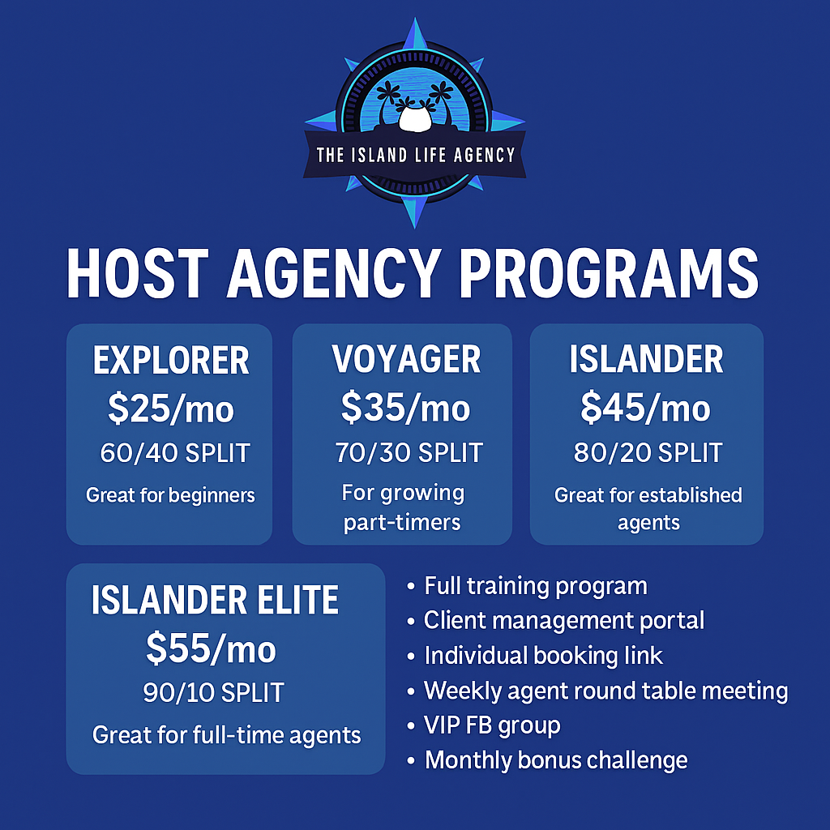

Exclusive Incentives
- Full training and certification Course (included)
- Client Management Portal
-Individual booking link
- Weekly Agent Round table meetings
- Access to VIP FB group
- Legacy leaders: Top earners receive a custom ring & spotlight recognition
- Island Life Retreats: Annual invite-only incentive trip for elite agents
- Monthly Bonus Challenges: Earn perks, coaching, or supplier rewards
- Complete orientation and Mentorship
Get Started
No experience needed - just your passion for travel. Apply now or book a discovery call to see how
We can support your journey
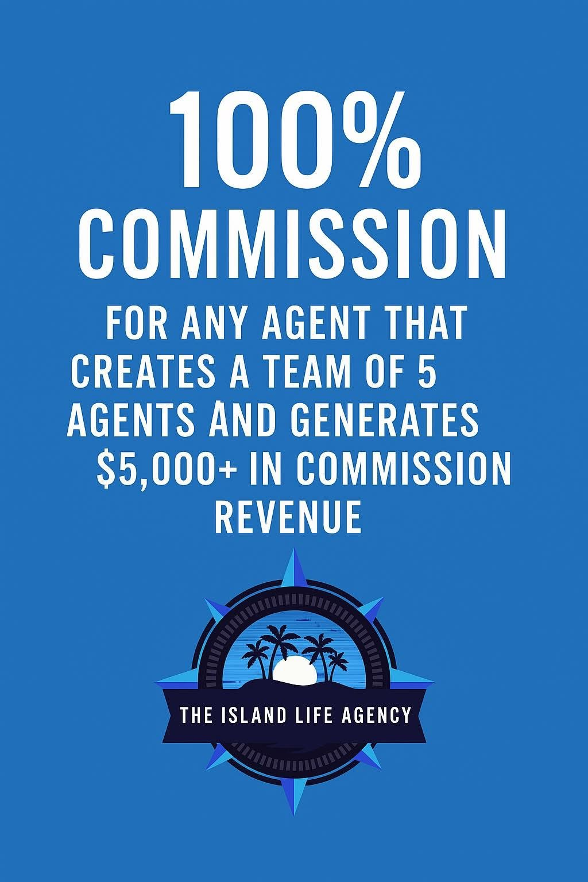
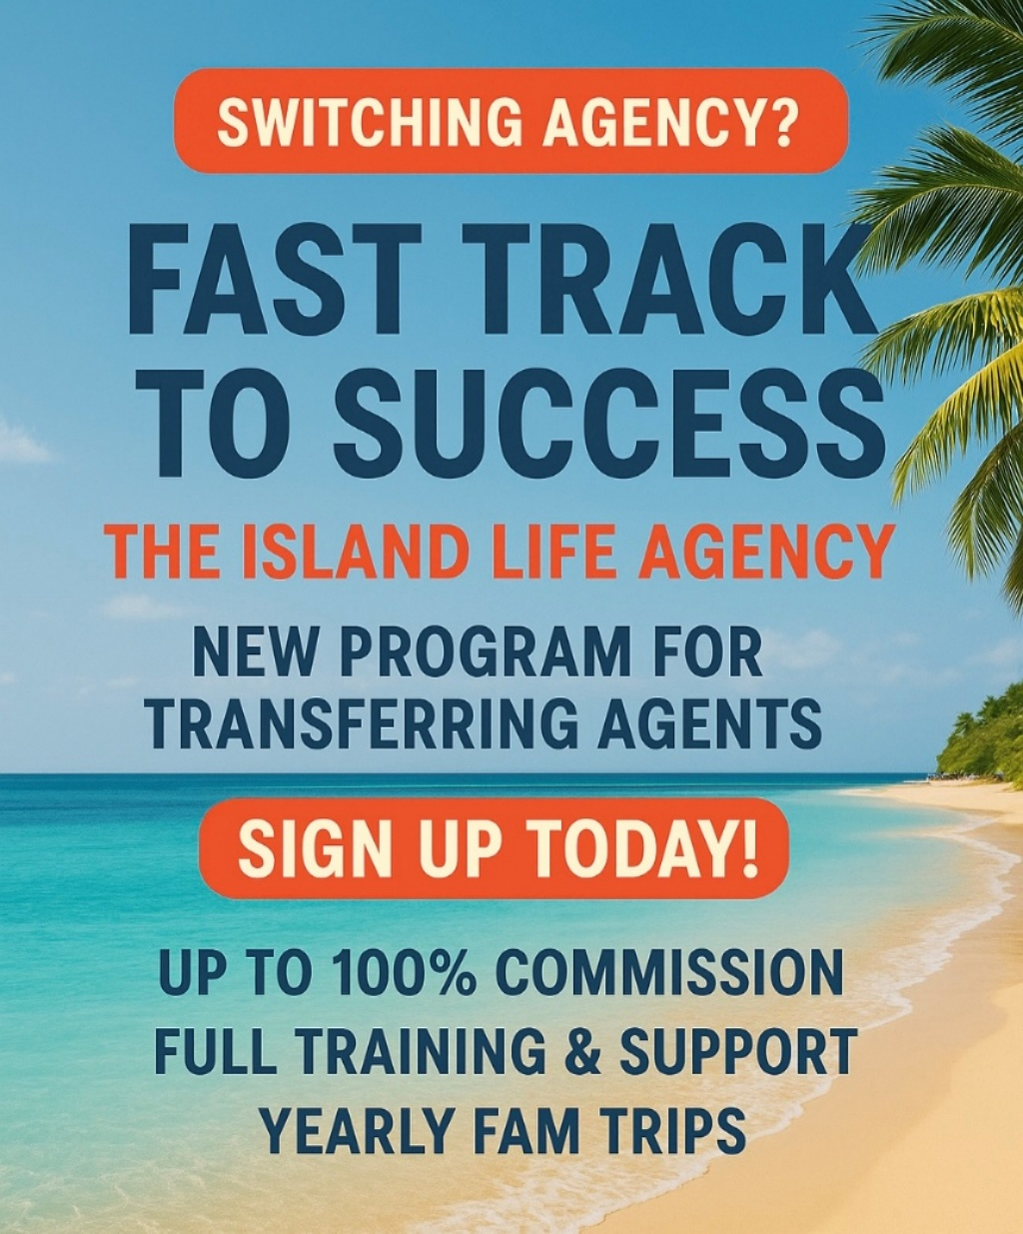

The Island Life Agency – New Agent Onboarding Process

Welcome to The Island Life Agency! We’re excited to have you on board. Below is your step-by-step onboarding guide to get started as a successful travel agent with us.

Step 1: Join Our Team (Pre-Application)

Before official onboarding begins, please visit our website and complete all four steps listed under the “Join Our Team” tab.

Once we receive your application and necessary documents, your onboarding process will begin.

Step 2: Welcome Email

You will receive a Welcome Email that includes:

- Email Setup Options:
  - Use your own travel-dedicated email
  - Or have us create a professional email (@theislandlifeagency.com) for $12.99/month
(Instructions for setup will be included)

- Tax & Banking Information:
Guidance on how to set up your business properly for income and commissions.
- Agency Policies:
A PDF of our agency policy manual to read thoroughly.
- Website Familiarization:
Take time to explore the Travel Agent Portal on our website for tools, resources, and updates.

Step 3: Email Confirmation & CRM Setup

Once your dedicated travel email is active:

- We will create your TESS CRM account.
- You’ll receive login details and instructions for using TESS to manage clients and bookings.

Step 4: Supplier Access & Training

After TESS activation:

- You’ll receive:
  - Self-sign-up supplier links
  - Special request links for suppliers that require agency-created accounts
  - Resort training list for major partners (e.g., Sandals, AMResorts, etc.)
  - Login credentials to access our in-house training program

Step 5: Training Completion & Team Leader Meeting

- Once your training modules are completed, you’ll:
  - Schedule a 1-on-1 Zoom call with your assigned Team Leader
  - Use this session to discuss goals, expectations, and get personalized onboarding support

You’re Now Ready to Sell Travel!

You’re officially ready to book travel, support clients, and live the Island Life! We’re here every step of the way.

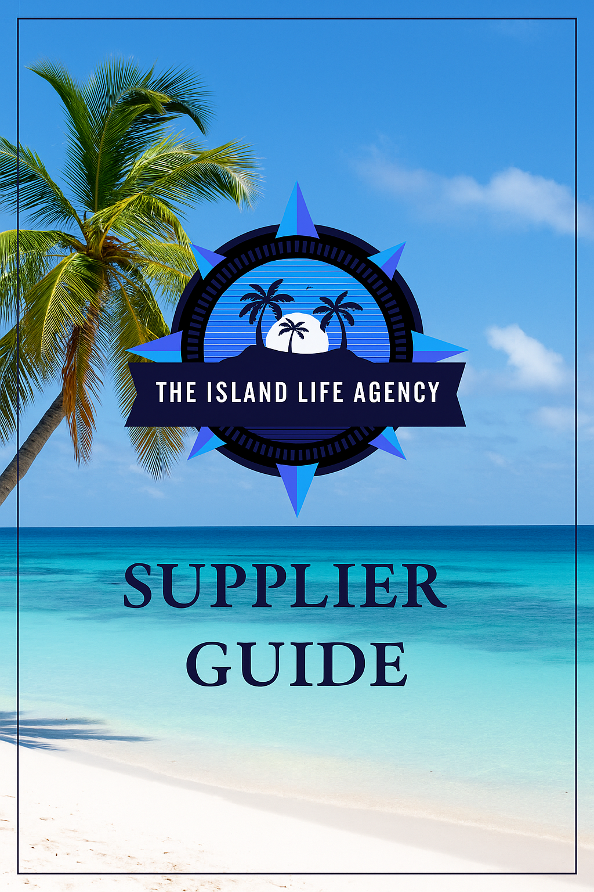
The Island Life Agency Supplier list:

Preferred suppliers: Preferred suppliers are the suppliers we recommend you use first before any other supplier.

Vax – Apple vacation- All-inclusive resorts- domestic travel- Universal- SeaWorld- ect
Vacation express- All-inclusive only
Norwegian cruise line – High end cruise line
Carnival Cruise line – Budget cruise line
Royal Caribbean – Mid budget cruise line
Viator – Excursions
European Express- Europe travel
Avanti – Europe/ international travel
Sandals- High end all inclusive

Preferred All- Inclusive brands resort brands:
Hyatt All-inclusive which includes the following brands:
Hyatt All-Inclusive Resorts
Mexico (46)
- Breathless Cabo San Lucas Resort & Spa –
- Breathless Cancun Soul Resort & Spa –
- Breathless Riviera Cancun Resort & Spa –
- Dreams Acapulco Resort & Spa
- Dreams Aventuras Riviera Maya –
- Dreams Bahia Mita Surf & Spa Resort –
- Dreams Cozumel Resort & Spa –
- Dreams Estrella del Mar Mazatlan (opening soon) –
- Dreams Huatulco Resort & Spa –
- Dreams Jade Resort & Spa –
- Dreams Los Cabos Suites Golf Resort & Spa –
- Dreams Natura Resort & Spa–
- Dreams Playa Mujeres Golf & Spa Resort –
- Dreams Riviera Cancun Resort & Spa –
- Dreams Sands Cancun Resort & Spa –
- Dreams Sapphire Resort & Spa –
- Dreams Tulum Resort & Spa–
- Dreams Vista Cancun Golf & Spa Resort –
- Dreams Vallarta Bay Resort & Spa –
- Impression by Secrets Isla Mujeres –
- Impression bv Secrets Moxché –
- Hyatt Zilara Cancun –
- Hyatt Zilara Riviera Maya–
- Hyatt Ziva Cancun –
- Hyatt Ziva Los Cabos –
- Hyatt Ziva Puerto Vallarta – Category D
- Hyatt Ziva Riviera Cancun –
- Now Emerald Resort & Spa (closed and rebranding as Secrets) –
- Secrets Akumal Riviera Maya –
- Secrets Aura Cozumel –
- Secrets Bahia Mita Surf & Spa Resort –
- Secrets Huatulco Resort & Spa –
- Secrets Maroma Beach Riviera Cancun –
- Secrets Moxché Playa del Carmen –
- Secrets Playa Blanca Costa Mujeres –
- Secrets Playa Mujeres Golf & Spa Resort –
- Secrets Puerto Los Cabos Golf & Spa Resort –
- Secrets Riviera Cancun Resort & Spa –
- Secrets Tulum Resort and Beach Club –
- Secrets The Vine Cancun -
- Secrets Vallarta Bay Puerto Vallarta
- Zoëtry Casa del Mar Los Cabos -
- Zoëtry Villa Rolandi Isla Mujeres -
Costa Rica (2)
- Dreams Las Mareas Costa Rica —
- Secrets Papagayo Costa Rica —
Curaçao (3)
- Dreams Curaçao Resort, Spa & Casino —
- Sunscape Curaçao Resort, Spa & Casino —
- Zoëtry Curaçao Resort, Spa & Casino —
Dominican Republic (15)
- Breathless Punta Cana Resort & Spa
- Dreams Dominicus La Romana
- Dreams Flora Resort and Spa
- Dreams Macao Beach Punta Cana
- Dreams Onyx Resort & Spa
- Dreams Royal Beach Punta Cana
- Hyatt Zilara Cap Cana
- Hyatt Ziva Cap Cana
- Secrets Cap Cana Resort & Spa
- Secrets Royal Beach Punta Cana
- Secrets Tides Punta Cana
- Sunscape Coco Dominican Republic
- Sunscape Dominicus La Romana Dominican Republic —
- Sunscape Puerto Plata Dominican Republic —
- Zoëtry Agua Punta Cana —
Jamaica (6)
- Breathless Montego Bay Resort & Spa —
- Hyatt Zilara Rose Hall— Category E

Velas Resorts
The Velas Resorts collection includes the following luxury all-inclusive resorts and boutique hotels located in Mexico’s most beautiful destinations:
- Grand Velas Riviera Nayarit
- Velas Vallarta
- Casa Velas
- Grand Velas Riviera Maya
- Grand Velas Los Cabos
Sandals Resorts Locations
- Sandals Grande St. Lucian - Gros-Islet, Saint Lucia
- Sandals Grenada - St. George’s, Grenada
- Sandals Royal Barbados - St. Lawrence Gap, Barbados
- Sandals Royal Caribbean - Montego Bay, Jamaica
- Sandals Negril - Negril, Jamaica
- Sandals Montego Bay - Montego Bay, Jamaica
- Sandals South Coast - Whitehouse, Jamaica
- Sandals Ochi Beach Resort - Ocho Rios, Jamaica
- Sandals Regency La Toc - Castries, Saint Lucia
- Sandals Halcyon Beach - Castries, Saint Lucia
- Sandals Emerald Bay (currently closed for renovations) - Great Exuma, The Bahamas
- Beaches Turks & Caicos Resort Villages & Spa - Providenciales, Turks and Caicos Islands
- Beaches Negril Resort & Spa - Negril, Jamaica
- Beaches Ocho Rios Resort & Golf Club - Ocho Rios, Jamaica

Complete Supplier List:

To sign up for any self- Sign- up- Supplier
You must use the following information, along with your personal information:
The Island Life Agency
105 valley lane
Horseheads NY 14845
Phone Number- 6072155068
IATA – 99907732
CLIA- 00045834

Please note we are an independent host agency and do NOT work with a consortium.

Self – Sign – Up Suppliers- Please use the agency information above to sign up for the following suppliers:
Expedia TAAP account:
• Go to https://www.expediataap.com/TAAP-Agent?key=90eb498d-46a1-4cff957f-2c08b6b6bd5a
• Create an Expedia TAAP account
• Start booking!
• True Code- 99907732

Authentic vacations
Sign up at the link below
https://www.authenticvacations.com/travel-advisors/#signup

Resorts for a day
https://www.resortforaday.com/travel-agents/

Project expedition
https://www.projectexpedition.com/partners/?code=99907732&code_type=TRUE

Virgin voyages https://www.firstmates.com/s/login/?ec=302&startURL=%2Fs%2F

Beds online
https://discover.bedsonline.com/en-na/register-your-travelagency?utm_source=google&utm_medium=searchppc&utm_campaign=americas_ww_nca_acquisition2022&gad_source=1&gclid=CjwKCAiA2pyuBhBKEiwApLaIOwCfMtPjLwT7aUDnMo
LbWAHZWwNSwbKWYvGhjxHI3qMQ68aS1g__ghoCUVQQAvD_BwE#section1

Europe express- https://www.europeexpress.com/EmailApp/register-agencies.aspx

Exotica travel
https://www.exoticca.com/us/travel-advisor

Cruising power- https://secure.cruisingpower.com

Carnival cruise
https://www.goccl.com/

Avanti- https://book.avantidestinations.com/agentregistration

Viator- https://partners.viator.com/signup/with-invite/32017535-33ef-4f8c-a466-79467a905765

Viking cruise - https://www.myvikingjourney.com/Agent/CreateAccount

Supplier Accounts that need to be Created for you.
To have an account made- Please click the link below and select the supplier
account you need:
https://form.jotform.com/The_Island/supplier-registration-

Vacation express- Account will be created.
https://www.vacationexpress.com/

Princess cruise - Account will be created.
https://www.onesourcecruises.com/onesource/login

Norwegian- Account will be created.
https://sso.ncl.com/secureauth1/?SAMLRequest=jZFNb8IwDIbv%2BxVV7umXqhF
FtIhtQkNiWgVlh93S4EKk1mFxyvbzxwrVOE07Wnr92H48nX11bXACR8ZizpIwZgGgtju
D%2B5xtqwUXbFbcTUl17VHOe3%2FANXz0QD6YE4Hz57ZHi9R34DbgTkbDdr3K2c
H7I8koQus%2BYW8UakDvVBuibkNtu2gAtv3eYKQ0sWBhnYaBn7NGtQQsWD7lTKS
TeqKF5kldC541DfAaRM2bOFMZiB3UO3FOUqmIzAl%2Be4l6WCJ5hT5naZxmPL7na
VwlmcwymYhwkmTvLCid9Vbb9sHg5eTeobSKDElUHZD0Wm7mLyuZhrGsLyGSz1V
V8vJ1U7HgbVSX%2Fqg7y0SSw21%2Fo47Xuay4qh0Wdv8HqNE%2BK0bXRHbUO41
uqcVY3v6v%2BAY%3D&RelayState=%2F&cid=

Sandals- Account will be created.
https://taportal.sandals.com/landing/

Vax - Account will be created.
https://www.vaxvacationaccess.com/

MSC cruises - https://www.mscbook.com/pages/sdl/gl_en/select-country.html

Margaritaville cruises- https://bahamasparadise.gage.com/

Additional resources:
Travel Agent rates/ Resort supplier information:
https://www.spoiledagent.com/

Become a destination/ resort specialist

Resorts -

Hyatt all-inclusive collection

https://www.hyattinclusivecollection.com/en/travel-advisors/

Palace Resorts

https://www.palaceproagents.com/

Couple resorts

https://www.taconnect.net/rewards/couples

Excellence resorts

https://www.theexcellencecollection.com/affiliate-travel-professionals/

Caesars Resorts

https://www.caesarstravelpartners.com/

Destinations -

Hawaii

https://www.google.com/search?q=hawaii+travel+specialt&ie=UTF-8&oe=UTF-8&hl=en-us&client=safari

Disney

https://www.disneytravelagents.com/

Universal studios

https://www.universalpartnercommunity.com/s/login/SelfRegister?language=en_US

Jamaica

https://www.oneloverewards.com/

Bahamas

https://www.bahamas.com/travel-agents

United States Virgin Islands

https://www.visitusvi.com/travel-agents

Las Vegas

https://www.visitlasvegas.com/travel-professionals/

Australia

https://www.aussiespecialist.com/en-us

Cruise lines -

Carnival Cruise

https://www.goccl.com/

Princess cruise

https://www.onesourcecruises.com/onesource/login

Virgin voyage

https://www.firstmates.com/s/

Understanding All-Inclusive Resorts: Regular Rooms vs. Preferred Level Rooms
All-inclusive resorts are designed to provide guests with a seamless vacation experience, where accommodation, meals, drinks, and various activities are included in the price of the stay. However, within these resorts, there are often different tiers or levels of accommodations that offer varying degrees of luxury and exclusivity. This explanation will focus on how regular rooms compare to preferred level rooms at popular all-inclusive resort chains like Sandals, Secrets, Dreams, and Barceló.
1. Room Categories Explained
At many all-inclusive resorts, including those mentioned:
- Regular Rooms: These are typically the standard accommodation offered by the resort. They provide essential amenities such as comfortable beds, private bathrooms, and basic furnishings. While they may have views or locations that vary (e.g., garden view vs. ocean view), they generally do not include additional perks or services.
- Preferred Level Rooms: These rooms represent an upgraded category within the resort’s offerings. Guests who book preferred level accommodations often enjoy enhanced amenities and services compared to regular rooms. This can include:
  - Better Locations: Preferred level rooms may be situated in more desirable areas of the resort (e.g., closer to the beach or main facilities).
  - Upgraded Amenities: These rooms might feature higher-quality furnishings, larger spaces, or additional features like private balconies or swim-out pools.
  - Exclusive Access: Guests in preferred rooms often receive access to exclusive lounges or areas within the resort that are not available to regular room guests.
  - Enhanced Services: This can include concierge services that assist with reservations for dining or activities and priority check-in/check-out processes.

2. Specific Resort Examples
- Sandals Resorts: Sandals offer several tiers such as Luxury Included® (standard) and Club Level (preferred). Club Level guests benefit from personalized service and access to a private lounge with complimentary snacks and beverages.
- Secrets Resorts: Secrets has a “Preferred Club” option which provides guests with upgraded suites featuring better views and exclusive access to private pools and lounges.
- Dreams Resorts: Like Secrets, Dreams offers a “Preferred Club” that includes benefits like upgraded room categories and exclusive dining options.
- Barceló Resorts: Barceló categorizes its offerings into Luxury and Premium levels. The Premium level typically includes more luxurious accommodation along with additional services such as premium drinks at bars.
3. Pricing Structure
The pricing for preferred level rooms is generally higher than for regular rooms due to the added benefits provided. When booking travel packages for clients, it’s important for agents to communicate these differences clearly so clients understand what they are paying for:
- Regular room rates will be lower but come with fewer amenities.
- Preferred level rates reflect the added value of enhanced experiences.
Clients should weigh their preferences for luxury against their budget when deciding between these options.

Client Reservation Management Portal

At our travel agency, we use TESS (Travel eSolutions Software) as our client reservation and commission management system.

TESS is a powerful platform that allows us to efficiently organize bookings, track payments, and manage client information all in one place. It’s essential that all reservations are entered accurately and kept up to date—this includes correct travel dates, client details, and payment status.

Not only does this ensure a smooth experience for your clients, but it also directly impacts your commission. TESS is how we track and calculate what you’re owed, so if information is missing or entered incorrectly, it could delay or prevent payment. Using TESS properly helps us maintain accuracy, accountability, and timely compensation for your work.

TESS TRAINING VIDEOS-
Intro to TESS

https://youtu.be/soACPsKTXjo?si=NLSarjKYitENwlao

Client portal

https://youtu.be/lc22xFp4-gU?si=i_B--vXNui0Wsurd

proposals and Itineraries

https://youtu.be/gJnljHGisz0?si=AVWyL0Vyry5tfYFf

Team Lead Bonus Program
The Team Lead Bonus Program is The Island Life Agency's elite path for agents ready to lead, recruit, and grow thriving travel teams. This is more than just a title - it's your gateway to greater income, leadership recognition, and long-term impact in the travel industry.

Enrollment Requirements
- $200 one-time enrollment fee
- Active CLIA membership (yearly)
- Registered business with business bank account
- $59.99/month leadership program fee
- Must remain in good standing with the agency

Earnings & Incentives
- 100% commission on all personal bookings
- 10% Profit share on your team's total monthly commission revenue
- Legacy Leadership Status at $50,000+ in team revenue
- Opportunities to host supplier webinars and lead team retreats
- Free access to TBO holiday
Program Benefits
- Full earnings on your own sales

Host Program Overview
- Passive income from team production
- Custom team portal and onboarding support
- Legacy Leader spotlight & recognition
- Priority access to exclusive perks and FAM trips

Who Should Join
The Team Lead Bonus Program is for agents with vision - those ready to lead with heart, grow with purpose, and inspire others in the travel industry

The Island Life Agency - FAM Trips 2025-2026
Majestic Elegance Costa Mujeres
Dates: July 10-14, 2025
Cost: $360 pp
Extras: $175 for transfer and excursions - Catamaran to Isla Mujeres
Puerto Vallarta (Dia de Los Muertos)
Dates: November 1-5, 2025
Cost: $680 pp
Extras: $30 Sea Turtle Release and $25 to Yelapa
Ireland
Dates: May 6-12, 2026
Cost: $1350 pp
Scotland
Dates: May 12-15, 2026
Cost: $550 pp
Norwegian Cruise
Dates: November 8-13, 2026
Cost: Prices depend on cabin type

FAM Trip Rules & Etiquette:
- *You May bring (1) person that is not an agent with you at the same price*
- All prices are based on double occupancy.
- *Airfare is not included
- *All agents MUST attend our site tours- They are mandatory to attend to receive the discounted rate*
- Please come prepared with a positive attitude and willingness to learn.
- Please be willing to collaborate and work together with fellow travel agents on your FAM trip.
- Do not be late for scheduled events. When one person is late it holds events for the entire FAM trip and causes issues for our vendors and operations departments.
- You will be required to attend all scheduled events unless prior permission has been granted.
- Come prepared and dress appropriately and professionally. Dress codes will be sent for each FAM.
- Do not discuss with other guests what you paid for your stay.
- Do not ask guests to book travel with you.
- Please do not stray from our group when on-site inspections. Ample time will be given for photographs and questions.
- Be courteous while on-site inspections. Do not sit on beds or chairs, deposit anything into garbage cans or use any bathrooms while inspecting a property.
- Please be respectful and courteous to our hosts and resort staff.
- Tipping – Tips are not included and are highly suggested.
- Do not show up to any scheduled events intoxicated, you will be sent home at your own expense and barred from attending any further FAMs or events.

The Island Life Agency - Monthly Sales Challenge Calendar
July 2025 - June 2026

July 2025 Challenge: Most Group Bookings
Prize: $150 Bonus Commission
Theme: Jumpstart July - Group Getaways Galore!
August 2025 Challenge: Most Cruise Bookings
Prize: $100 Bonus Commission
Theme: Anchors Away August!
September 2025 Challenge: Most New Clients Booked
Prize: $75 Amazon Gift Card
Theme: September Sweep - Expand the Family!
October 2025 Challenge: Most Honeymoon or Romance Bookings
Prize: $100 Spa Gift Card
Theme: Love in the Air October!
November 2025 Challenge: Highest Total Sales Volume
Prize: $200 Bonus Commission
Theme: Thankful for Travel - Top Seller Showdown!

December 2025 Challenge: Most Winter Escape Bookings
(travel dates: Dec-Feb) Prize: $100 Bonus Commission + Tropical Swag Bag Theme: Sleigh the Winter Sales!
January 2026 Challenge: Most Caribbean Packages Sold
Prize: 2-night Hotel Stay (select destinations
) Theme: Caribbean Countdown!
February 2026 Challenge: Most Repeat Client Bookings
Prize: $100 Bonus Commission
Theme: Loyalty Love Month!
March 2026 Challenge: Most Spring Break Trips Booked (for March/April travel) Prize: $125 Visa Gift Card
Theme: Spring Break Blitz!
April 2026 Challenge: Most Social Media Engagements Leading to Inquiries
Prize: $100 Bonus + Social Media Spotlight Feature
Theme: April Amplify - Promote and Prosper!
May 2026 Challenge: Most Travel Insurance Add-ons
Prize: $75 Bonus Commission
Theme: Protect and Prosper May!
June 2026 Challenge: Most Upsell Packages (room upgrades, excursions, etc.) Prize: $150 Bonus Commission
Theme: Max Out June!

Agency Policies
Commission Policy
Overview of Commission Structure
The commission amount varies based on the resort and supplier involved in the booking process. Agents can expect commission rates to range from 10% to 20%, depending on these factors.
Payment Schedule
It is important to note that commissions are not disbursed until the client has completed their travel. This ensures that all services rendered are fulfilled before any financial compensation is allocated to agents.
Viator Bookings Update
Effective August 1st, 2024, all bookings made through Viator will be compensated at a rate of 100% for agents who achieve over 70% commission. It is crucial to understand that no other commissions will be paid out at this full rate.
Booking Entry Requirements
To ensure timely processing and payment of commissions, all bookings must be entered into the system within 48 hours of deposit. Failure to adhere to this timeline may result in delayed payments or forfeiture of commission.
Payment Updates Responsibility
Agents are responsible for updating payment information accurately. If payment updates are not made, agents will not receive their due commission for those bookings.
Agency Transition Protocols
In the event an agent decides to leave the agency while having active bookings, it is essential to note that the agency will assume control over these bookings. Consequently, agents will not receive any commission for these transferred bookings.
If Agency Administrators must input final payments on behalf of an agent, there will be a reduction in commission to 50%, reflecting the additional administrative work required.
Correct Booking Entry Requirement
To qualify for commission, it is imperative that all bookings are entered correctly in TESS (Travel Event Support System). Any inaccuracies in entry may lead to non-payment of commissions.
Commission Reduction Policy
Agents are strictly prohibited from reducing commissions on any vendor package under any circumstances. This policy maintains consistency and fairness across all transactions.
Gross Rate Payment Requirement
All bookings must be processed using the gross rate. Any booking made with a net rate will not qualify for commission, and agents will also bear responsibility for remitting the percentage owed to our agency.
Commission payments are disbursed on a biweekly basis. Please note that the processing of these payments may take up to 30 days from the end of the commission period
By adhering to these guidelines, we can ensure a smooth and efficient process regarding commission payments and maintain a professional standard within our agency operations.

Quote Policy
Free quotes:
We will provide FREE quotes for the following
*Up to 3 destinations
*Up to 6 quotes
Any quotes beyond the 6 quotes or additional destinations beyond the 3 will need to pay a research fee of $25.
Link will be available on our website for clients to pay.
Agents will receive the $25 for their clients *processing fees may apply
This change will be added to our jot form, so clients are aware.
In Addition:
Destinations weddings: will now have $300 research fee
This fee will need to be paid before research begins
Groups of more than 10 people will have a $150 research fee that will need to be paid before quotes are sent

ADD On services:

