Project Title

An investigation into the effect that being in a relationship has on a student’s academic performance, depending on their gender.

Introduction

Table of Contents
Project Title 1
Introduction 2
Method of Data Collection 3
Presentation of Data 4
Analysis of Data 8
Discussion of Findings 9
Conclusion 10
References 11
Appendix 12

Parents and teachers normally frown on their children or students dating or being involved in a romantic relationship citing that it would be a distraction for the student. This they say would “bring down their grades”.
However in stark contradiction to this the boy who places first in my class is on his fifth girlfriend for the year. As a CSEC Mathematics student I know that this one anecdotal piece of evidence doesn’t statistically mean being in many relationship results in good grades.

The purpose of this project is to look for and analyze patterns between being in a relationship and a form five student’s average academic performance. Additionally any difference in performance with respect to student gender will also be investigated.

Method of Data Collection

A questionnaire was created and handed out to form five students in my school. Data was captured from fifty (50) form five students. Twenty-five (25) of the participants were male and the other half female.

In addition permission was granted by the form five form teachers to peruse the Academic Records of participating students for the year 2018.

Presentation of Data

After the raw data was collected from the questionnaires and records the information was arranged into tables as follows:

Table 1: Average Percentage of Female Student
Table 2: Average Percentage of Male Student
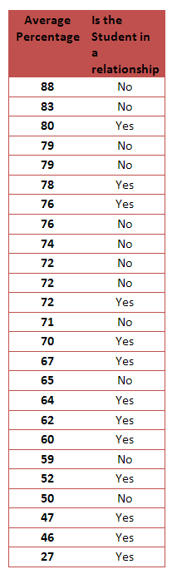
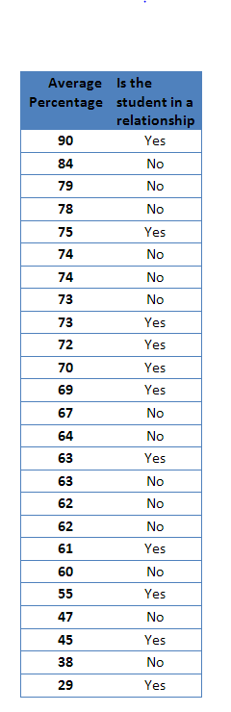
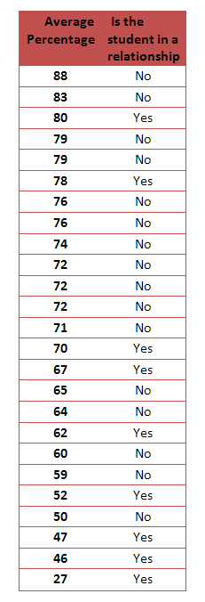

Average mark of a Boy NOT in a relationship
$$= \left(Sum of marks for boys NOT in relationships\right)÷ number of boys counted \\ =1027÷14 \\ =66.1 \%$$

Average mark of a Boy in a relationship
$$= \left(Sum of marks for boys in a relationship\right)÷ number of boys counted \\ =704÷11 \\ =64 \%$$

Average mark of a Girl NOT in a relationship
$$= \left(Sum of marks of girls NOT in relationships\right)÷ number of girls counted \\ =870÷12 \\ =72.5 \%$$

Average mark of a Girl in a relationship
$$= \left(Sum of marks of girls in relationships\right)÷ number ofgirls counted \\ =767÷13 \\ =59 \%$$

Comparative Bar Graph 1 - Average percentages of students depending on relationship status

Further information from the questionnaires was tabulated as follows:

Table 3: Number of Relationships Compared to Percentage of Student
Number of Relationships | Percentage
6 | 90
1 | 80
1 | 78
2 | 77
3 | 76
1 | 73
2 | 72
4 | 72
3 | 70
1 | 70
2 | 69
1 | 66
1 | 63
1 | 61
1 | 61
6 | 61
2 | 59
4 | 55
6 | 48
1 | 45
7 | 41
2 | 30
9 | 29
1 | 25

Note. Students who were not in a relationship have been excluded from this table.

Information from Table three was converted to an X-Y graph using a scatter plot method and the Trending Line Included.

Graph 1 : Scatter Plot of Student Percentage against Number of Relationships

Gradient of Trending Line in above graph

Using points (1, 65) and (9, 48)
$$Gradient=\frac{y_{2}-y_{1}}{x_{2}-x_{1}}$$

$$Gradient=\frac{48-65}{9-1}$$

$$Gradient=\frac{-17}{8}$$
$$Gradient=-2.125$$

Analysis of Data

From Table One and Table Two it was seen that the data represented a wide range of percentages.
Range in Table One = 88 −29 = 59 %
Range in Table Two = 90 − 27 = 63 %

In the Comparative Bar Graph there is a noticeable difference in the performance of students who were in a relationship during exams versus those who were not.

Boys in a relationship average 64% in exams but average 66.1% if they are not in a relationship. This is a 2.1% increase in Marks.
Girls in a relationship average 59% in exams but average 72.5% if they are not in a relationship. This is a 13.5% increase in Marks.
On average the grades of girls fall by 11.4 more marks than boys when they enter into relationships.

Table Three lists the number of relationships the students who said yes had already been in and shows their corresponding averages in the exam. Graph 1 uses this information to form a trending line between percentages and number of relationships which displayed a negative gradient which was -2.125.

Discussion of Findings

The wide range of data received from the survey suggests that the sample size is adequate for appropriate conclusions to be drawn from the Presentation of Data.
The claim by Teachers and Parents that being in a relationship can have a negative effect on your grades was proven true by this project. Although there were some outliers in the survey the average drops for both boys and girls in a relationship by 2.1% and 13.5% respectively. Girls do. The data revealed that girls perform better than boys on average however when they enter into relationships their grades fall by an 11.4% more than boys.

In addition, from the analysis, a gradient of 2.125% was found in a graph of percentage against number of relationships. This means that for every additional relationship a student has their percentage, by statistical average, drops by 2.125 %.

Conclusion

This research shows that the claim that a student’s percentage falls when entering into a relationship is valid for Form Five Students of my school. The drop in percentage is 2.1% for boys and 13.5% for girls. Exam marks for girls are more negatively affected (11.4%) than boys when in a relationship. Additionally in this investigation there was a fall of 2.125 % in exams for every additional relationship a student had.

References

Steele, Glendon, The Essential Mathematics SBA Handbook: A guide for CSEC examination.
Genesis Books.

Subscribe to Kerwin Springer
www.youtube.com
For more Maths, Chemistry and Physics help

Appendix

Questionnaire (Form Five SBA)
Information on this short survey will be kept anonymous… Please answer all questions correctly to the best of your ability.

- What form are you in?
- Have you been in a relationship during the past exam?
- How many relationships have you been in?
- What was the average percentage for your last exam?

DISCLAIMER:
This project was created for resource purposes only. While I love to help students I don’t want you to “short-change” the learning experience by plagiarizing my work wholesale. Enjoy responsibly.

Subscribe to my YouTube channel for more EPIC and VITAL help on a variety of topics and issues facing students!

Kerwin Springer.

