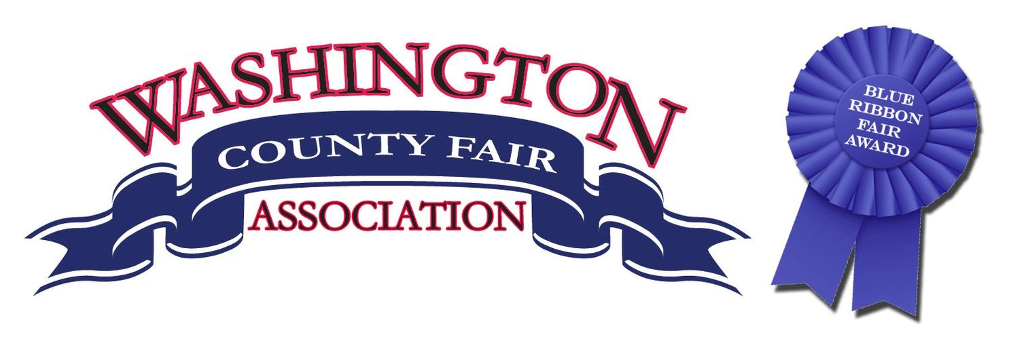

Motocross Rules

- All contestants must sign a liability waiver. A parent must sign if contestant is under 18 years of age.
- The Washington County Fair is not responsible for any injuries or medical bills as a result of being a contestant in this race.
- The Washington County Fair Board has the right to alter the class that a contestant is placed in based on their ability and experience.
- Washington County Fair Board has the right to cancel a class if there is only one entry.
- Contestants are not allowed to consume alcohol prior to the race.
- No fighting.
- All Quad A and B riders must have a tether kill switch on their quad. We highly recommend that Quad C riders have a tether kill switch on their quad.
- Rough riding in the pit area will not be tolerated.
- All contestants must wear helmets.
10.All decisions made by the Washington County Fair Board are final.
11.All contestants must have legible numbers on their bikes or quads. Quad numbers must be on the side or back.

