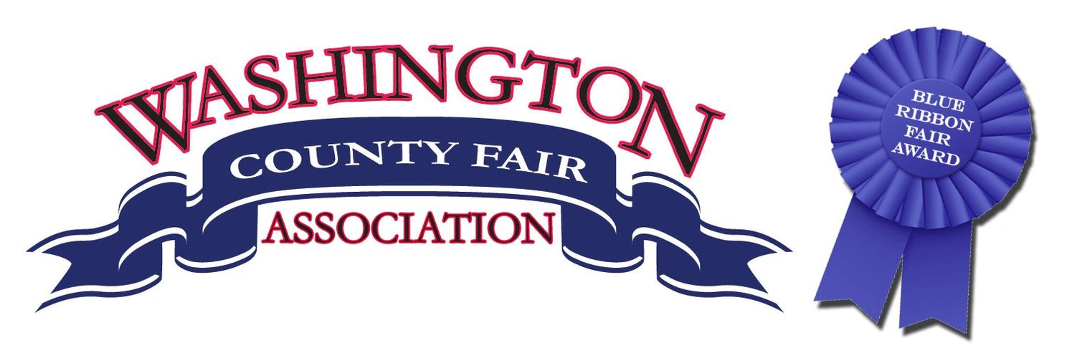

Motocross
Friday July 22,2022
Cash Classes No AMA Card Required
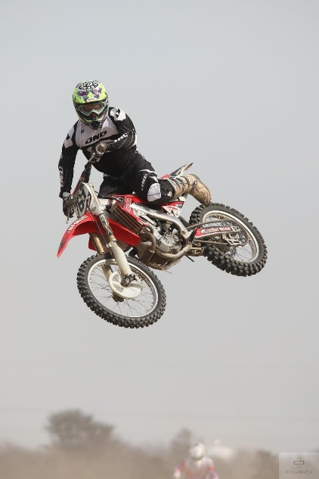
Open A Guaranteed Pro Payout
250A 611 Hwy 1 South
Quad A Washington, Iowa
16-24A
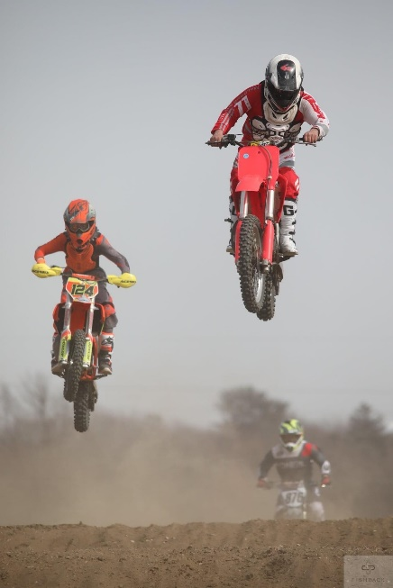
+25A
+30A
+40A

Trophy Classes
Open B
Open C
250B
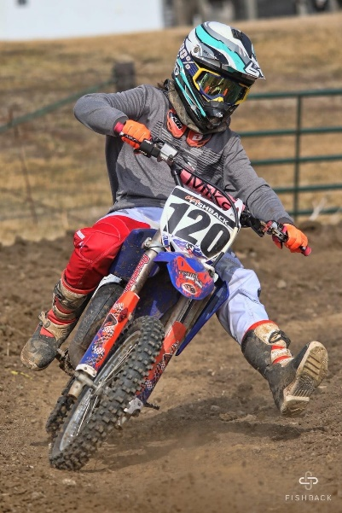
250C
85SR
85JR
65SR
65JR
50SR
50JR

Quad B Rider Sign Up 4-6pm
Quad C Practice 6pm
Quad 50cc Race Start 7pm
Quad 90cc Entry Fee $30.00
Quad 50cc Beginner 50cc $25.00
Quad 90cc Beginner
Admission $10.00
Utility 4 Wheelers 100-900cc must by 16 YOA 10 and under Free

Contact Information: Nick Shelman 319-653-1821
www.washingtoncountyfairia.com

