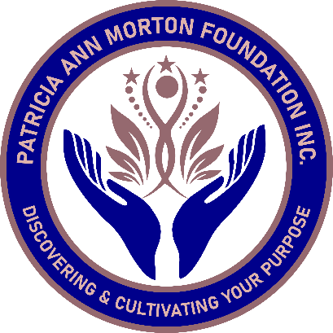
The Doris Fay Nobles Smithwick Scholarship Application
The Doris F. Nobles Smithwick scholarship will assist in paying for support to help you find your purpose in life. I.e., Life Coach, Counselor or Therapist.

Name: _______________________________________________________________________

Address: _____________________________________________________________________

Email: _______________________________________________________________________

Phone: ______________________________________________________________________

In 50 words or less please tell us how this scholarship will make an impact in your life:
______________________________________________________________________________________________________________________________________________________________________________________________________________________________________________________________________________________________________________________________________________________________________________________________________

Patricia Ann Morton Foundation Inc.
1290 E. Arlington Blvd. Suite 141 Greenville, NC 27858
www.pamfoundationinc.org
pamfoundationinc@gmail.com

