Blue Skies Health and Wellbeing
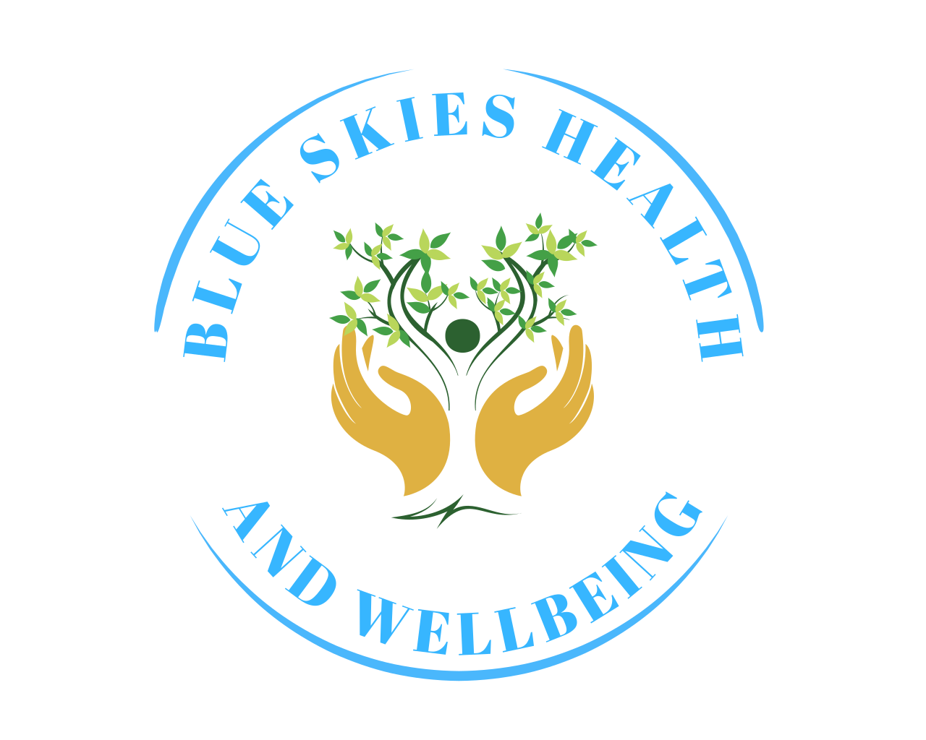

13 Dukes Rd
Fontwell
BN18 0SP
07974937577

Terms of Agreement

Congratulations on choosing to invest in you! This is your opportunity to take control of your health and wellbeing and understand how to look after your body. It is the only place you have to live!

We will work together to understand the root cause of your symptoms, how your mind and body works as a whole and create a plan to empower you to live the best life you can.

Our Agreement:

Initial 20-minute discovery call to determine if nutritional therapy is right for you and ascertain what you would like to achieve.

Initial Consultation:
A 90-minute in-depth holistic health consultation. We will discuss what concerns you have with your health and what you would like to achieve. We will assess all your body systems, family and personal health history and lifestyle, particularly sleep, stress management and movement and a physical examination of appropriate.

We will create a plan including nutrition, lifestyle, testing and supplements that will support you in achieving your goals. We will arrange follow-up if necessary to review results and your progression. There is no obligation to book a follow-up consultation although ongoing input often improves outcomes.

You will receive a written copy of our consultation and plan plus any informational handouts that will support you in achieving your goals.

You will receive a complementary 20 minute catch up call a week after receiving the written information to discuss if there are any significant issues or specific questions having instigated the plan.

Expectation:
Our relationship is completely confidential and an opportunity for you to reflect on your life. The more open and honest you are the more successful the outcomes. I am a non-judgemental resource for you to help guide through this journey, however, results cannot be guaranteed. You are entering into this process with the understanding that you are responsible for creating your results and this is an opportunity to empower you to take control of your own health and wellbeing.

Cancellation policy
If you need to cancel your appointment, please ensure it is at least 72 hours prior to the appointment otherwise the full consultation fee will be applicable.
If it is mutually agreed to terminate the programme before completion of all the sessions, any fees for unused services with be refunded to the client.

I, the undersigned, declare that I have read and understood the information presented above. I understand that I may withdraw this consent at any time.

_____________________________ __________________________
Client Name (Print) Date

_____________________________ __________________________
Client Signature Alex Hurd Blue Skies Health and Wellbeing

