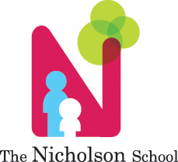

Snack Guidelines

We are a NUT FREE school!

All snacks must be NUT free, INDIVIDUALLY PACKAGED WITH the ingredient label available.

Examples: individual packages of goldfish, graham crackers, pretzels, pirate booty, raisins, applesauce

NO: Baked Goods, sweets (cupcakes, cookies, etc.) or open snacks!

Daily Snack Menu

* Each snack MUST include a bread or bread alternative (goldfish, pirate booty, pretzel etc.), ***OR*** a Milk alternative (Cheese stick, cheese spread on fruit, yogurt) **AND** a 100% fruit option (raisins, applesauce, dried fruit) and a beverage (usually water). 100% Fruit juice counts as a fruit option but is not encouraged by staff

EXAMPLES: Pretzels, raisins and water

    Goldfish, dried fruit and water

    Cheese stick, fruit juice

* Nutrigrain Bars DO NOT count as a fruit option
* Record the snack menu on the snack calendar by week
* Menu is supposed to be filled out at least a week in advance, and may be changed if menu changes
* Monthly menu must be posted and available to parents