+

Tennessee Elks Association

Convention Manual

Policies set by the Board of Directors and approved by the membership for
ANNUAL, MID-YEAR, and GRAND LODGE MEETINGS

Please address suggestions and amendments to the Tennessee Elks Association State Secretary

Table of Contents
Purpose and Use of the Convention Manual 4
TEA Annual Meeting: General Format 4
Location 4
Overview of Schedule 4
Hospitality Room 6
TEA Mid-Year Meeting: General Format 6
Location 6
Purpose 6
Overview of the Schedule 6
GENERAL INFORMATION 8
Solicitation of Funds 8
Local Convention Chairman 8
Duties of the Local Host Chairman 8
Expenses 8
Complimentary Rooms 8
Registration Fees 9
Flowers 9
Gifts 9
Awards 9
Local Lodge Activities and Program Expenses 9
Transportation 10
Hospitality Room 10
Room Guarantees 10
Refunds of Registration Fees 10
Accounting 10
Profit/Loss 11
Registration Procedures 11
Grand Lodge Convention 14
Donations 14
Finances 14
Operation 14
Business Session 14
Hospitality Room Coordinator 15
Bartenders 15
Recap 15
SUMMER BOARD MEETING 15
Facilities 16
Appendices 17
Appendix A: Annual Meeting Facility Requirements 18
Appendix B: Annual Meeting Agenda 20
Appendix C: Annual Meeting Awards and Benevolent Night Dinner Format 23
Appendix D: Grand Exalted Ruler Banquet Agenda 24
Appendix E: Complimentary (Comp) Room Guidelines 25
Appendix F: Registration Letter and Form Examples 26
Appendix G: Seating Chart Guidelines for Annual Meeting 29
Appendix H: Seating Chart Guidelines for Mid-Year Meeting 31
Appendix I: Mid-Year Meeting Facility Requirements 33
Appendix J: Agenda for the Mid-Year Meeting 34
Appendix K: Election Procedures for Contested Offices and Credentials Committee 37
Appendix L: Hospitality Room Policy 38
Appendix M: Preconvention Meeting Outline 39

Purpose and Use of the Convention Manual

Many of the activities of Tennessee Elks Association (TEA) occur annually; additionally, many of the elected leaders and appointed committee chairs serve a single 12-month term. Because of this, there may be questions regarding the activities associated with the annual events, the applicable acceptable practices, and roles and responsibilities. This manual serves as a guideline to answer these questions, and all information contained within this manual has been approved by the TEA Board of Directors. Questions pertaining to items not addressed in this document should be addressed to The State Convention Chairman.

TEA Annual Meeting: General Format

The TEA Annual Meeting will generally occur in early April. The dates of this meeting will be approved by the Grand Lodge Sponsor and will conform to the schedule of the Grand Exalted Ruler.

Location
The Convention Committee Chair (or delegate) will negotiate locations that will satisfy the facility requirements and promote attendance. The Annual Meeting will be conducted at a facility (-ies) which have appropriate accommodations for all planned meals and activities including Memorial Service, ritual contest, business meeting and other activities necessary to conduct the business of the state association. The facilities used for the Annual Meeting may include a local lodge. The State Convention Chairman is charged with the investigation, inspection, contract negotiation, and contract execution for facilities for the Annual Meeting.

Please see Appendix A for Meeting Facility Requirements.

Overview of Schedule
The following will provide a general overview of the Annual Meeting Activities.

Please see Appendix B for a more specific Agenda for the Annual Meeting.

Thursday:
- Early registration at the hotel

- The local lodge may choose to provide a program, dance, entertainment, transportation, or food at the lodge. These activities will not be included in the regular registration fee and attendance by members will be optional.

- The following standing committees will meet on Thursday:
  - Auditing
  - Convention
  - Planning

- A Preconvention (Precon) Meeting will be scheduled by the State Convention Chairman to meet with the hotel/facility representatives to review final details. The Registration Chairman and the Host Convention Chairman will also attend this meeting. Additional attendees may include the President, President-Elect, Chairman of the Board, Secretary, and any convention committee member.
  - Please see Appendix M for the Preconvention Meeting Outline

Friday:
- TEA/TECT/TEBT Advisory Meeting

- TEA/TECT Board of Directors Meeting

- TEBT Board of Directors Meeting

- Lunch:
  - Past State Presidents Luncheon for TEA and TEBT Past State Presidents. The TEA State Secretary will notify current and past TEA and TEBT presidents of the time and location of this event.
  - No luncheon will be scheduled or included in the registration fee for attendees.

- Friday Afternoon is the Business session and business must be concluded on this day.
  - Please see Appendix K for Election Procedures for Contested Offices and Credentials Committee information.

- The Awards and Benevolent Night is included in the registration fee and includes dinner (other entertainment is optional). (See Appendix C for Awards and Benevolent Night Format)

Saturday:
- Committee meetings and other seminars

- The State Sponsor will meet with District Deputy (DD) Designates and their Esquires

- The Memorial Service will be at a convenient local church, hotel, or lodge and is the responsibility of the State Chaplain. The President will ensure that the State Chaplain is aware of this responsibility and prepared.

- The Eleven O'clock Toast, Tribute to the Flag, and any other scheduled contests follow the Memorial Service and are open to the public.

- Saturday afternoon meetings may include the following
  - Committee meetings
  - The incoming president may meet with his officers and committees
  - There may be an indoctrination session conducted by the Leadership Training Committee and will include new directors, new officers, and new president-elect.
  - The State Sponsor may request meetings with specific groups
- Incoming President's Reception: The President may elect to have a reception. This is not a function of the TEA and will not incur any costs for the TEA.

- The GER Banquet is included in the registration fee and includes dinner (see Appendix F for the GER Banquet Agenda). The dress code is business attire for all attendees. The agenda for this event will include the following:
  - Introduction of Grand Lodge guests by the State Sponsor
  - The Grand Exalted Ruler’s message
- Following the conclusion of the GER Banquet, the Raffle Chairman have the drawings for raffle winners.

Hospitality Room
- The TEA will establish guidelines for the operation of the Hospitality Rooms (e.g., days and hours of operation) that are appropriate based on the Annual Meeting agenda and consistent with facility directives. Local lodges are responsible for the operation of the Hospitality Rooms.

- The Hospitality Room will be closed during the Memorial Service and GER Banquet.

- Please see Appendix L for the Hospitality Room Policy

TEA Mid-Year Meeting: General Format
The TEA Mid-Year meeting will generally occur in late September or October. The exact date will be coordinated by the State Convention Committee in collaboration with the State Sponsor, Chairman of the Board, and the hotel/facility.

In general, the rules for Mid-Year Meetings will follow those for the Annual Convention.

Accommodations for the PGER's, State President, and President-Elect will have complimentary (comp) rooms (not suites) and in accordance with established comp room guidelines. (See Appendix E for the Complimentary (Comp) Room Guidelines)

Location
The Mid-Year Meeting normally is held in a location which cannot host the State Convention. Every effort should be made to schedule the Mid-Year Meeting in a District other than the District of the Annual Convention. When selecting a location, consideration will be given to convenience of delegates, cost, facilities, new lodge facilities, and lodges that would receive a "shot in the arm" by hosting a Mid-Year.

The State Convention Chairman will inspect, negotiate, and execute all contracts. The Mid-Year Meeting will follow the same financial rules as the Annual Convention which are delineated in this manual.

Please see Appendix I for Mid-Year Meeting Facility Requirements.
Please see Appendix L for the Hospitality Room Policy

Purpose
The Mid-Year Meeting is a working session. In addition to the regular business session, the agenda should be composed of committee meetings and workshops to benefit the operation of local lodges and their club operations.

Overview of the Schedule
The general format of the Mid-Year Meeting must be consistent with the guidelines of this manual and is at the discretion of the State President.

Please see Appendix J for a more specific Agenda for the Mid-Year Meeting

Thursday
- Thursday afternoon there will be a pre-convention meeting held with the convention committee and the hotel staff.

- The local lodge may choose to provide a program, dance, entertainment, transportation, or food at the lodge. These activities will not be included in the regular registration fee and attendance by members will be optional.

- Early registration at the hotel

Friday
- The host lodge or a TEA committee may choose to schedule a golf tournament on Friday morning. This is not included in the registration fee and participation is optional.

- The President-Elect will meet with the Sponsor, Chairman of the Board, President, and Secretary to review and get approval of his chairmen, appointees, committees, and host chairmen. He should have sufficient copies for all.

- A TELAS Chinese Auction is permitted if requested and the Convention Chairman will work with the hotel to provide space at no charge. This activity will be at no expense to TEA.

- Friday afternoon is generally reserved for meetings of the Advisory Committee, Board of Directors TEA/TECT, Board of Directors and TEBT.

- A Benevolent Night Dinner will be scheduled and included in the registration price. It may be scheduled at the hotel or at the Host Lodge if appropriate. A head table will be used (see Appendix H for Seating Chart). Exalted Rulers will be introduced and instructed to stand when his/her name is called and remain standing until all are introduced. The audience will be instructed to hold applause until all Exalted Rulers are introduced.

- Entertainment may be scheduled at the Lodge to encourage participation at the local Lodge and provide a revenue source for the Lodge. However, the cost of this entertainment should not be included in the registration fee. Historically, most attendees return to hospitality rooms rather than participate in special entertainment.

Saturday
- Saturday morning - will be the general business session. Planning and Convention committee meetings will follow as well as any other needed committee meetings.

- Saturday afternoon will be for seminars.

- Saturday night - a dinner will be included in the registration fee. There will be a head table with remarks and introductions as appropriate. Meeting conducted by the State President. The State President usually gives his message at this time. The Thirsty Thespians perform after dinner followed by the Chinese Auction

GENERAL INFORMATION

Solicitation of Funds
Solicitation of funds, sale of chances, raffles, or other fund-raising items is not allowed at the convention

(including hospitality rooms) unless approved by the Executive Committee of the Board of Directors no later than 120 days prior to the meeting. Approval will be on an individual basis and will not carry over to the next convention. This applies to both state and local activities. This is an accepted method of raising money at the local level, but when it becomes too wide-spread, it becomes a problem with the delegates and can affect attendance. This will not prevent a desk being set up near the registration area to accept donations, sale of merchandise or raffle tickets for our state charity, The Tennessee Elks Benevolent Trust.

Local Convention Chairman
The President-Elect will select a local convention chairman for the State and Mid-Year Meetings. These names will be presented to the State Convention Chairman at the Convention when he is elected President. He should also name a host lodge for each event if possible.

Duties of the Local Host Chairman
The local chairman will coordinate all local activities, work with the State Convention Chairman to establish any committees he deems necessary, arrange for any functions at the lodge, golf outings, souvenir programs, gifts to delegates, table decorations, manpower for registration desk and any co-ordination necessary to insure local flavor and hospitality. He should get guidance from the State Convention Chairman. He should ensure that no expenditures within his control exceed the budget. Manpower may come from local lodges, district, or state as determined by the local chairman.

Expenses
There is always confusion on items properly charged to the convention to come out of the registration fee, and those that are paid by the state association and local lodge.

Complimentary Rooms
- A complimentary two-bedroom suite (living room and two bedrooms) will be provided for the Grand Exalted Ruler and Grand Lodge sponsor and another for the President and Pres. Elect.at the state convention. This should come from the free room allowance of the hotel and should be at no cost. Room service charges will be paid by the state association.
- In the event of two PGERs from the state, one will share the suite with the GER and the other will have a complimentary room nearby. At the Mid-Year any Past Grand Exalted Ruler will be provided a comp room only (no suite).
- All comp rooms will be for room and tax only, all other expenses will be the responsibility of the occupant.
For more information regarding Comp Rooms, see Appendix E.

Registration Fees
There are no complimentary registration fees for Elks. The state association pays for the Grand Exalted Ruler, the Sponsor, any Past Grand Exalted Ruler, and their spouses. The state officers, including president and secretary, pay their own registration, as do all members of the state association.

Flowers
Flowers will not be provided from convention funds for the meals or any functions. Flowers for the memorial service will be handled from a separate budget and will be paid for from the Memorial budget by the Chaplain. These same flowers can be used for the meal function. No corsage or flowers will be presented to the ladies in general, head table, or to the wife of the Grand Exalted Ruler or Sponsor.

Gifts
Gifts to the Grand Exalted Ruler and other dignitaries will be selected by the state president, state secretary or sponsor, and will be paid from the TEA budget. Any flowers, meals, or refreshments for the GER and PGER's will be provided by the State Secretary or his representative and included in the convention budget (GER expenses). The President's gift will be budgeted and handled by the State Secretary.

Awards
Awards will be paid from the appropriate state budget.

Local Lodge Activities and Program Expenses
- The local lodge may present an elaborate convention program at no charge to registrants and may sell ads for that purpose. Any profit or loss from that endeavor will belong to the local lodge.

- A simple program schedule of events - will be paid for from state convention funds, and will be handled by the State Secretary.

- Favors and door prizes may be provided at no charge to the registration fee. They should be provided at no charge by local merchants or from others.

- Free drink tickets will not be charged to the convention or included in the registration fee.

- Badges, head table cards, meal tickets, and programs will be furnished by the State Secretary and paid for from convention funds.

Transportation
Transportation will not be furnished between hotels and convention activities. No mileage is to be charged to the convention expense. Any transportation expenses must be approved by the State Convention Committee prior to budgeting and incurring the expense. Transportation to the local lodge may be provided by the local lodge at no expense to the convention.

Hospitality Room
No hospitality room charges will be charged to the convention registration fee or the state master account.

Room Guarantees
Room guarantees will not be guaranteed by the state convention. Names will be given to hotels by the state based on registrations. No rooms will be committed from the state association block except by the State Convention Chairman or the Registration Chairman. If the hotel requires a deposit, it must be included with the registration fee or remitted directly to the hotel as agreed on by the hotel and the Convention Committee. A separate check or credit card should be used.

Refunds of Registration Fees
Refunds of registration fees will not be made unless cancellation is received by the Registration Chairman at least 3 weeks prior to the first day of convention because of food guarantees and other expenses. Hotel room refunds are between the individual and the hotel involved.

Accounting
- Registration fees will be set by the State Convention Chairman based on the conference budget.

- All registration monies will be submitted to the State Registration Chairman on the approved forms, who will account for the funds and remit to the State Treasurer to be deposited in the convention account.

- Charges - All bills, cash tickets, etc., will be approved by the state convention chairman, properly identified according to guidelines and forms provided by the State Convention Committee, approved by the State Secretary who accounts for the monies to the proper budget and prepares them for approval by the President and payment by the Treasurer.

- Any expenses not specifically authorized by the State Convention Manual and in the approved Convention Budget or approved in advance by the State Convention Committee Chairman will be paid by the host lodge, or by whoever incurs the expense.

- Statistical data will be accumulated (attendance by lodge, number rooms used, number at each meal function, etc.) by the Registration Chairman as requested by the State Convention Committee and maintained in an ongoing file for planning purposes of future meetings. The various committees will furnish this information to the State Convention Chairman.

- Meal payments to the hotel - The hotel normally includes a total price for 2 meals in the contract including gratuity. The convention chairman will negotiate the price per meal and the menu about 6 months out when the hotel has a better idea of food costs. A guarantee, normally 10% less, or a lower figure based on history of attendance at the event rather guarantee the number registered, with an agreement with the hotel to set 10% extra above the guarantee. The hotel must be told that they will be reimbursed only for the meal tickets they take up at the meal and present for payment or the guarantee, whichever is the greater.

- Master account - The only signatures on the Master Account will be the State Convention Chairman, State Secretary, and designees, usually the registration chairman, who accounts for meal guarantees. Only meal functions and the PSP lunch will normally be on the Master Account.

- Past State President's lunch will be scheduled by the convention chairman and will be signed to the master account by the state secretary. This should exclude sales tax.

Profit/Loss
- The Convention Chairman will provide a detailed report of expenses and receipts and will determine the net profit or loss of the convention.

- It is not anticipated that the host lodge will suffer financially except for those expenses they incur which are not authorized in writing by the convention manual or the State Convention Chairman or their lodge sponsored events as Thursday night at the lodge or the golf tournament.

- Profits or losses will go to the TEA general fund and will not split with any other group.

- Conference budgeting will be to break even on a conservative attendance. Good attendance and good management of the conference should show some profit, but the object of state conferences is to encourage attendance rather than produce a profit. Our real reward should be our contribution to Elkdom, benefiting our fellow state Elks consistent with "Charity, Justice, Brotherly Love, and Fidelity".

Registration Procedures

The Registration Chairperson for Hotel/Motel registration and Convention registration shall be selected by the Convention Chairman, and s/he will perform those duties that pertain to registration. The following are guidelines regarding the duties of the Registration Chairperson and registration processes.

- Advance publicity of the date and place of meeting and utilization of the State Newsletter to the fullest.
  - Since there are two issues of this newsletter, s/he should plan to have something in the Winter/Spring issue for the Annual and in the Summer/Fall issue for the Mid-Year.

- Preparation for forms to be used by lodges for multiple registrations and forms to be used for individual ELK registration. (See Appendix F for examples)

- S/He should receive all reservations for convention and all Hotel/Motel registrations and forward registrations to Hotel/Motel. Convention registration receipts will be forwarded to the State Treasurer. Registrations should have a credit card or check made in favor of the hotel for the first night’s deposit.

- S/He should maintain a Master List of all registrations and the Master List Number will be the number of the meal ticket for purposes of cross reference.

- Registration fee, late registration fee and cut-off dates will be set by the Convention Committee.

- S/He will forward to the Hotel/Motel all reservations and each form should be serially numbered so as to locate a loss in transit. If prior arrangements with Hotel/Motel require an advance deposit for first night's stay, s/he will forward this to the Hotel/Motel.

- Refund policy for convention registration will be set by the convention committee. No refunds will be given for convention registrations unless cancelled at least 3 weeks prior to the first meal. Meal guarantees are made based on registrations and cannot be reduced. Meals are most of the registration fee. It will be the individual's responsibility to cancel rooms to the Hotel/Motel.

- Use of credit cards will be encouraged for Hotel/Motel and checks only for registration. Checks will be made payable to the State Association and Hotel/Motel as appropriate.

- The Registration Chairman, after consultation with the State Convention Chairman, will furnish guarantee numbers to the Hotel/Motel on time schedule as provided in the contract or agreed on with the hotel.

- The Registration Chairman will receive the collected meal tickets from Hotel/Motel representative and will sign the bill for that meal as soon after the meal function as possible after verifying numbers served are in agreement with the guarantee and tickets collected. Payment is for the guarantee or number served whichever is greater.

- The Registration Chairman will cooperate with lodges that want a hospitality space and cases of shortages of space the available space will be allocated on basis of largest convention registration delegation to get choice.

- The Registration Chairman shall not get involved in utilization of meeting space but will cooperate with the State President where space is a problem and available space is required for his committee meetings. (This would apply where a space could be used for hospitality or meeting space and the President's need would be primary).

- Refunds for convention registration shall be processed by the Registration Chairman on regular vouchers furnished by the State Secretary and sent to the State Secretary then approved by the President and the refund issued by the State Treasurer. Questionable refunds will be reviewed and approved or disapproved by the State Convention Chairman.

- Meal Tickets and programs will be ordered by the State Secretary as well as the necessary cards for badges to include holders and programs. Badges and other expenses may be by the reservation chairman and reimbursed by the secretary on voucher from convention funds.

- Preparation of registration envelopes and name badges will be the responsibility of the Registration Chairman. Each registrant will have an envelope name and lodge on the outside and will contain name badges meal tickets and program for registrant and spouse or guest.

- Operation of the Registration booth shall be under the direction of the Registration Chairman. His helpers will be furnished by the Local Convention Chairman. Hours will be established by the Registration Chairman as published in the program and space made available by the Hotel/Motel.

- Souvenir programs or other novelty items will be kept separate from the registration envelope.

- Budget required for the reservation function will be provided for in the budget for each convention but generally will be for postage, necessary long-distance calls, supplies and copying or reproduction costs.

- The Registration Booth should also be an information booth or message center. This is not the primary function, but they should be knowledgeable of hotel facilities to help ELKS and their spouses to find meeting rooms and other facilities.

- Plaques and other display items for the State Historian may be placed in the registration area but tables and other necessary items should be arranged in advance and the Registration Chairman should help where he can.

- The Registration Chairman should not be replaced annually, but only as necessary and s/he should attend the meetings of the site selection committee and s/he should be a member of the convention committee. S/he should attend the pre-con meeting with the hotel staff and, as necessary, the visit with the chairman to finalize details with the hotel.

- Every attendee must wear a badge to attend business sessions, hospitality rooms, all meetings and in the hallways. Badges will be furnished to all attending Elks and guests either preregistered or prepared at the convention registration desk. This includes everyone, whether fully registered, using a meal ticket, or just attending business sessions. Fees for badges only are set by the Convention Committee.

- The reservation chairman will receive a comp room.

Grand Lodge Convention

The state budget includes an amount for operation of the Tennessee Hospitality Room. Any additional monies will come from donations from Lodges or others.

The Housing Chairman will be the State Secretary unless someone else is appointed by the Board of Directors at the Mid-Year meeting preceding the Grand Lodge Convention. S/he will be budgeted for the same expenses as the State President. S/he will arrange with the hotel assigned to Tennessee for a suitable room for Hospitality and for the State President. Normally, a 1-bedroom suite with a living room is provided comp by GL contract and l for 50 rooms used. The housing chairman uses the 1-50 and the hospitality host (the president-elect has first option-if he refuses the president appoint someone who will use the comp room). The President will be in a connecting room to the suite if available; if not, close to the suite. The President will pay for his room from his budget. The Housing Chairman will be in a close room.

Donations
The State President will decide the amount each lodge will be requested to donate and will notify lodges of the amount and to send checks to the Housing Chairman. All lodges are expected to donate, especially if anyone from that lodge attends. This is currently $150 per lodge.

Finances
The Housing Chairman will requisition the state check and combine it with donations to determine the total amount available for the operation of the room. Room rental, ice, tips, etc. will be provided and anything left will be spent on food and refreshments. The Housing Chairman will be responsible for paying all bills and ensuring that available funds are not exceeded. The President will decide the hours of operation and the type and quality of refreshments served.

Operation
The room is normally open 3 days (Sunday, Monday, and Tuesday) with each of the three districts responsible for manning and being host on his/her assigned day and evening. The President could appoint a Chairman from each district (this is usually the 3 incoming District Deputies) or some other method. These district chairmen (District Deputies) will be responsible to determine the ERs and others attending from their district and assign and coordinate their hours. Bartenders and times are assigned from their respective districts. Although everyone helps, someone will be responsible at all times the room is open. The hospitality room will be closed when the Grand Lodge is in session. The hours of operation are usually 1:00 PM to 11:00 PM Sunday through Tuesday except for the Opening Ceremony, during which it is closed.

Business Session
The President usually assigns someone to arrive early at the Business Session and rope off space for the Tennessee Delegates. A Tennessee sign is usually used to identify this space. Those assigned are usually two district deputies each morning.

Hospitality Room Coordinator
The Hospitality Room Coordinator will be appointed by the incoming President prior to the Annual Convention to coordinate bartenders, see that the room is stocked, enforce operation hours, assist with shopping, etc. This is offered first to the president-elect. He will stay in the bedroom comped with the suite. There are no state funds allocated for his/her personal expenses. His/her interest in insuring that his President has a good hospitality room is the reward. S/he usually gives last call at 11:00 PM, has the Eleven O'clock Toast , empties the room, and locks the door. The room should be straightened, trash may be put out, and food put away. The housing chairman will try to arrange with the hotel to clean the room early each morning while it is not occupied.

Bartenders
Each district will act as host 1 day or night and bartenders will serve from that district on that night an assigned schedule by the District Deputy Designate. Schedules should be rotated so no one must serve excessive time on duty.

Refreshments to the PGER's will be furnished from the hospitality room by the housing chairman and presented to them by the state president.

Recap
The housing chairman will give a full accounting of funds with a copy to the chairman audit committee. Receipts will be attached to the Treasurer’s copy of the voucher.

SUMMER BOARD MEETING

Because of the limited time available for in-depth analysis, discussions, and decisions at the Annual and Mid-Year board meetings, a summer board meeting may be scheduled by the Board of Directors at the annual meeting. It will establish the date, usually around the first weekend in August, with approval of the Chairman of the Board and State Sponsor. The location will be central and may be at a lodge or hotel; this meeting may also be held remotely.

Expenses are paid for Board members. A budget will be established for coffee and a Saturday evening reception which may be a no host or bring your own bottle as arranged.

The Chairman of the Planning Committee will obtain the location and hotel and send notices to all board members as designated in the By-laws (8.1) plus any others who are presenters or may be interested.

Board members: TEA President, President Elect, Secretary, Treasurer, Any Past Grand Exalted Rulers residing in Tenn., TECT if different from TEA President, President Elect ,TEBT President and Vice President, 6 TEA Directors at Large, and all Active Past State Presidents of TEA, TECT, and TEBT. (This is about 48 people.)

Anyone receiving the notice should advise the Chairman of the Planning Committee if they are unable to attend and he will notify the Chairman of the Board.

Facilities
There should be tables and seating for about 50. There should be a podium, a table or two at the front for material and for PowerPoint, overhead projector, and screen. These are property of TEA and will be provided by the persons designated by the Chairman of the Board. Currently, the Powerpoint is with Lee Bliss who will assist presenter to put on PowerPoint if they give him enough notice. The other equipment is with Hershel Wilkes Chairman of the Elks Leadership Training Committee.

The planning committee at several meetings prior will investigate items of interest to the Association and will investigate and make recommendations to the Board. The chairman of the Planning Committee, with the concurrence of the Chairman of the Board, will develop the agenda and allocate time slots and presenters. The Planning Committee is responsible for content and quality and should have a presenter’s rehearsal if possible.

Time is usually 1:00 PM Saturday until 5:00 PM or so with a reception at the conclusion of the Saturday meeting - spouses are invited. Time should be allocated Saturday for remarks by the Sponsor and Chairman of the Board and provide for roll call, reading of minutes of the previous session, and actions of the Executive Committee since our last meeting.

Sunday 8:00 AM until 11:30 or until finished.

There may be a meeting of the planning committee or other committees after the board meeting if called by the chairman of those committees .

Appendices

Appendix A: Annual Meeting Facility Requirements

The following information delineates the general hotel requirements based on the current agenda format and historical attendance.

Dates for the Annual Meeting/State Convention are determined well in advance with the approval of the State Sponsor and based on the Grand Exalted Ruler’s approved travel schedule with is provided by the Grand Lodge.

Guest Room Estimates
Wednesday: 2 suites, 8 rooms
Thursday: 90 rooms
Friday: 150 rooms
Saturday: 150 rooms

Meeting Room Needs

THURSDAY

1:00-5:00 Registration Lobby
2:00-2:30 Pre-Convention Meeting 30 people
2:30-3:00 Convention Committee 30 people
3:30-5:00 Audit Committee 10 people
3:00-4:00 TEA/TECT Planning Committee 30 people

FRIDAY

8:00-8:45 TEA/TECT/TEBT Advisory 30 people – Boardroom style
8:45-9:30 TEA/TECT Board of Directors 30 people – Boardroom style
9:00-5:00 Registration Lobby
9:45-11:00 TEBT Board of Directors 30 people – Boardroom style
12:00 - 1:00 Past State Presidents’ Lunch Box lunch or buffet for 25
2:00-5:00 TEA/TECT/TEBT General Business-Corp. Meeting 150 People theater style
7:00- Awards Banquet and Special Recognition’s Benevolent Night
(Doors open 6:45) Plated dinner for 175

SATURDAY

8:00-9:00 Breakfast—Current DD’s and Esq. to DD
9:00-10:30 Registration Lobby
10:00-10:30 Memorial Service 150 people – theater style
10:30-12:00 Eleven O’clock Toast and Tribute to the Flag Contest 30 people – theater style
1:30 – 2:00 Incoming President meets with new officers, ERs, and Committee Chairmen 30 people – theater style
2:00 – 2:30 Indoctrination-Incoming Pres. Elect and VP Elect, and New Directors (By Leadership Training Committee) 15 people theater style
2:00 – 2:45 Training 30 people - classroom
2:00 – 2:45 Training: 30 People - classroom
2:45 – 3:30 Training: 30 people - classroom
2:45 – 3:30 Training: 30 People - Classroom
4:00 – 5:30 Incoming President Reception Come and Go reception
6:30 - GER’s Banquet Plated dinner for 175 (Doors open 6:15)

We also need a room to have a hospitality room in that can accommodate 100 people

Appendix B: Annual Meeting Agenda

The following is the 2023 TEA Annual Meeting Program which includes the agenda; this should be used as a guideline when developing future agendas. From year to year, with the approval of the Convention Chair (and Board as appropriate), minor amendments may occur to the order of events or scheduled times.

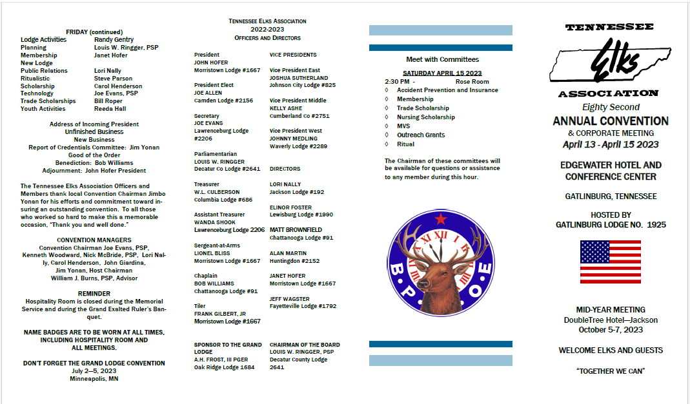
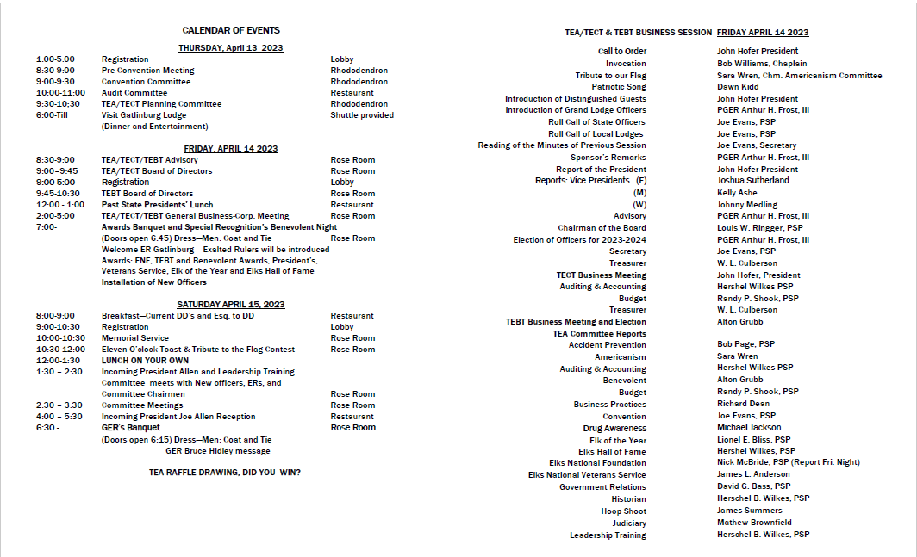

Appendix C: Annual Meeting Awards and Benevolent Night Dinner Format

On Friday night the TEA State President will serve as the Master of Ceremonies for Benevolent Night. The general order of events will be:
- State Chaplain: Invocation
- State President: Recognize State Sponsor
- State Sponsor: Introduce the Grand Exalted Ruler and First Lady and special guests
- Host Lodge Exalted Ruler: Welcome
- State President: Introduction of Exalted Rulers
- State President: Introduction of remaining members of the Head Tables
- TEBT President: Report, awards, and donations
- ENF Chairman: Report, awards, and donations
- President’s Award (See TEA By-Laws 8: 12 for more information)
- Veterans Service Award
- Other awards-only as approved by the TEA Board of Directors
- Elk of the Year presented by Committee Chair
- Elk Hall of Fame presented by Committee Chair
- State Sponsor will recognize the Nominating Committee Chair who will read the names of Officers and Directors elected for the coming year.
- State Sponsor will install Officers and Directors.
- Announcements including
  - Hospitality Room policy (including that badges must be worn to enter) and closure during Saturday night dinner for GER.
- State Chaplain: Benediction
- Adjourn

Appendix D: Grand Exalted Ruler Banquet Agenda

On Saturday night the TEA State President will serve as the Master of Ceremonies for Grand Exalted Ruler Night. The general order of events will be:
- State Chaplain: Invocation
- Dinner
- Introduction of State Sponsor who will introduce the Grand Exalted Ruler, First Lady, and other special guests
- State President introduces remaining members of the head tables.
- Sponsor introduced GER for his message
- Ritual Chair: acknowledges judges and presents awards
- TEA President’s wife (or designate) will present gift to the First Lady
  - This gift is coordinated by the State Sponsor, or his wife, and will be paid for with TEA Convention funds.
- TEA President presents gift to Grand Exalted Ruler
  - The TEA Secretary will coordinate this gift with the State Sponsor and the gift will be paid for with TEA Convention funds.
- TEA Secretary presents Honorary Colonel on the Governor’s Staff certificates to the Grand Exalted Ruler and outgoing TEA President
- Outgoing TEA President gives President's badge and gavel to incoming President (The State Secretary will furnish badges)
- Incoming President gives Past State Presidents badge to outgoing President
- Gifts to outgoing President and wife by incoming President. (Furnished by the state secretary from state funds.) Remarks by outgoing President
- Any remarks by incoming President
- Benediction by outgoing State Chaplain
- Adjournment by new President

Appendix E: Complimentary (Comp) Room Guidelines

It is customary for a hotel to give one complimentary room for some specific number of paid rooms (e.g., 1 comp room for every 25 paid rooms). Some do not allow fractions, some use total room nights, and some will grant rooms for the period of the Convention. This will be spelled out in the hotel contract.

When negotiating with the hotel, every attempt should be made to get 2 two-bedroom suites complimentary in addition to the complimentary rooms allowed based on number used. Often suites require two to six complimentary rooms for their use, not just one for one.

All complimentary rooms belong to the state association and will be allocated according to the policy below and monitored by the State Secretary and the State Convention Chair. Bills will be submitted by the state Secretary to the individuals involved when reimbursement is indicated.

Rooms will be allocated in the order presented until all complimentary rooms are used.
I. Two-bedroom suite for the Grand Exalted Ruler and the Past Grand Exalted Ruler
2. Two-bedroom suite for the presiding state president and the president elect
3. Bedroom near GER suite for PGER if there are two in the state.
4. Host lodge general chairman
5. State registration chairman
6. State Convention Chairman
* 8. State secretary
* 9. Chairman of the corporation
* 10. State treasurer
* These individuals have convention expense budgets, and the convention chairman will notify them and the hotel that they will receive comp. rooms which will be charged to the master account. This will save the sales tax since TEA is tax exempt but only for those charges directly to TEA.

At the Mid-Year meeting the same order will be followed except that PGERs, state president, and president-elect will receive rooms only (no suites).

Appendix F: Registration Letter and Form Examples

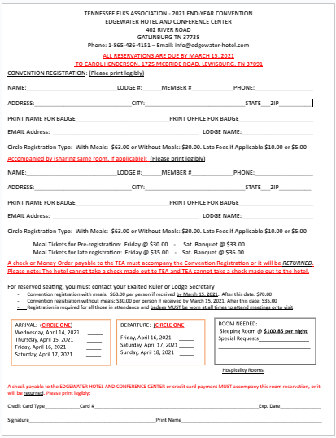

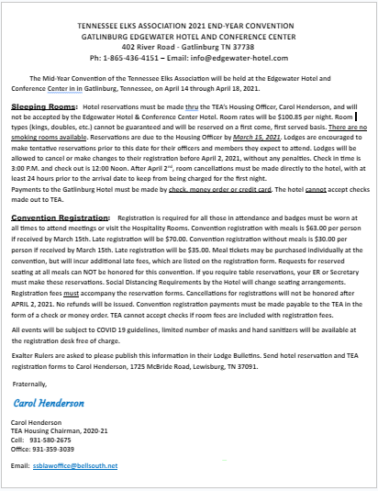

Appendix G: Seating Chart Guidelines for Annual Meeting

FRIDAY NIGHT DINNER
SEATING CHART ANNUAL
UPPER HEAD TABLE
1 | 2 |  | 3 |  | 4 |  | 5 |  | 6 |  | 7 |  | 8 |  | P |  | 9 |  | 10 |  | 11 |  | 12 |  | 13 |  | 14 |  | 15 |  | 16
LOWER HEAD TABLE
17 |  | 18 |  | 19 |  | 20 |  | 21 |  | 22 |  | 23 |  | 24 |  | 25 |  | 26 |  | 27 |  | 28 |  | 29 |  | 30 |  | 31 |  | 32

1. Chairman of the Board 17. VP Elect West Spouse
2. COB Spouse 18. VP Elect West
3. Grand Trustee Spouse 19. VP West Spouse
4. Grand Trustee 20. VP West
5. State Sponsor Spouse 21. VP Elect Middle Spouse
6. State Sponsor 22. VP Elect Middle
7. GER Wife 23. VP Middle Spouse
8. GER 24. VP Middle
9. TEA President 25. VP Elect East Spouse
10.TEA President Spouse 26. VP Elect East
11. President Elect 27.VP East Spouse
12. President Elect Spouse 28. VP East
13. Treasurer 29. ENF Chairman Spouse
14. Treasurer Spouse 30.ENF Chairman
15. Secretary Spouse 31. TEBT President
16. Secretary 32. Chaplain

SATURDAY NIGHT DINNER
SEATING CHART ANNUAL

UPPER HEAD TABLE
1 | 2 |  | 3 |  | 4 |  | 5 |  | 6 |  | 7 |  | 8 |  | P |  | 9 |  | 10 |  | 11 |  | 12 |  | 13 |  | 14 |  | 15 |  | 16
LOWER HEAD TABLE
17 |  | 18 |  | 19 |  | 20 |  | 21 |  | 22 |  | 23 |  | 24 |  | 25 |  | 26 |  | 27 |  | 28 |  | 29 |  | 30 |  | 31 |  | 32

1. Chairman of the Board 17. Chaplain
2. Chairman of the Board Spouse 18. Chaplain Spouse
3. Grand Trustee Spouse 19. Esquire to DD Spouse
4. Grand Trustee 20. Esquire to DD West
5. State Sponsor Spouse 21. DD West Spouse
6. State Sponsor 22. DD West
7. GER Spouse 23. Esquire to DD Middle Spouse
8. GER 24. Esquire to DD Middle
9. TEA President 25. DD Middle Spouse
10. TEA President Spouse 26. DD Middle
11. President Elect 27.Esquire to DD East Spouse
12. President Elect Spouse 28. Esquire to DD East
13. Treasurer 29. DD East Spouse
14. Treasurer Spouse 30. DD East
15. Secretary Spouse 31. Raffle Chairman Spouse
16. Secretary 32. Raffle Chairman

Appendix H: Seating Chart Guidelines for Mid-Year Meeting

FRIDAY NIGHT DINNER
SEATING CHART MID-YEAR

UPPER HEAD TABLE
1 | 2 | 3 | 4 | 5 | 6 | PODIUM |  | 7 | 8 | 9 | 10 | 11 | 12
LOWER HEAD TABLE
13 | 14 | 15 | 16 | 17 | 18 | 19 | 20 | 21 | 22 | 23 | 24 | 25 | 26

1. Chairman of the Board 17. VP Middle Spouse
2. Chairman of the Board Spouse 18. VP Middle
3. Grand Trustee’s Spouse 19. VP East Spouse
4. Grand Trustee 20. VP East
5. State Sponsor’s Spouse 21. ENF Chairman Spouse
6. State Sponsor 22. ENF Chairman
7. TEA President 23. TEBT President Spouse
8. TEA President’s Spouse 24. TEBT President
9. TEA President Elect 25. TEA Treasurer’ Spouse
10. TEA President Elect Spouse 26. TEA Treasurer
11. TEA Secretary Spouse
12. TEA Secretary
13. Chaplain
14. Chaplain Spouse
15. VP West Spouse
16. VP West

SATURDAY NIGHT DINNER
SEATING CHART MID-YEAR

UPPER HEAD TABLE
1 | 2 | 3 | 4 | 5 | 6 | PODIUM |  | 7 | 8 | 9 | 10 | 11 | 12
LOWER HEAD TABLE
13 | 14 | 15 | 16 | 17 | 18 | 19 | 20 | 21 | 22 | 23 | 24 | 25 | 26

1. Chairman of the Board 17. DD East Spouse
2. Chairman of the Board Spouse 18. DD East
3. Grand Trustee Spouse 19. DD Middle Spouse
4. Grand Trustee 20. DD Middle
5. State Sponsor Spouse 21.
6. State Sponsor 22.
7. TEA President 23. LTC Spouse
8. TEA President Spouse 24. Leadership Training Chairman
9. TEA President Elect 25. TEA Treasurer Spouse
10. TEA President Elect Spouse 26. TEA Treasurer
11. State Secretary Spouse
12. State Secretary
13. Chaplain
14. Chaplain Spouse
15. DD West Spouse
16. DD West

Appendix I: Mid-Year Meeting Facility Requirements

The following information delineates the general hotel requirements based on the current agenda format and historical attendance.

Dates for the Annual Meeting/State Convention are determined well in advance with the approval of the State Sponsor and based on the Grand Exalted Ruler’s approved travel schedule with is provided by the Grand Lodge.
Guest Room Estimates
Wednesday: 10 rooms
Thursday: 50 rooms
Friday: 80 rooms
Saturday: 86 rooms
Meeting Room Needs
THURSDAY
1:00-5:00 Registration Lobby
2:00-2:30 Pre-Convention Meeting 30 people

FRIDAY
1:00-5:00 Registration Lobby
2:30- 3:00 State Sponsor Meets with President Elect 20 people Boardroom
3:00 – 3:30 TEA/TECT Advisory 25 People Boardroom Style
3:30-4:15 TEA/TECT Board of Directors 30 people – Boardroom Style
4:15 – 5:00 TEBT Board of Directors 30 people – Boardroom style
7:00- Awards Banquet and Special Recognition’s Benevolent Night
(Doors open 6:45) Plated dinner for 150

SATURDAY
8:00-10:30 General Business Session 150 people - Theater Style
10:30 – 11:00 – Planning Committee 25 People Boardroom Style
11:00 – 11:30 Convention Committee 25 people Boardroom Style
2:00 – 2:45 Training 30 people - classroom
2:00 – 2:45 Training: 30 People - classroom
2:45 – 3:30 Training: 30 people - classroom
2:45 – 3:30 Training: 30 People - Classroom
6:30 - Banquet Plated dinner for 175 (Doors open 6:15)

We also need a room to have a hospitality room in that can accommodate 100 people

Appendix J: Agenda for the Mid-Year Meeting

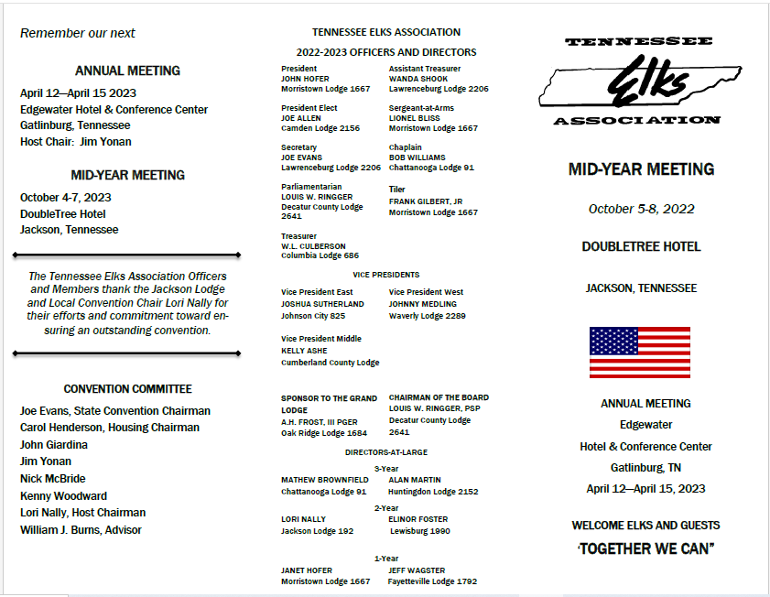

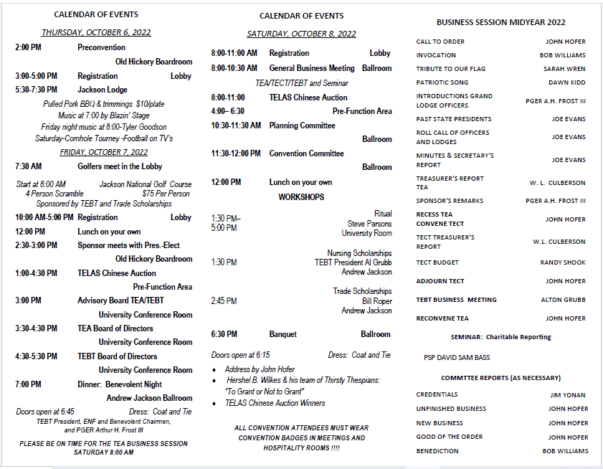

Appendix K: Election Procedures for Contested Offices and Credentials Committee

The chairman of the credentials committee should review the By-Laws 9.12 - Credentials Committee and 3.02 Delegates and write each lodge, both ER and Secretary, reminding them of the necessity of appointing delegates to the Annual and Mid-Year Convention.

By-Laws 3.01 Voting Delegates

By-Laws 3.03 Selection and Certification of Delegates. The usual procedure is for the Advisory Committee, which also serves as the nominating committee, to nominate a slate of elective officers at the first business session. Any uncontested officers will be elected immediately. If there is a nomination from the floor for any office (s) the president will announce the schedule and rules for voting.

The Association Secretary will furnish the Credentials Chairman with the lodge membership numbers as paid to the Grand Lodge as of April 1 of the previous year and calculate the number of delegates to which each lodge is entitled.

Procedure for credentials - The Chairman:
1. A list of active Past State Presidents will also be furnished by the Secretary.
2. verifies those lodges which are entitled to vote by virtue of submitting its delegate list on time and compares this with the number to which the lodge is entitled.
3. has the list filed in such manner that it can be easily accessed to check off names during the election
4. Chairman will have tables and chairs available at the time designated by the President for the vote. The hotel will furnish. Coordinate with the Convention Chairman.
5. Procedure:
Delegate must appear in person with a signed, paid-up membership card for this or the previous year and checker will verify that he is entitled to vote as a Past State President or a delegate but not both.
Clerk will mark the list as voted, give the voter a ballot which he will mark and place in the ballot box. Voting stations may be divided into districts and Past State Presidents (4 stations). Each station will have its list of qualified delegates. If there is more than one office contested, all offices will be on the same ballot. If a delegate is unable to vote and if the lodge has appointed alternates, the Credentials Chairman will be given, inwriting, signed by the Lodge Secretary or Exalted Ruler, the name of the delegate not voting and the name of the alternate to vote in his place. The chairman will
then update his delegate list.
6. All votes will be placed in one box.
7. At the conclusion of the voting time specified, the Credentials Chairman will report to the President.
8. The President will allow each candidate to appoint an observer to observe the counting by the Credentials Committee. Votes will be pulled by one member of the Credentials Committee, the name called, and a tally made by another member. Totals will be made and verified.
9. The credentials chairman will bring the tally sheet and the ballots to the State Secretary. Upon instructions of the President, the Secretary will read the results and upon order of the President, will destroy the ballots.

Appendix L: Hospitality Room Policy

(To be posted in hospitality rooms and distributed to each person receiving a badge} (Passed by a vote of the membership October 11, 2003)

Hospitality Rooms shall close their doors and give a "last call" at midnight on Thursday and Friday, and at 1:00 AM on Sunday morning.

No music will be played after 11:00 PM.

The name of the person responsible (usually the ER) will be given to the reservation chairman at the time of reserving the room and will serve as the contact person for hotel security. He will be responsible for closing on time and maintaining order. His name will be included in the list of hospitality rooms.

Vice Presidents are responsible for the lodges in their district to monitor and notify those responsible for the hospitality room when action needs to be taken.

Elks are requested not to congregate in halls in groups and continue to drink after rooms are closed.

Responsible Bartending:
Do not serve persons who have had enough. You, personally, and your lodge may be legally liable for any problems to the individual or any they may cause.
Everyone should have fun but when they become loud, use foul language, or become lovers or fighters, they bring discredit to your lodge and the Elks. It is everyone's responsibility to give an early word of warning which will usually solve the problem without embarrassing the individual.

Hospitality rooms will be closed during the Memorial Service and during the Banquet when the Grand Exalted Ruler is attending.

Everyone shall wear a name badge furnished by the registration desk. Badges will
be issued to all those not getting a full registration.

Each individual is responsible for complying with this policy and violations can
result in disciplinary action.

Thank you for your co-operation and for remembering that there are other guests in the hotel and for showing respect to our Memorial Service and to our Grand Exalted Ruler.

Your convention committee.

Appendix M: Preconvention Meeting Outline

PRECON, Doubletree, Jackson
October 6 , 2022
(Hotel Staff)
Introductions Sales:

Catering/Banquet:

Room/Front Desk:

Gen. Manager:

Set-up:
Pass out Programs

- Meal Guarantees: Friday____ Sat. Night____

We pay the guarantee or # served, whichever is greater
- Who will collect tickets?
- Note: we want to open the door 15 minutes prior to meal service time
- Guest must have a ticket to enter (I will assist)
- Make sure proper ticket is presented (#1) Friday (#2) Sat night (show color)
- Count and verify with me or Carol
- Joe Allen will need access to put name cards out
- American Flag (and Tennessee Flag if you have one) in the meetings in University Room Friday and Ballroom on Saturday and also all meals
- Who do we contact if there are set up issues with meeting rooms. How do we contact them.
- Who do we call for catering issues?
- Who do we call for room issues?

- Serve Upper and Lower head tables first at meals. Start serving right after invocation
- Master account: Only Carol Henderson or Joe Evans, please let your staff know not to accept any charges to TEA master account but Carol and myself.

- Hospitality Room Charges only to those responsible for room. NO CHARGES TO TEA MASTER ACCOUNT!!!
- Would like to pull the master account on Sat. mid-day so we can go over it will verify room count/comps it will have the Friday, so only thing left will be the Sat. Night banquet count. If there is a problem, we can straighten it out before late Sat. night.

- Verify the master account on Sat. night and pay the bill. (who will be here??)

