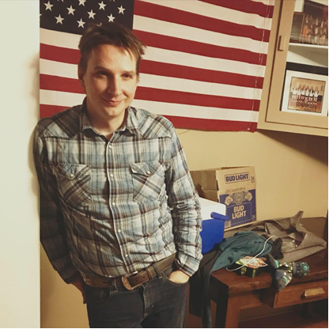
Michael Hoffman – Music Bio
Michael Hoffman began performing live music around the suburbs of Detroit, MI in middle school. He moved to Bozeman, MT where he co-founded regional touring band The Dirty Shame with lead singer Brandon Hale. The five-piece band toured Montana, Idaho, Wyoming, Washington, Nebraska, and Alaska for ten years between 2004 and 2014. The band’s version of gritty outlaw country inspired by the likes of Willie Nelson and Waylon Jennings delighted audiences from small to large venues and street dances and opened for the likes of Gary Allan, Craig Morgan, and Eric Church. During that period, the band released one full length self-titled studio album, a live recording from the PBS television program 11th and Grant, and a farewell EP titled Last Call. In 2015, Michael joined up with Quenby and the West of Wayland band, a Bakersfield swing and Mavericks inspired four-piece ensemble that toured regularly throughout the Northwest. In 2019, Michael released his first solo album, Liar’s Dice and began performing to audiences around Montana, and was a regular performer at several breweries and local bars. His original music is heavily influenced by his roots in Outlaw Country, but also classic rock and roll. You may hear a song from Waylon Jennings, the Rolling Stones, and the Grateful Dead all in one set. Michael’s original songs are often influenced by lived experiences, and range from pastoral depictions of a small western town dying after the loss of the drilling industry to deeper personally explorative material. Michael and his family have recently relocated to Los Ranchos, NM where he is currently working on his follow up solo endeavor and enjoying the vibrant energy of New Mexico.
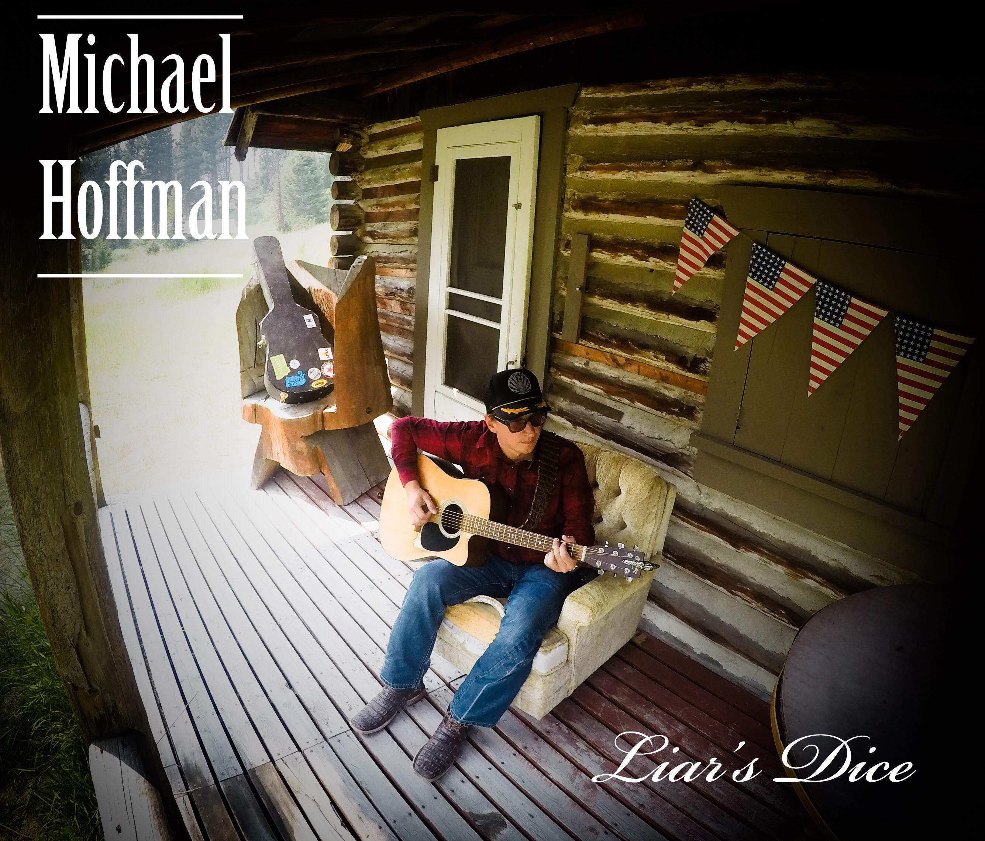
Outlaw Country
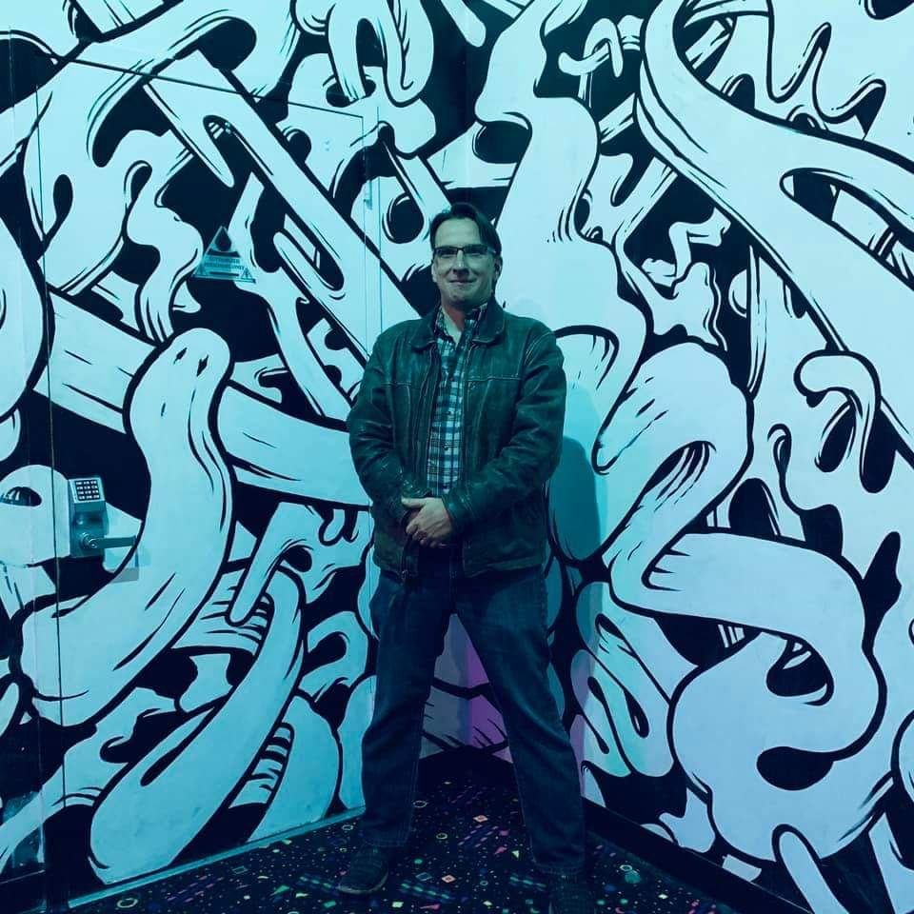
Original
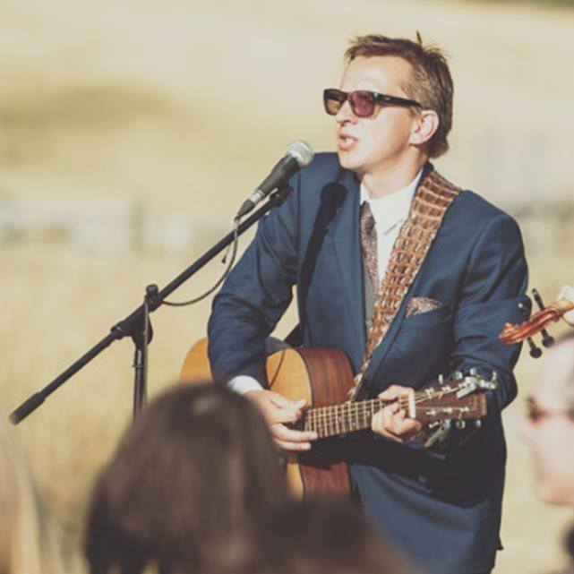
Events
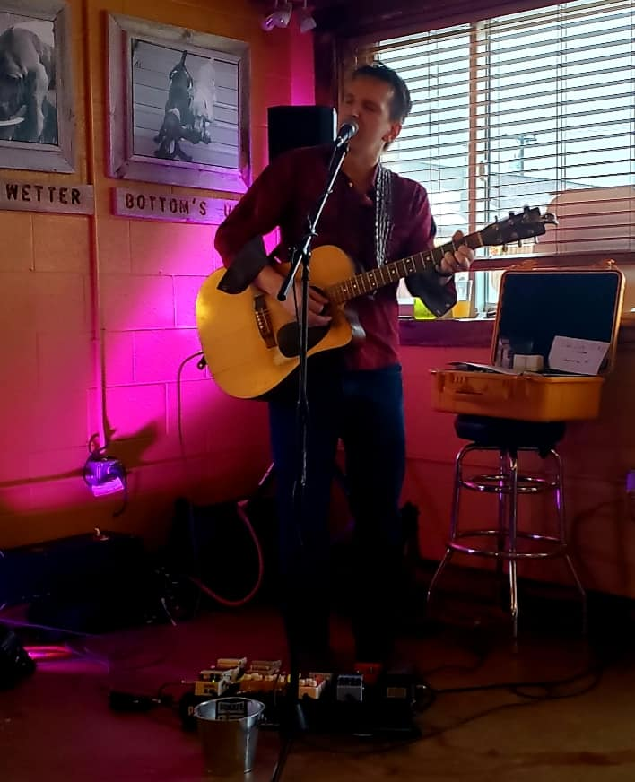
Acoustic Rock

