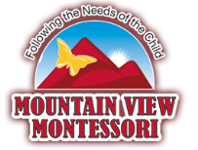
We are a Peanut-Free School
“Food impacts how well a child’s brain works, effecting their moods and abilities. In a child’s brain, junk food can cause neurotransmitters, which pass along information, to function improperly. Smart food, however, allows information to be processed correctly and help the child function at their optimal level”
-Dr. Sears, one of America’s most renowned pediatricians and author of over 40 books

LETS HELP OUR CHILDREN DO THEIR BEST AT SCHOOL BY
SENDING IN SMART “REAL FOOD” PEANUT-FREE SNACKS & LUNCH
Real food is:
- 100% whole grain
- Made with very little (or no) refined sweeteners like white sugar or corn syrup
- Fresh fruits and vegetables, dairy products, seeds, dried fruit, humanely raised animal products.
- More a product of nature than a product of industry
Real food is not:
- “low fat” or “low carb”, or “ low calorie” products (in most cases)
- Made with artificial sweeteners like Splenda
- Deep fried in refined oil
- 100-calorie packs made with refined grains like white flour (labeled as wheat four)
- Something out of a package containing ingredients you cannot pronounce
- Highly processed food that is labeled as organic

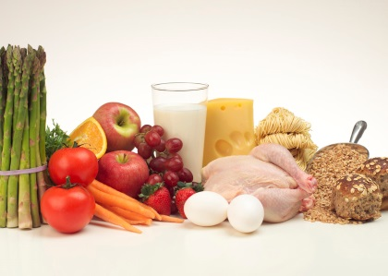

School Snack Suggestions
Fruits & Veggies Dry Foods
Orange/Apple Slices Vanilla Wafers
Blueberries, Blackberries, Raspberries Pretzels
Bananas Corn Chips & Salsa
Fresh Fruit Salad Pita chips
Veggie Tray Trail mix
Sliced apples or applesauce Cereal
Strawberries Bagels
Carrots/Celery Graham Crackers
Watermelon Muffins or special breads
Peaches Pinwheels
Cantaloupe Loaf of Bread & Jelly
Cucumbers

Dairy/Sides Drinks
Quesadillas Water
Yogurt Squeezers Milk
String/Cube Cheese 100% Apple juice
Cashew/Almond butter 100% Orange juice
Jelly Preserves 100% Mixed juice
Cream Cheese 100% Cranberry juice

Thank you for choosing a healthy snack diet for your child!

