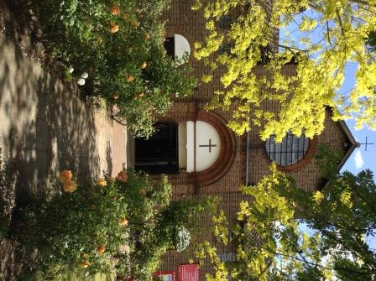

St. Barnabas, Downham
Catford (Southend) and Downham Team Ministry
Rev’d Stuart Leck, 1 Churchdown, Bromley, BR1 5PS
Tel: 020-8698-0283 E-mail: revdstuartleck@btinternet.com
www.stbarnabasdownham.co.uk

March 2025

Dear Brothers and Sisters,

I hope you are having a blessed Lent as we reflect on our Lord’s journey towards the cross at Calvary.

As a Church we continuing to grow and it always a pleasure to welcome new people to the Church and to support them – and all of you – in your Christian journey.

As we move slowly into Spring, there are lots of opportunities to deepen our faith and to contribute to our life together.

Confirmation

This year’s confirmation service will be on Sunday 29th June at 5.00 p.m. at St John’s. Classes will be held on Sunday afternoons at 3.00 p.m. at St John’s starting on the 11th May. If you would like to know more about Confirmation and the Christian faith, please do please speak to me.

Admission to Communion before Confirmation

This is open to any young person aged 8 years or older who is a regular member of the Church and has been baptised. I am planning to run the preparation classes after Easter so if you and your child(ren) are interested please do speak to me.

Woolwich Area Lay Conference – Saturday 5th April

This year’s Lay Conference is being held at the Ark Academy in Peckham and is an opportunity to meet with other lay leaders across the Woolwich Area. It is a free day and if you are interested in attending, please do speak to me.

Annual Meeting and Electoral Roll

This is also the time of the year for Annual Meetings and elections. Our Annual Meeting will be on Sunday 4th May at 11.00 a.m. and in preparation for this the Electoral Roll – our membership list – is being fully revised this year. Forms are available in the Narthex and please do speak to Lindsay Cooke or myself if you are unsure what this is and how you can join it.

To emphasise we do not give your details to any outside body and the Roll is separate from any Council or National Register of Electors that you may be on.

Opportunities to support our life together

As Jesus said “The harvest is plentiful, but the labourers are few” (Matt 9 v 37).

We are a growing Church and the demands to maintain our life together are increasing. With this letter you will find a leaflet detailing some of the roles that are required to help the Church provide a welcoming and worshipping community.

Please do prayerfully consider whether God is calling you to offer yourself to fulfil one of these roles – or equally to step back from a role.

At our Annual Meeting there will be the opportunity to offer yourself for one of the Elected Offices within the Church – Churchwarden, PCC Member, DCC Member, Deanery Synod Representative. If you would like to know more about these rolls and what is involved, please speak to Lindsay Cooke or myself.

Financial Support

Alongside the practical support, we rely on the generosity of those who attend to fund our life together. Over the past few years the Church, alongside all organisations, has seen a considerable increase in our weekly running costs.

Please do use this Lenten season to prayerfully consider how you support the Church financially. The tithing principle that the Church teaches encourages us all to review our giving regularly – up or down as our income increases or decreases - so that we maintain the same proportionate level of giving.

Hall

Our Hall continues to see an increase in demand, and Faye, our Administrator, is working hard to promote it to the local community, and we have a number of regular weekday lets supporting local community organisations.

As with the Church we have a responsibility to maintain it and I am grateful to all those who have helped with the recent works when the lights were upgraded to LED bulbs and new curtain rails fitted.

Thank you for all that you do to contribute to our life together and may God continue to bless you this Lent.

Fr. Stuart

