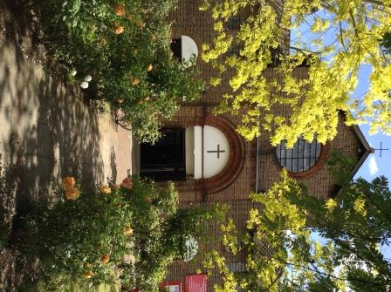

St. Barnabas, Downham
Catford (Southend) and Downham Team Ministry
Rev’d Stuart Leck, 1 Churchdown, Bromley, BR1 5PS
Tel: 020-8698-0283 E-mail: revdstuartleck@btinternet.com
www.stbarnabasdownham.co.uk

July 2018

Dear Brothers and Sisters,

I hope you are enjoying the weather and that it has not been too uncomfortable for you.

I am writing to provide you with an update on our life together and to let you know about various events that are taking place here over the next few weeks and to ask for prayer for some of our future plans and projects.

The last few months have been very busy, with good links established with a number of local groups and organisations and these are starting to lead to really positive opportunities for joint working, alongside planning for future projects and building works.

There are several forthcoming events being held at St. Barnabas:-

Thursday 12th July - 9.30 a.m. – Rangefield School Summer Concert – It will be great to welcome the school back to St. Barnabas for their summer concert and if you are able to help steward please speak to Joan Cooke.

Wednesday 25th July - 2.00 p.m. – 4.00 p.m. – Ageing Well in Lewisham Intergenerational Tea in the Hall – we are helping to facilitate a tea in the Hall for local individuals and families. It is open to anyone so please do come along if you are free.

Phoenix Community Housing Association Young Promoters Projects – 30th July – 17th August (Monday – Friday 9.30 a.m. – 4.30 p.m.) – We are facilitating a three week Arts Project being run by Phoenix for young people aged between 8 – 12 years old. They will be using the Church and the Hall and will be enjoying a variety of activities involving dance, drama and music. The Projects are being run by experienced teachers and staffed by youth workers and Phoenix staff. There will be no impact on the Friday Mass which will be held as usual at 10.00 a.m.

Alongside these exciting events our normal pattern of worship and service continues and in order to develop our life together and maintain our buildings for both the current and future generations we have applied for the following funding:-

All Churches Trust Mission Money - £750.00 to help provide seed money for “Tea @ 2” which has been running as a pilot project for the last few months and has been very successful. The grant will provide a float to help with activities and publicity.

Diocese of Southwark/Marshalls Charity – we are in discussion with the Diocese to apply to Marshalls Charity for a further grant of £10,000 to contribute towards the repairs to the North Side (Cinderford Way) parapet. As you may remember when the roof works were undertaken it was discovered that there are major problems with this parapet and it could not be repaired at that time.

Garfield Weston 60th Anniversary Fund – we have submitted an application for £147,000 for repairs to the Hall which will cost in the region of £170,000 including VAT and fees. We have drawn up a comprehensive specification of repairs to the external fabric of the Hall, and internal decorations, and if we are successful we will look to undertake the work in the summer of 2019.

Please pray for these three funding opportunities and the possibilities that they will generate if we are successful and if we are not successful that other opportunities will present themselves.

There is much to celebrate here at St. Barnabas as we move into the summer months but also much to do and our continued life together does rely on everyone playing a part, not just on Sunday mornings.

I hope you will have an opportunity for a break over the summer months and a chance to refresh and re-charge before we launch into our autumn programme, which starts with our Quiet Day on Saturday 8th September. Watch out for details.

Thank you for your continued support and prayers.

Father Stuart
Team Vicar

