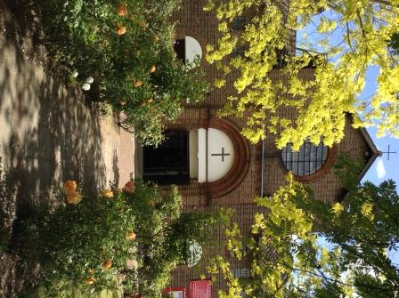

St. Barnabas, Downham
Rev’d Stuart Leck, 1 Churchdown, Bromley, BR1 5PS
Tel: 020-8698-0283 E-mail: revdstuartleck@btinternet.com
www.stbarnabasdownham.co.uk

5th November 2020

Dear Brothers and Sisters,

I am writing as we enter into a second period of lockdown with all the uncertainty and isolation that this will bring to us all.

Whilst we may be in lockdown, as Bishop Karowei said yesterday, the Gospel is never locked down and the central message of love and hope is as strong and as needed as ever. We are Easter people and we need to hold on to that knowledge during these coming weeks.

St. Barnabas will continue to play a central part in the life of our community and we will maintain a presence to serve those in need and continue our rhythm of prayer for God’s creation and ourselves. Thank you for all that you are doing to support each other and those in need.

Church closed for Public Worship - Streamed Services

As the Church is closed for public worship our worship has reverted back on-line with the usual pattern being as follows:-

Compline @ 9.00 p.m. – Tuesday, Wednesday, Thursday and Friday.

Said Mass – Sunday at 9.30 a.m.

Changes to this pattern will be advised on the Church website, which contains the link to the Youtube channel and the reading sheets, etc. will be uploaded weekly.

Alongside the streamed services, I will maintain a pattern of Morning and Evening Prayer in Church. Due to the restrictions sadly these cannot be public services.

Prayer for the Nation

The Archbishops of Canterbury and York have called for a month of Prayer for the Nation during the second lockdown.

It is suggested that this takes place at 6.00 p.m. each evening. I enclose/attach a copy of the national resource for your use. I will incorporate the time of prayer into both Evening Prayer and Compline.

I hope you will be able to join with Christians across the country praying for the nation at this time.

Opening the Church for Private Prayer

Under the current guidelines we are able to open the Church for private prayer during this period of lockdown.

It is my intention to open the Church on Saturdays between 10.00 a.m. – 12 Noon although this Saturday, 7th November it will be open between 2.00 p.m. – 4.00 p.m.

If you attend the Church please follow the normal hygiene and social distancing protocols, etc. and wear a face mask.

Remembrance Sunday – 8th November 2020

Sadly we are unable to hold the usual Remembrance Sunday Service in Church this year.

A Mass will be streamed at 9.30 a.m. from the Vicarage and then an Act of Remembrance will be held in the quadrant, commencing at 10.45 a.m., with the intention being to stream this as well. Please see the website for details.

A visible symbol of remembrance will be left in the grounds of the Church.

The next few months will continue to be a challenging and to an extent an uncertain time and we need to continue to remain firm in our faith and trusting in a loving God.

The Dean of Southwark Cathedral, the Very Revd Andrew Nunn has written the following prayer which I commend to you as we enter this next lockdown:-

Lord Jesus,
who entered the locked room
and made yourself known to your friends;
be with us in this lockdown
that we may be aware of your presence
and know your blessing upon us.
Amen.

Please continue to keep safe and if I can be of any assistance please do not hesitate to contact me.

Fr Stuart

