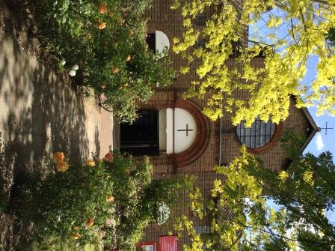

St. Barnabas, Downham
Catford (Southend) and Downham Team Ministry
Rev’d Stuart Leck, 1 Churchdown, Bromley, BR1 5PS
Tel: 020-8698-0283 E-mail: revdstuartleck@btinternet.com
www.stbarnabasdownham.co.uk

February 2021

Dear

“Be strong and let your heart take courage, all you who wait on the Lord”
Psalm 31 v 24

We continue to journey on within a period of challenges and uncertainty and will soon approach a full year of lockdowns, restrictions and separation, conscious that God has been journeying alongside each us during this time.

I know this has been a challenge for each of us, no matter what our individual circumstances and demands, and there is a sense of frustration and lethargy, given the lack of clarity as to when we may be able to return to some sense of normality.

I am very conscious that the on-going closure of the Church is painful for all of us and I am keeping the national and local situation under regular review and await the Government announcement on the 22 February that is due to provide the roadmap and a way forward.

On Wednesday we enter in to the season of Lent as we start our journey towards our Lord’s passion and then the joy of Easter and new birth.

This year we may not be able to gather together for all the normal Lenten services and I am hopeful that we will be able to gather together at Easter.

Whilst we are still closed the following services will be streamed with the service sheets available on the website to download:-

Ash Wednesday Mass – Wednesday 17th February 2021 at 8.00 p.m.

Sunday @ 4.00 p.m. – Stations of the Cross,
commencing on Sunday 21st February.

These services are alongside the existing streamed services of Sunday Mass and Compline as published on the website.

If, as hoped, we are able to re-open during Lent, our usual Saturday Lenten meditations will be held at mid-day, although without the Lent lunch to follow.

I also enclose your copy of the #LiveLent booklet from the Church of England which contains daily reflections to help each of us observe this time and grow in our faith.

I hope you will find this of help during this time when at the moment we cannot easily hold our normal Bible Study or meditative services.

If you have access to the website I have also placed a link to the Diocesan website where you will find information on the 2021 Bishop’s Lent Call which this year focuses on food insecurity both in our Diocese but also in our link Dioceses of Zimbabwe and Jerusalem. Again at the moment we cannot hold our normal pattern of events and we will need to think how we as a Church can support the Bishop’s Call.

All of us are facing challenges and demands at this time and there can be that sense that this crisis will never end.

As pilgrim people we know that God journeys alongside each one of us and we are Easter people, with faith in a God of the miraculous as well as the ordinary.

We can hold onto this faith when we are feeling abandoned and separated and can be reassured through God’s word. Lent provides us an opportunity to spend more time in study and prayer as we seek to grow in our own faith.

May you have a blessed Lent and please continue to keep safe and if I can be of any assistance please do not hesitate to contact me.

With kind regards

Fr. Stuart

