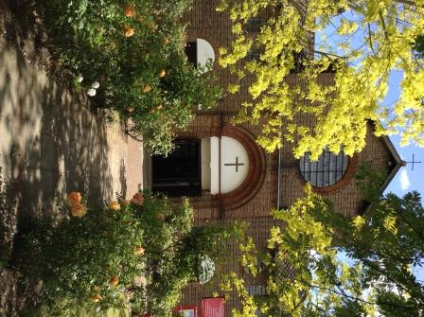

St. Barnabas, Downham
Catford (Southend) and Downham Team Ministry
Rev’d Stuart Leck, 1 Churchdown, Bromley, BR1 5PS
Tel: 020-8698-0283 E-mail: revdstuartleck@btinternet.com
www.stbarnabasdownham.co.uk

July 2021

Dear Brothers and Sisters,

“He made the storm be still, and the waves of the sea were hushed.
Then they were glad because they had quiet, and he brought them to their desired haven.”
Psalm 107 v29 –30

These words from Psalm 107 remind us that within the storms of life God can bring calm and lead us to a safe place and as we enter into this next phase of the pandemic we can give thanks that God has been directing and guiding us as we have sought to navigate our way.

It has been and continues to be a challenging time and whilst many of the legal restrictions as to what we can do or how we should act have been removed, the onus is very much on personal responsibility

During recent months our worshipping life has been maintained and I am grateful to all those who have enabled the Church to remain open and a place where people can seek peace and quiet.

Whilst the removal of legal restrictions has been announced, churches have been encouraged to consider what is appropriate for their own situation and there is certainly no pressure to return to pre-pandemic “normality” overnight. Indeed I think it will be many months before we are at that point in our life together and we need to remain focussed on God to support us through these times.

In respect of our worshipping life together I am not proposing to make any major changes to our current arrangements and I, alongside the DCC, will keep these aspects under regular review, in line with the local and national situation.

From Sunday 25th July the following arrangements will be in place at St. Barnabas although there may be variations for a particular service:-

- Seating will be arranged to maximise the space and everyone is encouraged to spread out. Please do not assume someone will be happy for you to sit next to them – please ask.

- Whilst not legally required, I would encourage those who wish to continue to wear face masks.

- Sanitiser will continue to be available.

- The peace will continue to be shared from our places without physical shaking of hands.

- There will be no change to the offertory arrangements with the plate being available by the font for tithes to be placed in upon entry.

- Congregational singing will be introduced for the introit and recessional hymns only, with the choir continuing with the offertory and communion hymn. The Liturgy will continue to be said.

- The Chalice will be introduced from the 29th August but no-one should feel pressured into receiving the wine. Receipt of the bread only is full communion in our understanding of the Eucharist.

- I will continue to consecrate the elements as now with the peoples’ elements covered. I will wear a face mask when administering and we will continue with the same system at present.

- Refreshments will be introduced in the Hall from 1st August for those who wish to meet socially after the service.

As I said earlier, we will continue to keep all these arrangements under review and adapt as necessary.

In early September we will hold a “Back to Church Sunday” to mark the re-starting of parts of our common life – Junior Church, Bite-Size Bible Study, Tea@2, Wednesday and Saturday services.

The past 18 months have been a tough and challenging time and we are encouraged where possible to rest and reflect over the next few weeks to enable each of us to be equipped for the autumn months and the challenges these will bring as we seek to rebuild and move forward.

May God continue to bless and refresh you in the days ahead.

Fr. Stuart

