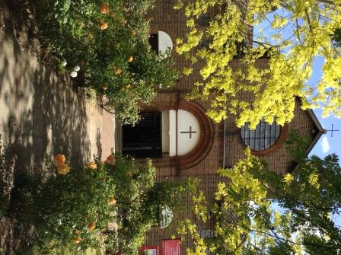

St. Barnabas, Downham
Rev’d Stuart Leck, 1 Churchdown, Bromley, BR1 5PS
Tel: 020-8698-0283 E-mail: revdstuartleck@btinternet.com
www.stbarnabasdownham.co.uk

14 October 2020

Dear Brothers and Sisters,

I hope you are continuing to keep safe and well during these uncertain times which look to be continuing for several more months at least.

I am writing to update you on life at St. Barnabas and to provide you with information regarding forthcoming services, that, God willing, we will be holding at the Church.

Firstly, thank you to everyone who supported our Harvest Festival recently and for the generosity of the donations that have been passed on to the Food Project.

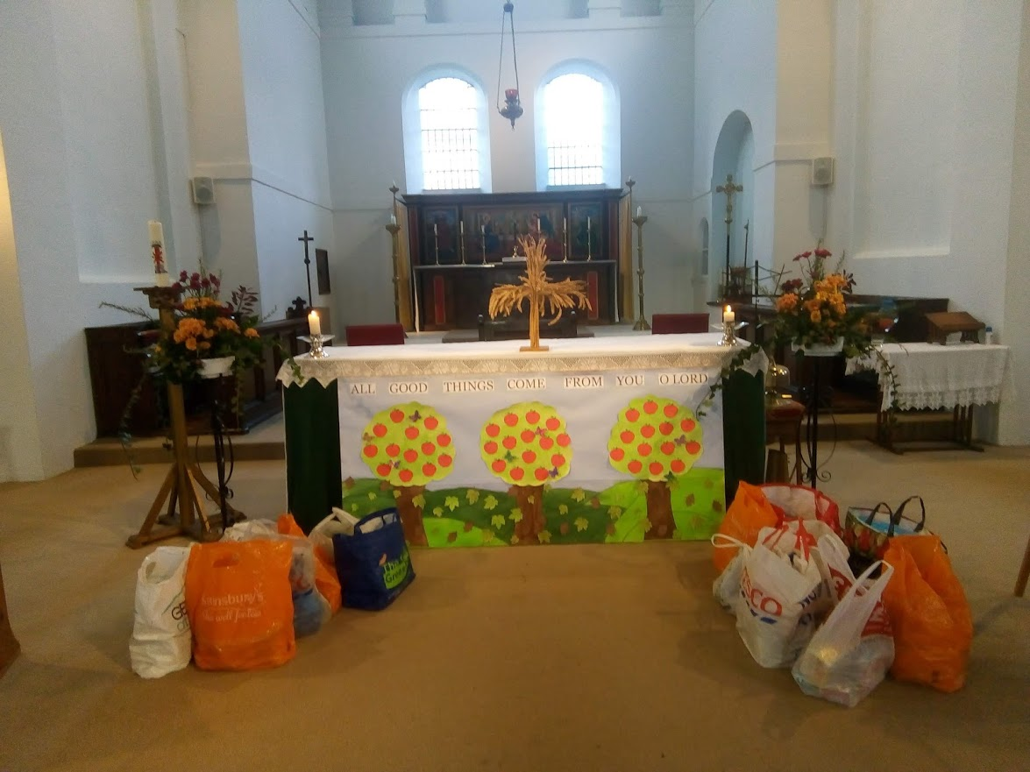

Alongside the Church celebrations, I have also been able to maintain our links with Rangefield and Downderry Schools and participated in their Harvest Assemblies via the wonders of Zoom and Google!

The current level of restrictions remain and I am grateful to all those who are helping to maintain our life together, yet apart, and I am conscious that there are a number of our congregation still shielding and unlikely to return in person to the Church whilst the current situation continues.

I will continue to stream the Sunday Mass at 11.15 a.m. on the Youtube Channel and Compline at 9.00 p.m. on Tuesday, Wednesday and Friday evenings.

Details of any variations to these arrangements will be on the weekly sheet that is also uploaded on to the Church website.

We are moving in to the season of remembrance within the Church’s calendar, with All Saints Day, All Souls’ Day and Remembrance Sunday prominent in our thoughts.

This year by necessity our observance of these Festivals will be different but we will mark them within our life together as follows:-

Sunday 1st November – All Saints’ Day – Said Mass at 9.30 a.m.

Monday 2nd November – All Souls’ Day – Said Mass at 7.30 p.m.

Remembrance Sunday – Said Mass and Act of Remembrance at 10.00 a.m.

Within this season of remembrance we would normally host the Annual Memorial Service for those families who have lost loved ones over the past 18 months or so.

Sadly we cannot do so under the current guidelines and we will remember those who have died and whose funerals we have taken within the All Souls’ Day service. If you would like a loved one remembered during this service please let me know or, if you are able, add their name to the list in Church.

In addition, the Church will be open on Saturday 7th November between 2.00 p.m. – 4.00 p.m. to enable people to come in and light a candle and sit quietly.

The next few months will continue to be a challenging and to an extent an uncertain time and we need to continue to remain firm in our faith and trusting in a loving God.

Jesus said, “Come to me, all you that are weary and are carrying heavy burdens, and I will give you rest.”
Matthew 11 v 28.

Do continue to rest on Jesus and allow him to journey with you through these difficult days and weeks ahead.

Please continue to keep safe and if I can be of any assistance please do not hesitate to contact me.

Fr Stuart

