 Sponsorship Bench Purchase Form

Name:
Address:
Phone:
email:

Line 1 (Optional) Limit 40 Characters.
Line 2 (Optional) Limit 40 Characters.
Line 3 (Optional) Limit 40 Characters.
Line 4 (Optional) Limit 40 Characters.
Line 5 (Optional) Limit 45 Characters.
Line 6 (Optional) Limit 45 Characters
Line 7 (Optional) Limit 45 Characters.

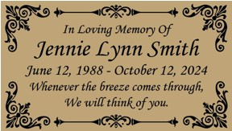 | Plaque example. You can specify up to 7 lines of text. Proper names will be displayed in a larger font as per the example on the left. The font type will be similar to Monotype Corsiva Italic.  Please note: the amount of text and lines will determine the overall font size.

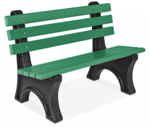  $700 per bench | Includes 4-ft. 100% UV-protected recycled plastic bench, durable 2-in. thick planks, installation, concrete base, and name plaque. Virtually maintenance-free.  Make check payable to: GREENFIELD TOWNSHIP COMMUNITY PARK & VETERANS MEMORIAL  Complete this form and send with your check to: Greenfield Township Supervisors, 424 Route 106, Greenfield Township,  PA 18407.

