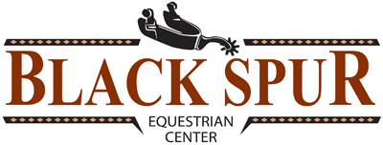
The following Rules will be followed by everyone while on the property of Black Spur Equestrian Center:
- No Smoking

- No offensive language

- All children under the age of 12 must be supervised by an adult at all times

- Do not use others belongings without their permission

- Do not open or enter a stall or paddock without horse owner or barn manager’s permission

- Communicate with others regarding shared areas: cross ties, arenas, grooming area, etc.

- Do not feed anything to anyone’s horse without their permission

- Horses must have a halter and lead rope on when out of their stall or pasture - no loose horses

- All riders must sign a release before mounting a horse

- Clean up all messes you or your horse make

- People under the age of 18 must wear a helmet while riding

- Hard soled footwear must be worn while riding

- All animals that do not reside at Black Spur Equestrian Center must be on a leash

- Horses may not be turned out in arenas – turnout available in turnout paddock

- Black Spur closes at 10:00 p.m. and arenas close at 9:30 p.m.

- Report any unsafe condition to Black Spur management immediately

- Park vehicles on gravel drives, parking lots and designated parking areas only

- If you have questions or need help, please see Black Spur manager

