**  
The Peaceful Pony CIC**

**Learner Attendance Policy and Procedure**

**Written by- Holly Lockwood-Waduge 25/10/2024**

**Approval Date: 1/11/2024 (Senior Managers of TPP)**

**Last Review 1/11/2024**

**Next Review 01/11/2025**

**Senior Attendance Champion – the senior leader responsible for the strategic approach to attendance in our provision, is:**

Holly Lockwood-Waduge

[Holly@thepeacefulpony.org](mailto:Holly@thepeacefulpony.org)

**Provision staff member; Learners and parents should contact about attendance on a day-to-day basis is:**

Name: Claire Narayanaswamy

[admin@thepeacefulpony.og](mailto:admin@thepeacefulpony.og)

01268202777

07541100022

**If you need to speak our SENCO or Therapeutic team for more individual support with attendance please contact:**

[Tash@thepeacefulpony.org](mailto:Tash@thepeacefulpony.org)

[Jolyne@thepeacefulpony.org](mailto:Jolyne@thepeacefulpony.org)

[Ruth@thepeacefulpony.org](mailto:Ruth@thepeacefulpony.org)

[Kaz@thepeacefulpony.org](mailto:Kaz@thepeacefulpony.org)

Telephone number: 01268202777 or 07541100022

**The Peaceful Pony Specialist Alternative Provision**

**Learner Attendance Policy**

**Introduction and Background**

*The Peaceful Pony (TPP)* recognises that positive behaviours and good attendance are essential for learners to get the most of their provision experience. Including their attainment, wellbeing and wider life chances.

The law entitles every child of compulsory provision age to an efficient, full-time education suitable to their age, aptitude and any special educational need they may have. It is the legal responsibility of every parent to make sure their child receives that education, either by attendance at a school or by education otherwise such as that of a provision (such as TPP).

The Department for Education (DfE) has produced statutory guidance for maintained schools, Academies, Independent provisions, and local authorities. It is called “[Working together to improve provision attendance](https://www.gov.uk/government/publications/working-together-to-improve-school-attendance)” and it includes a National Framework in relation to absence and the use of legal sanctions. Our Learner Attendance Policy reflects the requirements and principles of that guidance.

This policy is written with the above guidance in mind and underpins our provision ethos to:

* Promote children’s welfare and safeguarding.
* Ensure every learner has access to the full-time education to which they are entitled.
* Ensure that learners succeed whilst at provision.
* Ensure that learners have access to the widest possible range of opportunities at provision and when they leave provision.

This policy has been developed in consultation with the Local Authority and Education networks, parents and carers. It seeks to ensure that all parties involved in the practicalities of provision attendance are aware and informed of attendance matters in provision and to outline the provisions commitment to attendance matters. It details the responsibilities of individuals and groups involved and the procedures in place to promote and monitor attendance.

In addition, all Education settings follow the DfE’s statutory safeguarding guidance, Keeping Children Safe in Education, which emphasises the importance of understanding the potential vulnerabilities of children who are missing or absent from education.

[https://www.gov.uk/government/publications/keeping-children-safe-in-education--2](https://eur02.safelinks.protection.outlook.com/?url=https%3A%2F%2Fwww.gov.uk%2Fgovernment%2Fpublications%2Fkeeping-children-safe-in-education--2&data=05%7C01%7CSimone.Webb%40essex.gov.uk%7C5c8058b1ee3d474f51f108db99695c74%7Ca8b4324f155c4215a0f17ed8cc9a992f%7C0%7C0%7C638272450024518381%7CUnknown%7CTWFpbGZsb3d8eyJWIjoiMC4wLjAwMDAiLCJQIjoiV2luMzIiLCJBTiI6Ik1haWwiLCJXVCI6Mn0%3D%7C3000%7C%7C%7C&sdata=lSwIxjDkmFwEjJNhg6jSTy57KDKtya4eJKgS30bZtDQ%3D&reserved=0)

Our policy aims to raise and maintain levels of attendance by:

* Promoting a positive and welcoming atmosphere in which learners feel safe, secure and valued.
* Raising and maintaining a whole provision awareness to the importance of good attendance and punctuality.
* Ensuring that attendance is monitored effectively and reasons for absences are recorded promptly and consistently.

For our children to gain the greatest benefit from their education it is vital that they attend regularly and be at our provision on time, every day they are due to attend at our setting unless the reason for the absence is unavoidable. **It is expected that learners must attend our setting every day they are commissioned to attend, unless there are exceptional circumstances, and it is the *Senior Leadership team*, not the parent, who can authorise the absence.**

**Promoting Regular Attendance**

At TPP, we believe in developing good patterns of attendance and set high expectations for the attendance and punctuality for our learners from the outset. It is a central part of our provisions vision, values, ethos and day to day life. We recognise the strong connections between attendance, attainment, safeguarding and wellbeing.

**Senior Attendance Champion – the senior leader responsible for the strategic approach to attendance in our provision, is:**

Holly Lockwood-Waduge

[Holly@thepeacefulpony.org](mailto:Holly@thepeacefulpony.org)

Helping to create a pattern of regular attendance is the responsibility of parents, learners, all members of provision staff and commissioners.

To help us all to focus on this, we will:

* Submit a daily attendance return to commissioned services in line with the legal expectations placed on all provision
* Build strong relationships and work jointly with families.
* Give parents/carers details on attendance in our newsletters.
* Promote the benefits of high attendance.
* Review all possible barriers to attendance
* Offer adaptive ways of being able to undertake a session at our setting/ another agreed risk assessed setting to promote engagement.
* Report to parents/carers regularly on their child’s attendance and the impact on their progress.
* Contact parents/carers should their child’s attendance fall below the provision ’s target for attendance.

**Understanding Types of Absence**

Any absence affects the routine of a child’s provision and regular absence will seriously affect their learning journey and ability to progress. Ensuring a child’s regular attendance at provision is a parental responsibility and allowing absence from provision, without a good reason, creates an offence in law and may result in prosecution.

Every half-day absence from provision has to be classified as either **authorised** or **unauthorised**. This is why information about the cause of any absence is always required. Each half-day is known as a ‘session’.

**TPP are not able to confirm if leave is authorised or unauthorised. It is the role of TPP to report attendance and absence only, as well as reported reasons. TPP will also support where we can with adapting delivery of our service such as offering outreach/ online support**.

**Authorised absences** are morning or afternoon sessions away from provision for a genuine reason such as illness. TPP will never ask for medical evidence to be provided, but this may be something commissioning schools and local authorities wish to see.

**Unauthorised absences** are those which the commissioning schools/local authorities do not consider reasonable and for which no ‘leave’ has been granted.

Unauthorised absence includes, (however this list is not exhaustive):

* Parents/carers keeping children off unnecessarily e.g. because they had a late night or for non-infectious illness or injury that would not affect their ability to learn;
* Absences which have never been properly explained.
* Children who arrive at the provision after their expected start time will be marked with a U. This indicates that they are in provision for safeguarding purposes, however is counted as an absence for the session;
* Shopping trips;
* Looking after other children or children accompanying siblings or parents to medical appointments;
* Their own or family birthdays;
* Holidays taken during term time, not deemed ‘for exceptional purposes’, including any arranged by other family members or friends;
* Day trips;
* Other leave of absence in term time which has not been agreed.

**Persistent Absenteeism (PA) and Severe Absenteeism (SA)**

A learner defined by the Government as a **‘persistent absentee’** when they miss 10% or more of education across the academic year for any reason; this can be authorised or unauthorised absence. Absence at this level will cause considerable damage to any learners' education and we need the full support and cooperation of parents to resolve this. All learners who have attendance levels of 90% or below are considered a persistent absentee.

A learner who has missed 50% or more of school/ provision is defined by the Government as ‘**severely absent’**. Learners within this cohort may find it more difficult to be in school or a provision or face bigger barriers to their regular attendance and, as such, are likely to need more intensive support. This is usually when learners may also be commissioned to attend TPP who can provide specialist support to address wellbeing needs.

**Absence Procedures**

**Our provision staff member, contactable about attendance on a day-to-day basis is:**

Name Claire Narayanaswamy

[admin@thepeacefulpony.og](mailto:admin@thepeacefulpony.og)

01268202777

07541100022

We monitor and review all learners’ absence and the reasons that are given, thoroughly.

**If a child is absent from our provision the parent must follow these procedures:**

* Contact the provision on the first day of absence before the agreed start time the child will be due to attend.
* The provision has an answer phone available to leave a message if nobody is available to take your call, or you may call into TPP personally and speak to the office staff. Please be aware that, if you leave a voicemail to report your child’s absence, you may receive a call from TPP so that we may discuss the absence before making a decision as to whether the absence is to be recorded as authorised;
* Contact the provision on every further day of absence, again before their start time.
* Ensure that your child returns to TPP or school as soon as possible and you provide any medical evidence, if requested, to support the absence. Medical evidence may be requested where your child is having multiple periods of absence which are reported as being due to medical reasons. When determining whether a child is too ill to attend provision, both parents and provision staff can consider the advice contained within the NHS and Essex County Council Guidance on Provision Absence and Childhood Illness.

**If your child is absent, we will:**

* Telephone or text you on the first and every subsequent day of absence, if we have not heard from you. However, it is your responsibility to contact us;
* If we are unable to contact parents by telephone, we will telephone emergency contact numbers, send letters home and a home visit may be made, in the interests of safeguarding.
* TPP will inform the child’s commissioners/schools daily to notify of rationale for not attending TPP that day.

**If absence continues, we will:**

* Arrange a meeting with yourself and the commissioning school/ LA to discuss the situation with our Senior Team.
* Create a personalised action/support plan, such as an attendance contract, to address any barriers to attendance and make clear each person’s role in improving the attendance patterns of your child;
* Offer signposting support to other agencies or services, if appropriate.

**Lateness**

TPP understands that within our provision, there may be times where lateness may occur for several reasons. Good timekeeping is a vital life skill which will help children as they progress through their provision life and out into the wider world.

Learners who arrive late can disrupt others and, if a child misses the start of the day, they can feel unsettled, embarrassed and risk missing learning. The times your child will attend our provision will be agreed with parents and commissioning LA’s/Schools.

**How we manage lateness:**

* The provision day starts usually at 9.30 unless otherwise stated.
* Registers are taken at the first 30 minutes of a child’s sessions and reported to schools and LA via TPP reporting system ‘Different Class”***;***
* In accordance with the Regulations, if your child arrives after that time, they will receive a mark that shows them to be on site – ‘U’, but this will **not** count as a present mark and it will mean that they have an unauthorised absence;
* The provision may contact parents/carers regarding punctuality concerns.

Unauthorised lateness could result in TPP having to link with referring schools or the Local Authority for sanctions and/or legal proceedings. If your child has a persistent lateness record, you may be asked to meet with Holly Lockwood-Waduge or other SENCO/Therapists to discuss what support we can put in place to address difficulties your child may have arriving on time.

**Understanding barriers to attendance**

Children may occasionally have time off attending TPP due to ill health or other factors meaning children can feel reluctant to attend. Any barriers preventing regular attendance are best resolved between TPP and commissioning parties. If a parent thinks their child is reluctant to attend provision, then we will work with that family to understand the root problem and provide any necessary support. There may be other outside wider agencies to help with this, such as the school nurse, mental health and emotional wellbeing support services, a child and family support worker or the relevant Local Authority team/s. Where outside agencies are supporting the family, you may be invited to attend a ‘Team Around the Family’ meeting (TAF) to consider what is working well and what needs to improve. An individual support plan will be agreed and subsequently reviewed.

Some learners face greater barriers to attendance than their peers. These can include learners who suffer from long-term medical conditions or who have special educational needs and disabilities, or other vulnerabilities. High expectations of attendance remain in place for these learners. However, we will work with families and learners to support improved attendance whilst being mindful of the additional barriers faced. There will be reasonable adjustments and additional support from external partners, where appropriate.

TPP will provide information to commissioning schools and LA during periods of absence.

TPP will always share information and work collaboratively with other Education settings in the area, local authorities and other partners, when absence is at risk of becoming persistent or severe.

**Annex A: DfE guidance Summary table of responsibilities for provision attendance. From 19th August 2024**

[https://assets.publishing.service.gov.uk/media/65e8ae343649a2001aed63aa/Summary_table_of_responsibilities_for_provision _attendance__applies_from_19_August_2024_.pdf](https://assets.publishing.service.gov.uk/media/65e8ae343649a2001aed63aa/Summary_table_of_responsibilities_for_school_attendance__applies_from_19_August_2024_.pdf)

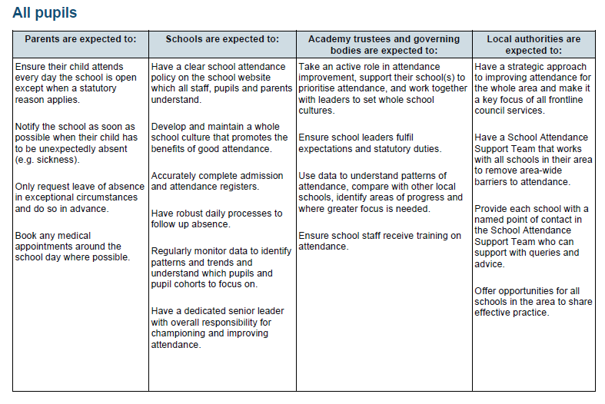

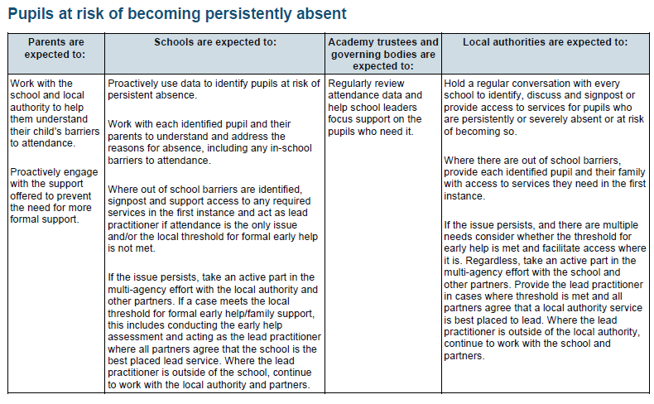

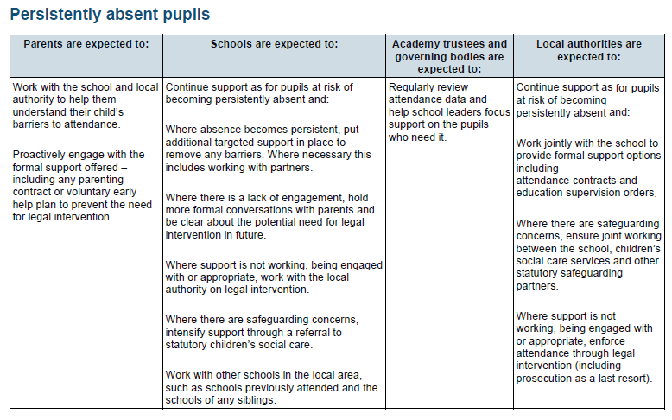

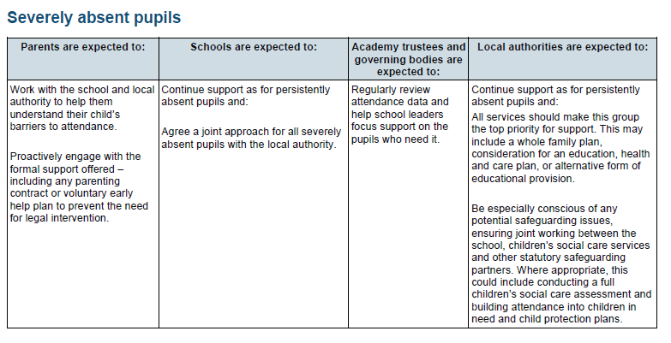

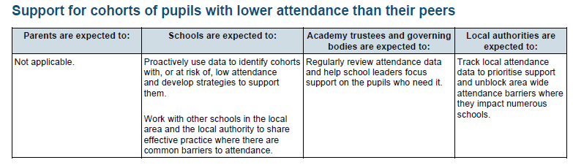

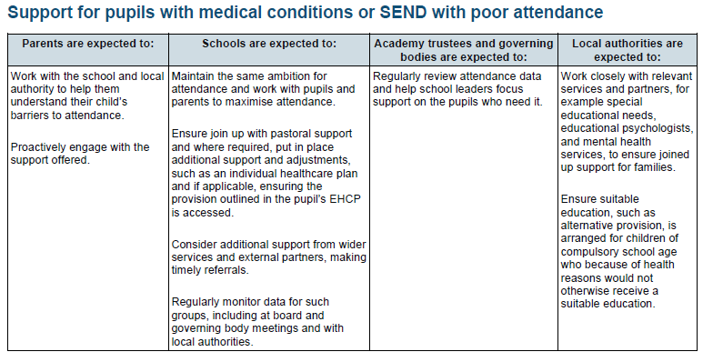

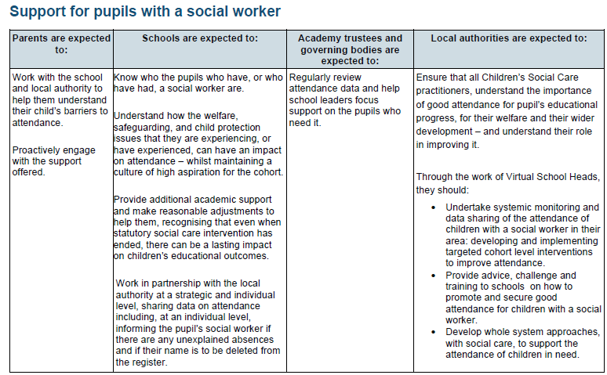

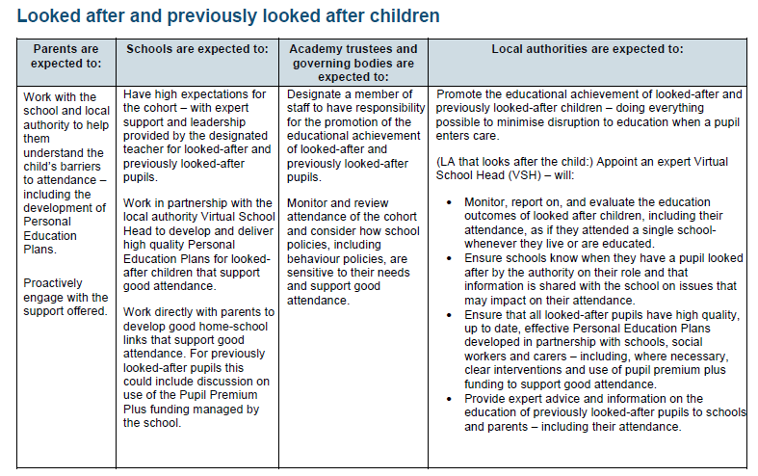

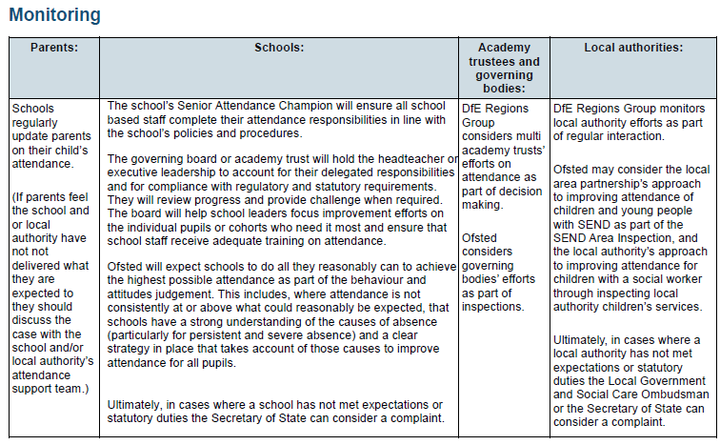

**Annex B**

**ESSEX CODE OF CONDUCT: PENALTY NOTICES FOR PARENTS OF TRUANTS AND PARENTS OF LEARNERS EXCLUDED FROM PROVISION ANTI-SOCIAL BEHAVIOUR ACT 2003 SECTION 23**

[https://www.essex.gov.uk/provision s-and-learning/provision s/provision -attendance-and-absence/penalty-notices](https://www.essex.gov.uk/schools-and-learning/schools/school-attendance-and-absence/penalty-notices)

**Annex C**

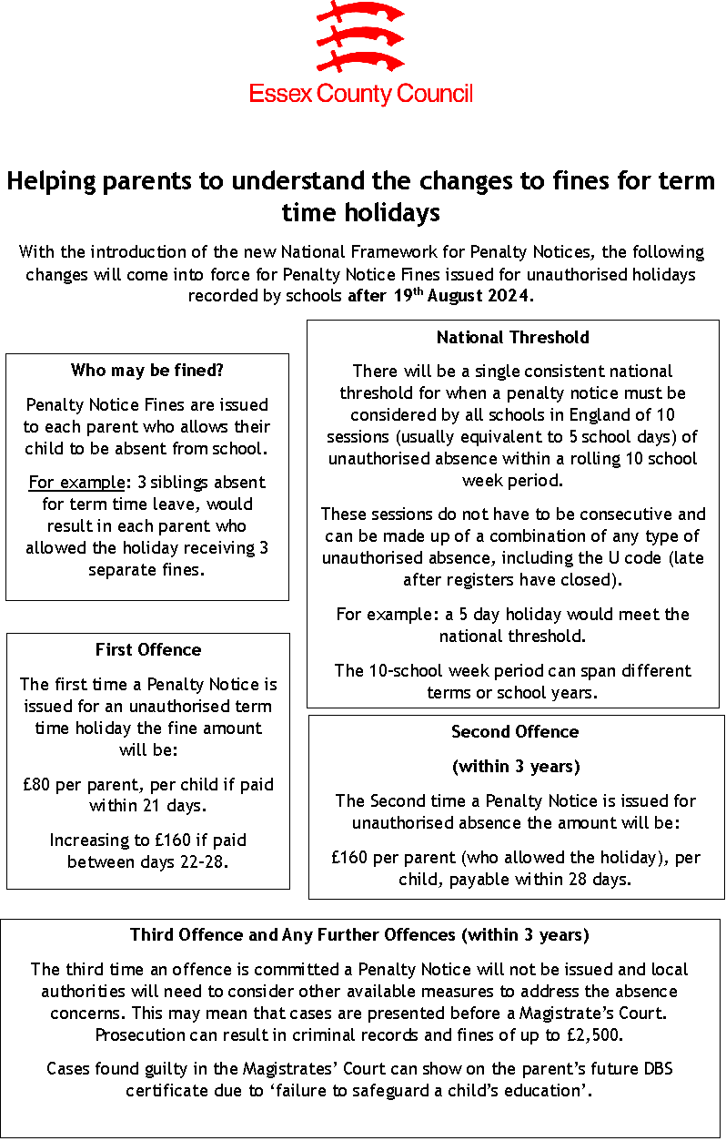

**Annex D – Illness Absence Guidance**

[https://secureprovision s.essex.gov.uk/DisplayDocument.aspx?DocID=276](https://secureschools.essex.gov.uk/DisplayDocument.aspx?DocID=276)

[https://assets.publishing.service.gov.uk/media/626669cb8fa8f523b7221b98/UKHSA-should-I-keep-my_child_off_provision _guidance-A3-poster.pdf](https://assets.publishing.service.gov.uk/media/626669cb8fa8f523b7221b98/UKHSA-should-I-keep-my_child_off_school_guidance-A3-poster.pdf)

[DfE external document template (childrenscommissioner.gov.uk)](https://assets.childrenscommissioner.gov.uk/wpuploads/2022/12/aaa-guide-for-parents-on-school-attendance.pdf)