The Peaceful Pony
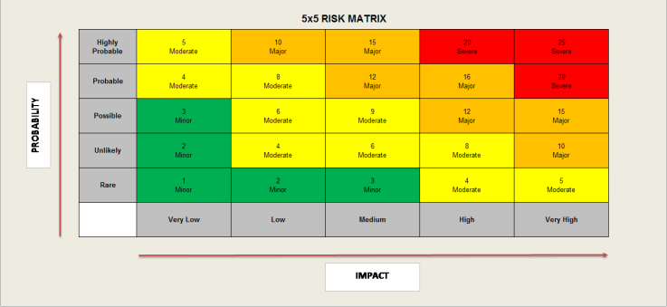
Activity Risk Assessment

• 1-4: Acceptable – no further action may be needed and maintaining control measures is encouraged.
• 5-9: Adequate – may be considered for further analysis.
• 10-16: Tolerable – must be reviewed in a timely manner to carry out improvement strategies.
• 17-25: Unacceptable – must cease in activities and endorse immediate action.

Area to be assessed | Online Gaming Activity | Person assessing area | K Reid H&S Officer
Date of assessment | 15/12/24 | Date of next review | 15/12/25

 | IMPACT DESCRIPTION | IMPACT  LEVEL | PROBABILITY LEVEL | PRIORITY LEVEL | MITIGATION NOTES | Control Measures Checked | Final Risk Rating
What Is the Hazzard | Who Is at Risk? | Rate  1 (LOW) to 5 (HIGH) | Rate  1 (LOW) to  5 (HIGH) | (IMPACT X  PROBABILITY)  Address the  highest first. | What can be done to lower or eliminate the impact or probability? | Who is responsible? | Rate  1 (LOW) to  5 (HIGH)
Online gaming can lead to access of other sites if not monitored correctly to –  Online shopping/commerce  File sharing  Social media  Messaging/chat  Entertainment streaming e.g. Netflix, Disney+  Use of video broadcasting, e.g. YouTube and TikTok | Children | 3  MINOR | 4  MODERATE | 12  MAJOR | To mitigate risks, all staff have an awareness of current online safety matters/trends and of the current Online Safety Policy and practices.  Staff have the skills and knowledge to use digital technologies safely and responsibly.  Staff understand that online safety is a core part of safeguarding and have  read, understood and signed the staff acceptable use agreement (AUA) and reports to DSL any concerns. | Manager  DSL  Lead Staff  Support staff carrying out activities  On going daily checks  H&S Officer | 3  LOW
Access of inappropriate sites  Offensive & pornographic material & images  Incidents of online-bullying, sexual harassment, discrimination, hatred etc | Children | 4  Moderate | 4  Moderate | 16  MAJOR | To mitigate risks - where internet use is pre-planned learners should be guided to sites checked as suitable for their use and that processes are in place for dealing with any unsuitable material that is found in internet searches.  All staff have a zero-tolerance approach to incidents of online-bullying, sexual harassment, discrimination, hatred etc • | Manager  Senior Staff  H&S Officer  DSL  On going daily checks | 6  MODERATE
Access to online gaming without parental consent or awareness.  Miscommunication  Sharing personal details  Online grooming | Children | 3  MINOR | 3  MINOR | 9  MODERATE | To mitigate risk - All parents to be informed by signing consent form giving authorisation for their child to access their allocated online gaming session with their support worker. | Manager  Senior staff  H&S Officer  DSL  On going daily checks | 2  Low
Online sessions not regulated or monitored.  Risk of no authoritative person present. | Children | 3  Low | 3  Low | 9  Moderate | To mitigate risk - All online gaming sessions must be prebooked with client and parent on a weekly basis with key worker.  Sessions will be monitored and appropriate for age of client.  Lessons will last between 1 – 2 hours maximum. | Manager  DSL  Lead Staff  Support staff carrying out activities  On going daily checks  H&S Officer | 2  Low

