The Peaceful Pony
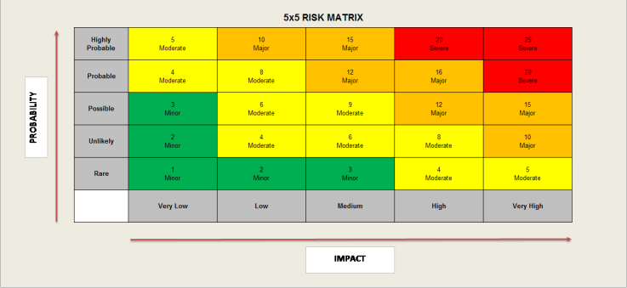
Activity Risk Assessment

• 1-4: Acceptable – no further action may be needed and maintaining control measures is encouraged.
• 5-9: Adequate – may be considered for further analysis.
• 10-16: Tolerable – must be reviewed in a timely manner to carry out improvement strategies.
• 17-25: Unacceptable – must cease in activities and endorse immediate action.

Area to be assessed | Electrical Appliances Cooking Activities | Person assessing area | K Reid H&S Officer
Date of assessment | 15/12/24 | Date of next review | 15/12/25

 | IMPACT DESCRIPTION | IMPACT  LEVEL | PROBABILITY LEVEL | PRIORITY LEVEL | MITIGATION NOTES | Control Measures Checked | Final Risk Rating
What Is the Hazzard | Who Is at Risk? | Rate  1 (LOW) to 5 (HIGH) | Rate  1 (LOW) to  5 (HIGH) | (IMPACT X  PROBABILITY)  Address the  highest first. | What can be done to lower or eliminate the impact or probability? | Who is responsible? | Rate  1 (LOW) to  5 (HIGH)
Multiple Electrical appliances used for cooking activities.  Could cause electrical shocks or burns.  Covered appliances can overheat | Children  Staff | 3  MINOR | 4  MODERATE | 12  MAJOR | All electrical appliances should be checked prior to use they are operating safely to minimise the risk of harm.  All operations of appliances must be carried out to manufacturers instructions  All appliance surfaces must be kept clear to reduce the risk of over heating | Manager  Lead Staff  Support staff carrying out activities  On going daily checks  H&S Officer | 3  LOW
Plug sockets and extension leads are not to be overloaded  To be checked and tested regularly  Risk of power surge, blown fuses, fire, power outage. | Children  Staff | 4  Moderate | 4  Moderate | 16  MAJOR | All plugs to be PAT tested on an annual basis  Plug sockets and extension leads are not to be overloaded, to remove plugs after use.  To have no more than two appliances plugged in to extension lead at any one time. | Manager  Senior Staff  H&S Officer  On going daily checks | 8  MODERATE
Use of sharp utensils, hot trays, hot liquids  Risk of scolds from hot liquids, burns from handling hot trays, cuts from sharp knives.  Risk of sharp objects being used in a threatening behaviour | Children Staff | 3  MINOR | 3  MINOR | 9  MODERATE | Supervision by support staff always.  All sharp objects to be locked away when not in use.  Staff only to remove trays from ovens.  Supervision of melting food e.g.: lard, to reduce the risk of scolding | Manager  Senior staff  H&S Officer  On going daily checks | 4  MODERATE
All participants care plans to be checked for allergies and parental authorisation prior to cooking activity  Risk of anaphylaxis  Risk of miscommunication | Children  Staff | 4  MODERATE | 5  MODERATE | 20  HIGH | All care plans of participants must be checked prior to activity to mitigate risk of lack of authorisation and additional allergies  First Aider always on site  Adult supervision is always required ratio when equipment being used by children | Manager  All Staff  H&S Officer  On going daily checks | 3  LOW

