The Peaceful Pony
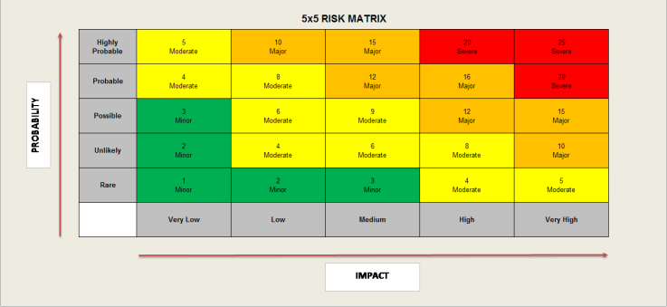
Activity Risk Assessment

• 1-4: Acceptable – no further action may be needed and maintaining control measures is encouraged.
• 5-9: Adequate – may be considered for further analysis.
• 10-16: Tolerable – must be reviewed in a timely manner to carry out improvement strategies.
• 17-25: Unacceptable – must cease in activities and endorse immediate action.

Area to be assessed | Use of Internet Services | Person assessing area | K Reid H&S Officer
Date of assessment | 03/01/25 | Date of next review | 03/01/26

 | IMPACT DESCRIPTION | IMPACT  LEVEL | PROBABILITY LEVEL | PRIORITY LEVEL | MITIGATION NOTES | Control Measures Checked/Dates | Final Risk Rating
What Is the Hazzard | Who Is at Risk? | Rate  1 (LOW) to 5 (HIGH) | Rate  1 (LOW) to  5 (HIGH) | (IMPACT X  PROBABILITY)  Address the  highest first. | What can be done to lower or eliminate the impact or probability? | Who is responsible? | Rate  1 (LOW) to  5 (HIGH)
Incorrect use of manufacturer’s instructions  Covered appliances can overheat.  Power leads trip hazards | Children, Staff | 3  LOW | 4  MODERATE | 12  MAJOR | All electrical appliances to be checked prior to use to ensure they are operating safely to minimise the risk of harm.  Operation of laptops must be carried out to manufacturer’s instructions  All appliance surfaces must be kept clear to reduce the risk of overheating.  Power leads to be kept clear or taped to floor to mitigate risk of trips and falls. | Manager  Lead Staff  Support staff carrying out activities  On going daily checks  H&S Officer | 3  LOW
Plug sockets and extension leads are not to be overloaded  To be checked and tested regularly  Risk of power surge, blown fuses, fire, power outage. | Children, Staff | 3  LOW | 4  MODERATE | 12  MAJOR | All plugs to be PAT tested on an annual basis  Plug sockets and extension leads are not to be overloaded, to remove plugs after use.  To have no more than two appliances plugged in to extension lead at any one time. | Manager  Senior Staff  H&S Officer  On going daily checks | 4  MODERATE
Laptops used in different areas of site, risk of being dropped or handled incorrectly when being transported. | Children, Staff | 1  VERY LOW | 4  Moderate | 4  Moderate | Laptops to be transported between rooms by supervising adult to mitigate risk of damage to appliance. |  | 2  LOW
Access to inappropriate internet sites  Online security breach  Downloading content can risk Data and virus to system | Children, Staff | 4  Moderate | 5  Moderate | 20  SEVERE | To follow ECC guidelines set out at TPP for online teaching to mitigate risk of inappropriate use.  http://safety.ngfl.gov.uk/schools/  Site filtering and monitoring of systems by staff to reduce risk of access to inappropriate sites. | Manager  Senior staff  H&S Officer  On going daily checks | 6  MODERATE
Personal flash drives, memory sticks can cause data corruption or risk of leak of personal information.  Miscommunication regarding usage of internet | Children/Staff | 4  Moderate | 5  Moderate | 20  SEVERE | All children to have appropriate training to access the internet to reduce risk of corruption of data and avoid viruses  All children must have authorised consent from parent or care giver. | Manager  All Staff  H&S Officer  On going daily checks | 4  Moderate

