The Peaceful Pony
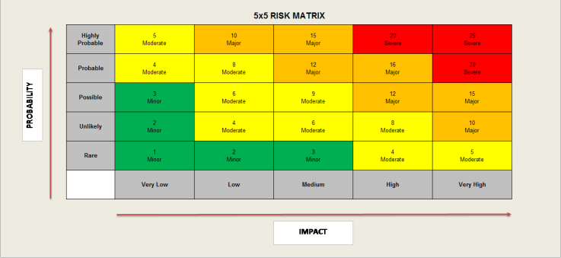
Activity Risk Assessment

• 1-4: Acceptable – no further action may be needed and maintaining control measures is encouraged.
• 5-9: Adequate – may be considered for further analysis.
• 10-16: Tolerable – must be reviewed in a timely manner to carry out improvement strategies.
• 17-25: Unacceptable – must cease in activities and endorse immediate action.

Area to be assessed | Reptile Activities | Person assessing area | K Reid H&S Officer
Date of assessment | 15/12/24 | Date of next review | 15/12/25

 | IMPACT DESCRIPTION | IMPACT  LEVEL | PROBABILITY LEVEL | PRIORITY LEVEL | MITIGATION NOTES | Control Measures Checked | Final Risk Rating
What Is the Hazzard | Who Is at Risk? | Rate  1 (LOW) to 5 (HIGH) | Rate  1 (LOW) to  5 (HIGH) | (IMPACT X  PROBABILITY)  Address the  highest first. | What can be done to lower or eliminate the impact or probability? | Who is responsible? | Rate  1 (LOW) to  5 (HIGH)
Risk of harm to reptiles or from reptiles if not authorised from Lead member of staff.  Risk of mishandling reptiles, breakages to vivarium glass, loss of keys  Free roaming reptiles can escape or come to harm if door left open or could be stepped on. | Children  Staff  Reptiles | 3  MINOR | 4  MODERATE | 12  MAJOR | Authorisation must be given by lead staff prior to handling or removing reptiles from their vivarium’s.  All vivarium’s to be locked and keys hung back on appropriate hooks to reduce risk of unauthorised access or loss of keys.  All doors must be closed and staff and children made aware that a reptile is free roaming on the floor. | Manager  Lead Staff  Support staff carrying out activities  On going daily checks  H&S Officer | 3  LOW
Plug sockets and extension leads are not to be overloaded  To be checked and tested regularly  Risk of power surge, blown fuses, fire, power outage.  Risk of burns from heat lamps. | Children  Staff  Reptiles | 4  Moderate | 4  Moderate | 16  MAJOR | All plugs to be PAT tested on an annual basis  Plug sockets and extension leads are not to be overloaded, to remove plugs after use.  To have no more than two appliances plugged in to extension lead at any one time.  Do not touch heat lamps inside enclosures to mitigate risk of burns | Manager  Senior Staff  H&S Officer  On going daily checks | 8  MODERATE
Use of sharp utensils, cleaning products.  Risk of ingestion, spillage of cleaning products  Risk of sharp objects causing cuts, risk of being used in a threatening behaviour | Children  Staff | 3  MINOR | 3  MINOR | 9  MODERATE | Supervision by support staff always.  All sharp objects to be locked away in cupboard when not in use.  All spillages to be cleared up immediately to reduce risk of slips.  All reptiles to be bathed only with staff supervision to reduce risk of scolds to person or reptile | Manager  Senior staff  H&S Officer  On going daily checks | 4  MODERATE
Incorrect temperatures causing risk of death to reptiles  Lack of electricity to building causing lack of heat  Risk of incorrect diet causing illness to reptiles | Children  Staff  Reptiles | 5  MODERATE | 5  MODERATE | 25  HIGH | All reptiles will be checked by Animal Lead, for wellbeing to reduce risk of harm to reptile or person.  Do not feed or water the reptiles unless authorised by Lead to mitigate risk of causing harm  All UVB/UVA plugs to be checked, and appropriate temperatures set at the beginning / end of day. | Manager  All Staff  H&S Officer  On going daily checks | 3  LOW

