The Peaceful Pony
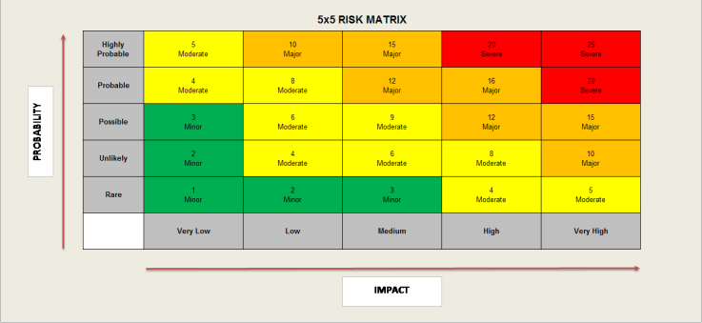
Activity Risk Assessment

• 1-4: Acceptable – no further action may be needed and maintaining control measures is encouraged.
• 5-9: Adequate – may be considered for further analysis.
• 10-16: Tolerable – must be reviewed in a timely manner to carry out improvement strategies.
• 17-25: Unacceptable – must cease in activities and endorse immediate action.

Area to be assessed | WORKING WITH HORSES | Person assessing area | K Reid H&S Officer
Date of assessment | 03/01/25 | Date of next review | 03/01/26

 | IMPACT DESCRIPTION | IMPACT  LEVEL | PROBABILITY LEVEL | PRIORITY LEVEL | MITIGATION NOTES | Control Measures Checked/Dates | Final Risk Rating
What Is the Hazzard | Who Is at Risk? | Rate  1 (LOW) to 5 (HIGH) | Rate  1 (LOW) to  5 (HIGH) | (IMPACT X  PROBABILITY)  Address the  highest first. | What can be done to lower or eliminate the impact or probability? | Who is responsible? | Rate  1 (LOW) to  5 (HIGH)
HORSES  Bitten  Scratched  Knocked over  Tripping over  Trod on  Allergic Reaction  Infection | Children, Staff | 4  MODERATE | 4  MODERATE | 16  MAJOR | Qualified & experienced staff.  All horses to have care checks each morning to reduce risk of harm to self or others. Animals are tame, encouraged not to bite, not fed treats and regularly assessed either directly or indirectly by The Peaceful Pony.  First Aider on site  Hand Sanitising facilities. | Manager  Lead Staff  Support staff carrying out activities  On going daily checks  H&S Officer | 6  MODERATE
Activities around horses  Routine care and  management of animals. Cleaning of areas. Animal checks Provision of food & water. Leading animals.  Observations and interactions.  Bitten  Scratched  Knocked over  Tripping over  Trod on  Allergic Reaction  Infection | Children, Staff | 4  MODERATE | 4  MODERATE | 16  MAJOR | Introduction and induction given to all new clients and visitors for safety awareness and to mitigate risk of harm.  Qualified & experienced staff  Sensible, well-mannered horses.  Horses matched the learner's confidence and ability.  Supervised at all time  First Aider on site  Hand sanitising Facilities. | Manager  Senior Staff  H&S Officer  On going daily checks | 4  MODERATE
Inexperienced of being around horses  Children not adequately supervised  Bitten  Scratched  Knocked over  Tripping over  Trod on | Children, Staff | 4  Moderate | 5  Moderate | 20  Severe | Qualified & experienced staff (at least one member of staff per child and one member of staff per horse) to mitigate risk of harm to child or staff. | Manager  Senior staff  H&S Officer  On going daily checks | 2  LOW
Muck Heap Area  Allergic Reaction  Infection  Tripping Over | Children  Staff | 2  Low | 3  Low | 6  Moderate | Muck heap area is out of bounds to clients to mitigate risk of harm.  Signs visible to advise no unauthorised admittance. | Manager  Senior staff  H&S Officer  On going daily checks | 2  Low
Gates not closed properly  Electrical fencing  Uneven surfaces are everywhere on site. | Children, Staff | 3  Low | 3  Low | 9  Moderate | Safety Instructions in induction and explanation out of bounds for unauthorised persons to reduce risk of trips and falls and electrical shocks.  All gates to be closed to mitigate risk of horses escaping.  Muck  to clients. | Manager  Senior staff  H&S Officer  On going daily checks | 4  MODERATE
Equipment around horses (including  trailer,  forks,  shovels)  Grooming equipment  Wheelbarrows  Manual Handling/Trips and falls | Children  Staff | 2  Low | 3  Low | 6  Moderate | Direct or indirect supervision at all  times regarding the access  and use of equipment.  Information provided on  equipment safe use before use.  The Peaceful Pony to be notified  immediately if danger is seen and  activity stopped. | Manager  Senior staff  H&S Officer  On going daily checks | 4  Moderate
Inappropriate footwear and attire worn on site around horses.  Bitten  Scratched  Knocked over  Tripping over  Trod on | Children/Staff | 4  Moderate | 4  Moderate | 16  Major | Safety Instructions in induction and explanation of correct closed in footwear to mitigate risk of injury to feet from horses.  Weather appropriate clothing to be worn. | Manager  All Staff  H&S Officer  On going daily checks | 4  Moderate
Allergic Reactions  Anaphylaxis | Children  Staff | 4  Moderate | 3  Low | 12  Major | Health issues must be raised by clients before coming on site or disclosed at induction to mitigate risk of anaphylaxis.  Ensure clients have Epi pens if required.  Staff’s discretion if any disclosure  stops the individual remaining on site.  First Aid Trained people on-site. | Manager  Senior staff  H&S Officer  On going daily checks | 4  Moderate

