The Peaceful Pony
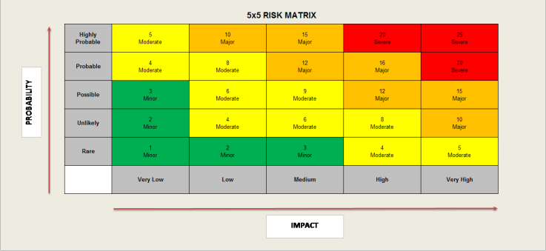
Activity Risk Assessment

• 1-4: Acceptable – no further action may be needed and maintaining control measures is encouraged.
• 5-9: Adequate – may be considered for further analysis.
• 10-16: Tolerable – must be reviewed in a timely manner to carry out improvement strategies.
• 17-25: Unacceptable – must cease in activities and endorse immediate action.

Area to be assessed | Arts & Crafts Activities | Person assessing area | K Reid H&S Officer
Date of assessment | 03/01/25 | Date of next review | 03/01/26

 | IMPACT DESCRIPTION | IMPACT  LEVEL | PROBABILITY LEVEL | PRIORITY LEVEL | MITIGATION NOTES | Control Measures Checked | Final Risk Rating
What Is the Hazzard | Who Is at Risk? | Rate  1 (LOW) to 5 (HIGH) | Rate  1 (LOW) to  5 (HIGH) | (IMPACT X  PROBABILITY)  Address the  highest first. | What can be done to lower or eliminate the impact or probability? | Who is responsible? | Rate  1 (LOW) to  5 (HIGH)
Craft Space & Equipment (i.e. Tables, Chairs etc)  Set up / Pack down of equipment (injury)  Obstacles (Trips/Falls, Injury, Safety) | Children  Staff | 3  MINOR | 3  Minor | 9  Moderate | •Appropriate space & equipment to be identified for the activity.  •Tables & chairs to be set up, using safe lifting and carrying methods.  •Craft area should provide sufficient space for young people to complete the activity safely & comfortably.  •Chairs to be tucked under tables, when not being used, to reduce trip hazards. | Manager  Lead Staff  Support staff carrying out activities  On going daily checks  H&S Officer | 2  LOW
Scissors & Sharp Objects  Cuts / Injuries (Injury)  Inappropriate use (injury/Safety)  Missing Scissors/sharp objects (Injury/Safety) | Children  Staff | 2  Low | 3  Low | 6  Moderate | - Leaders to brief young people on use of scissors or other sharp objects, before handing them out, including expected use, safety and behaviour whilst using them.  - Appropriate type/sharpness of scissors or sharp objects for the age group and ability (I.e. safety scissors).  - Scissors/sharp objects to be counted out and counted back in.  - Sufficient leaders for supervision (based on age, ability, additional support needs)  - Young people to be seated and not moving about, whilst holding or using sharp objects.  Safety & behaviour prompts throughout. | Manager  Senior Staff  H&S Officer  On going daily checks | 4  MODERATE
Glue, Paint, Solvents & other Resources  Drinking/Eating Resources (Illness)  Inappropriate use (injury/Illness)  Chemicals / Toxins (Illness)  Small items (choking) | Children Staff | 3  MINOR | 3  MINOR | 9  MODERATE | - Staff to brief young people on use of resources, before the activity, including expected use, safety and behaviour whilst using them.  - Glue/Paints or similar to be placed in appropriate tubs/pots, to help contain them.  - Appropriate clothing/coverings/PPE, where required.  - Glue/paints/small items to be kept away from mouths/eyes.  - Non-toxic paints to be used, where possible.  - Paints/solvents – space to be well ventilated  - Resources checked for manufacturers guidance on appropriate use.  Staff to collect in unused resources after the activity. | Manager  Senior staff  H&S Officer  On going daily checks | 4  MODERATE
Additional Needs  Unsafe Activity (Safety/Injury)  Exclusion (wellbeing/inclusivity) | Children  Staff | 4  MODERATE | 4  Moderate | 16  Major | Staff to consider any additional support needs and provide appropriate support, supervision and resources to any young people who require it to mitigate risk of harm and/or exclusion. | Manager  All Staff  H&S Officer  On going daily checks | 3  LOW

